Engels on Development of the Proletarian Movement
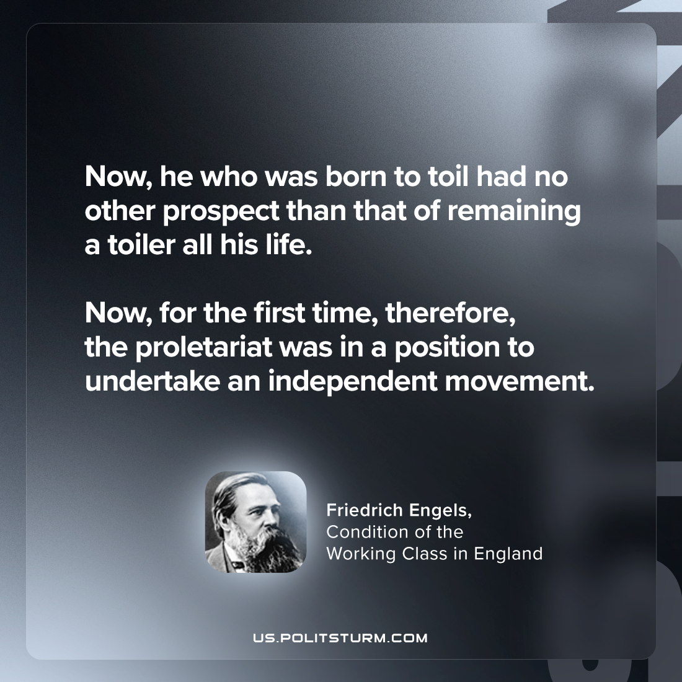

Original article
2024-03-10

"Now, he who was born to toil had no other prospect than that of remaining a toiler all his life. Now, for the first time, therefore, the proletariat was in a position to undertake an independent movement."
Friedrich Engels, The Condition of the Working Class in England

Original article

