Engels on Class Struggle
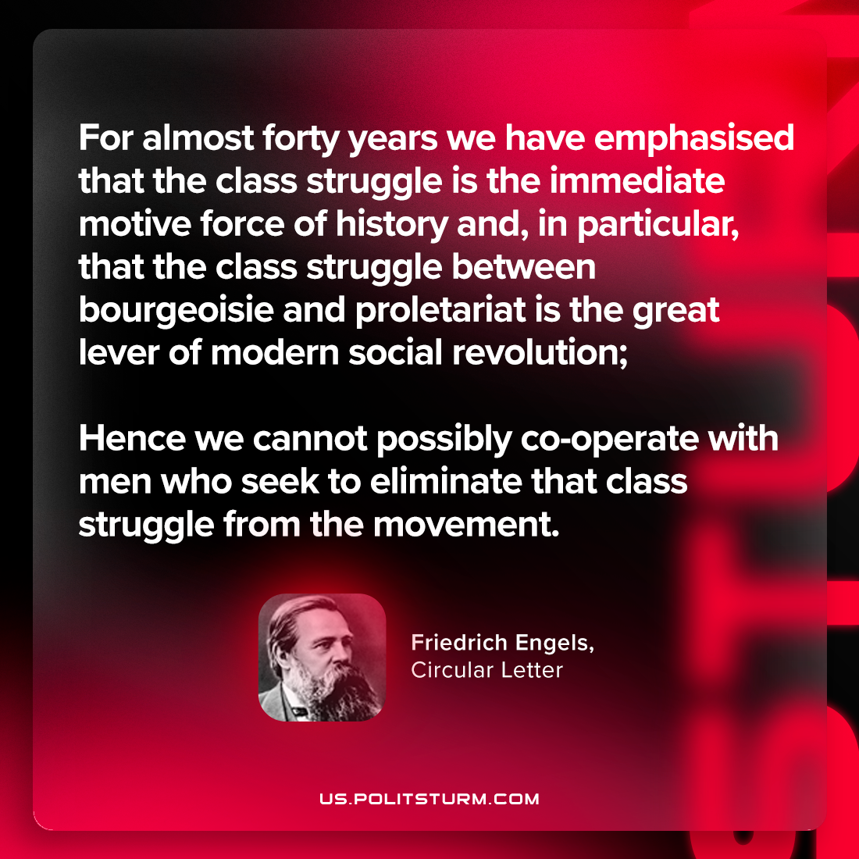

Original article
2024-04-21

“For almost forty years we have emphasised that the class struggle is the immediate motive force of history and, in particular, that the class struggle between bourgeoisie and proletariat is the great lever of modern social revolution; hence we cannot possibly co-operate with men who seek to eliminate that class struggle from the movement.”
Friedrich Engels, Circular Letter

Original article

