Engels on Communists Creating Conditions for People to Flourish
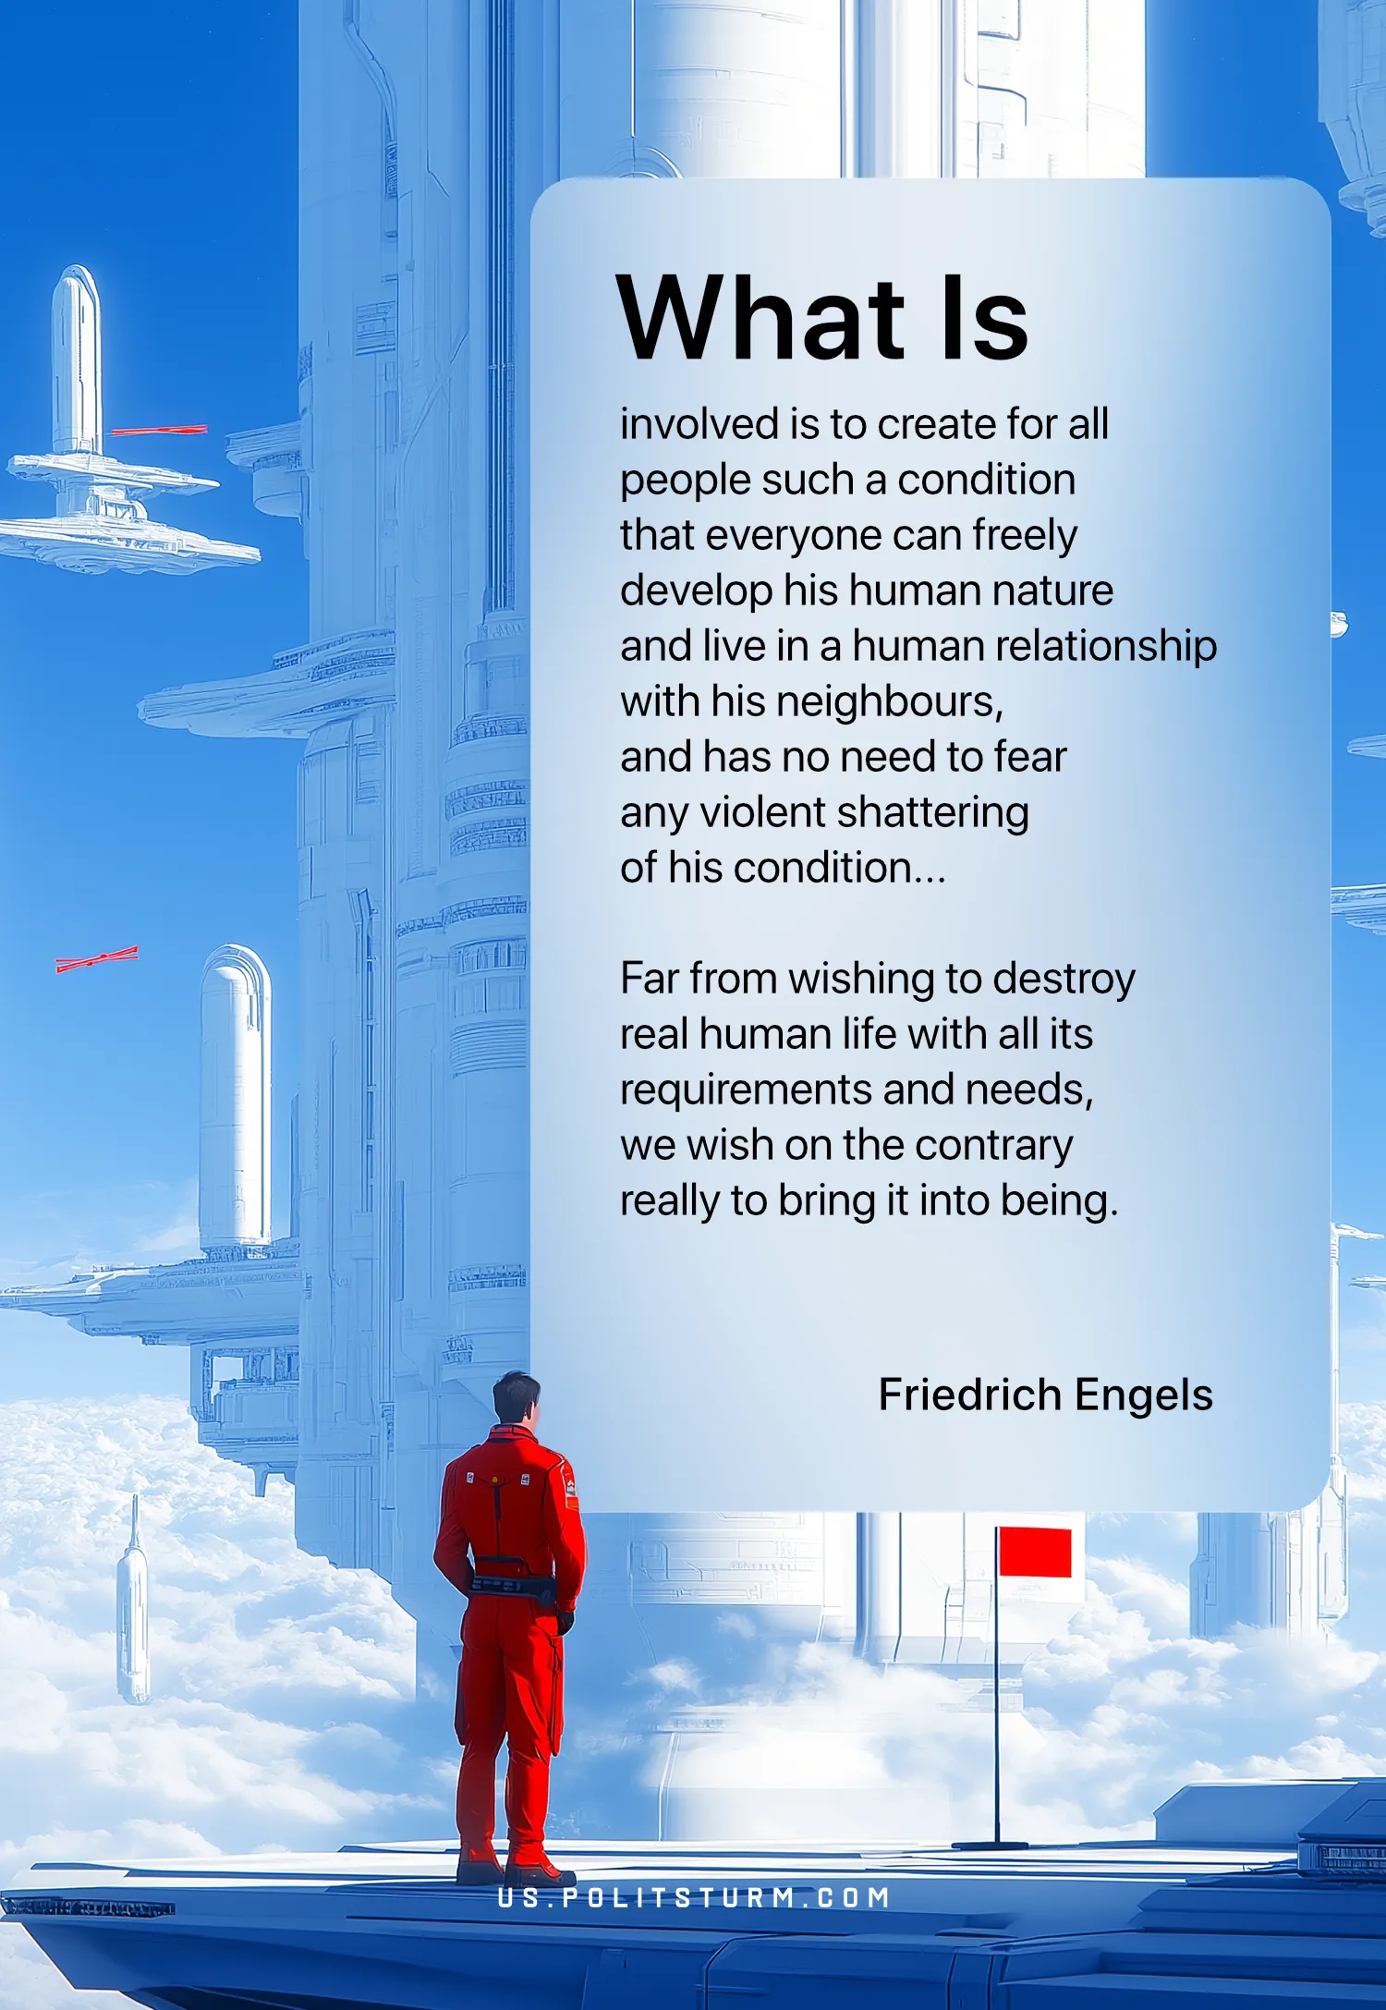

Original article
2025-02-08

“What is involved is to create for all people such a condition that everyone can freely develop his human nature and live in a human relationship with his neighbours, and has no need to fear any violent shattering of his condition...
Far from wishing to destroy real human life with all its requirements and needs, we wish on the contrary really to bring it into being.”
Friedrich Engels, Speeches in Elberfeld

Original article

