Engels on the Freedom and Oppression of Nations
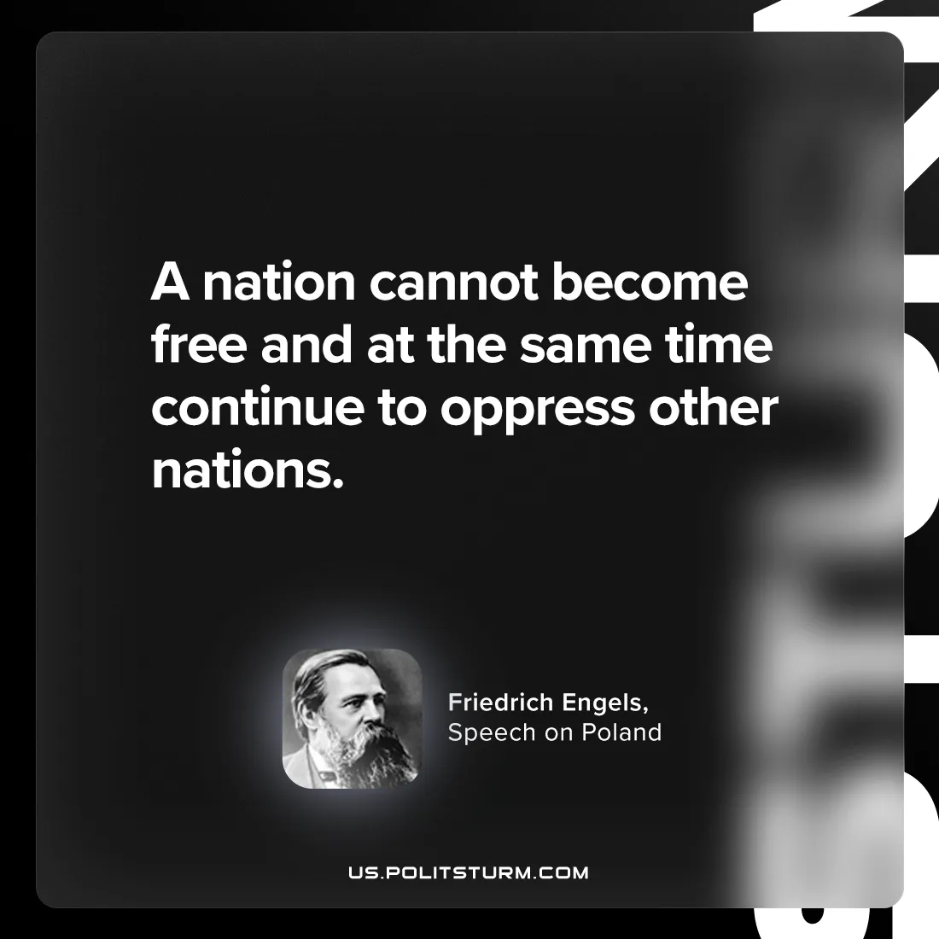

Original article
2024-08-08

"A nation cannot become free and at the same time continue to oppress other nations."
Friedrich Engels, Speech on Poland

Original article

