Energy Crisis Pushing Chinese Workers into Overtime
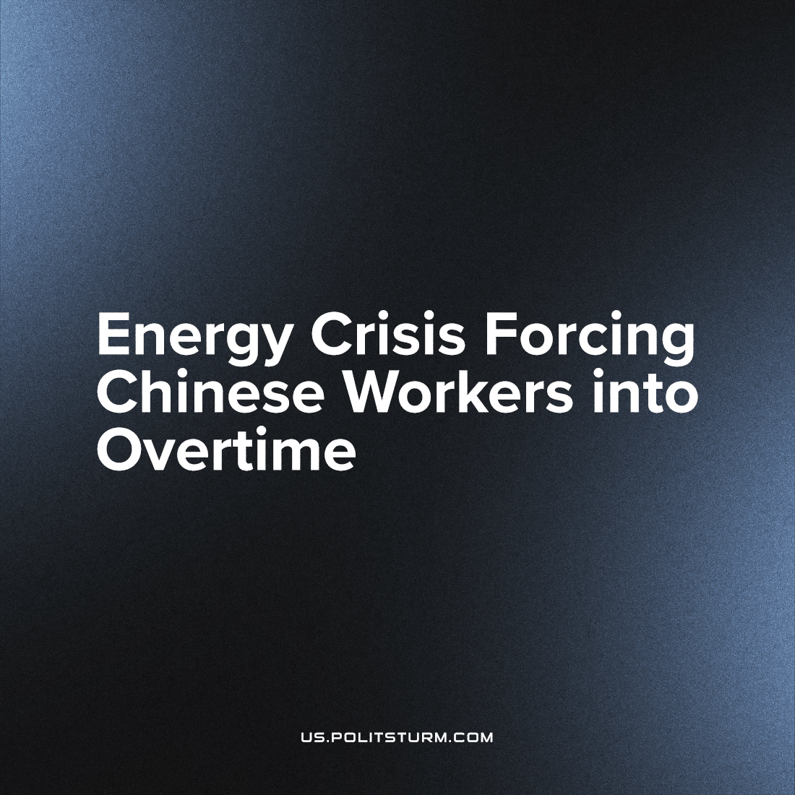

Original article
2022-10-27
2 min read

Chinese workers are forced to work overtime to fulfill the rush of new orders for warm clothing coming from Europe. According to the Global Times, the energy crisis has caused high demand and rising prices before the winter heating season.
“Searches for men’s turtlenecks have increased 13 times in the last 30 days in our company’s online shop,” said Luo Jun, head of Xiamen Premium Import & Export Co. Trade volume between the EU nations and China increased 28.5% from 2022 compared to the same time last year, according to Eurostat.
This company’s employees began to work overtime in May 2022. Many large companies in China practice a “9-9-6” schedule, which means they work from 9:00 to 21:00, six days a week. And, even though this work schedule was banned in 2021, it is not profitable for anyone following this ban. As a result, 996 practice is still considered to be entirely normal especially in the internet industry.
While Xiamen manufacturing workers may not be working this particularly infamous schedule, it is important to note that forming trade unions independent of the Chinese “Communist” Party is prohibited. So, it is difficult to confirm the direct conditions and complaints of the workers in such tightly-run facilities without independent representation. China is still the world’s source of cheap labour, despite President Xi Jinping’s declaration to the contrary in the most recent Chinese party congress; cases of exploitation of workers and non-observance of working conditions are no secret. It unequivocally follows that the party only masks its petty imperialist interests with a false face. As for the trade unions, it is to the advantage of the Chinese ruling class to control them and prevent the workers from creating effective organization.
Many workers in China are in distress, living in poverty. But the capitalists there are jubilant: they have successfully minimized the costs of paying for their working class’ needs. Of course, they will never make real concessions. The working people will inevitably realize their interests and what they have to fight for, but this will happen faster if they are theoretically prepared and well-united. With the consistent struggle of the entire working class against the merciless machine of capitalism, it will be possible to achieve justice and build a real communist system not just flags and slogans.
Sources: 1

Original article

