Elon Musk Called Demographic Collapse ‘The Biggest Problem That Humanity Faces’
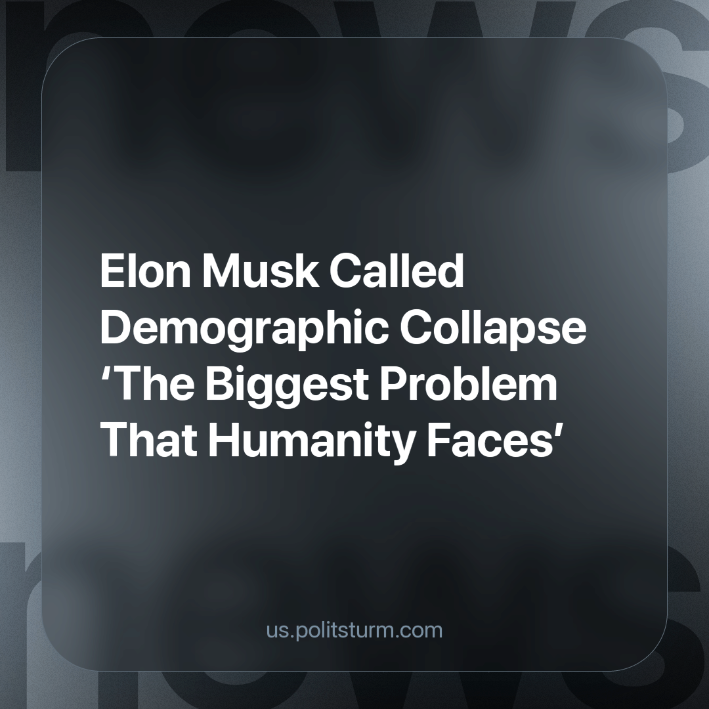

Original article
2024-02-03
2 min read

Last month, American billionaire Elon Musk made headlines for a claim about demographic collapse. His X post read as follows: “The biggest problem facing humanity is demographic collapse”. Musk has stated in a prior month that the United States will someday face a “big reckoning” caused by low birth rates.
Declining birth rates are certainly a problem in the United States. In 2019, the total fertility rate in the United States was 1.71, the lowest level since the 1970s. A study from Ohio State University suggested a potential cause: that young people have become more worried about the future and are therefore postponing having children. The study focuses on the importance of creating good conditions for families, rather than on attempting to force young people into having children.
The demographic crisis did not arise in a vacuum. A low standard of living, high unemployment, and a lack of confidence in the future stops young people from even thinking about having children.
Social and economic relations under capitalism result in the enrichment of a minority who attains profits by exploiting the working majority. Against this background, Elon Musk’s concerns are contradictory, because he is a billionaire, and contributes to the development of low birth rates. He does this by regularly cutting the salaries of his employees, and firing them during economic crises in order to preserve and exaggerate his own profits. This results in workers losing the security and wealth they need to raise children.
Musk does this and turns around to complain that the current low birth rate will make it difficult for billionaires like him to find cheap labor in the future. He is right, it will be harder to find cheap labor in the future. The population decline will also lead to a reduced number of consumers he can sell products to.
This is the contradiction - the capitalist cannot help but rob the worker for profit. The workers, driven into conditions of survival, are not ready to have children, thereby depriving the capitalists of future prospects. This leads to increased competition between corporations for a smaller amount of spoils.
For the sake of survival, humanity should change its socio-economic formation away from a system that prioritizes short-term profits over long-term well-being. The USSR was a shining example of such a system. Even the devastation of WW2 did not stop the socialist state.
Source: Izvestia - “Musk called demographic collapse the biggest problem of humanity” from January 03, 2024

Original article

