Eight Principles of Socialism
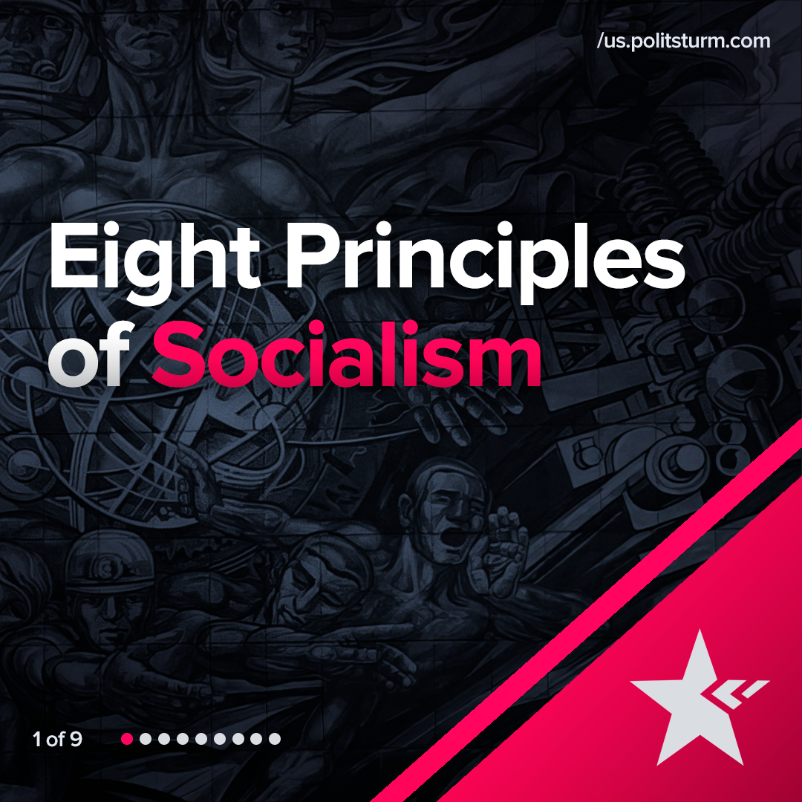

Original article
2022-01-28
1 min read

Error loading image
Error loading image
Error loading image
Error loading image
Error loading image
Error loading image
Error loading image
Error loading image

Original article

