Engels on the Need to Abolish Competition Among the Workers
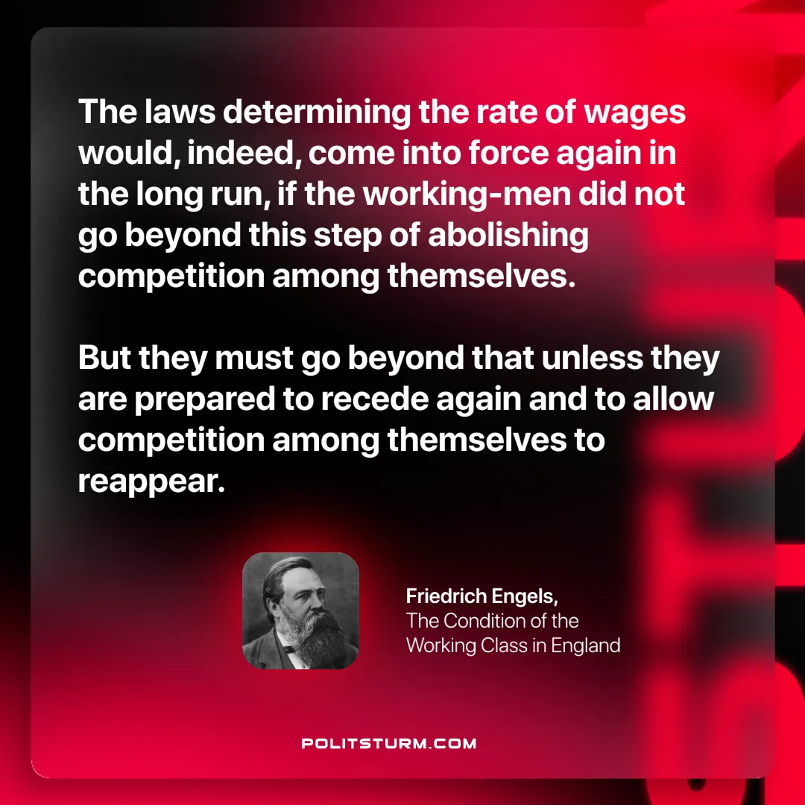

Original article
2024-12-29

“The laws determining the rate of wages would, indeed, come into force again in the long run, if the working-men did not go beyond this step of abolishing competition among themselves. But they must go beyond that unless they are prepared to recede again and to allow competition among themselves to reappear.”
Friedrich Engels, The Condition of the Working Class in England

Original article

