Engels on Humanity Making its own History
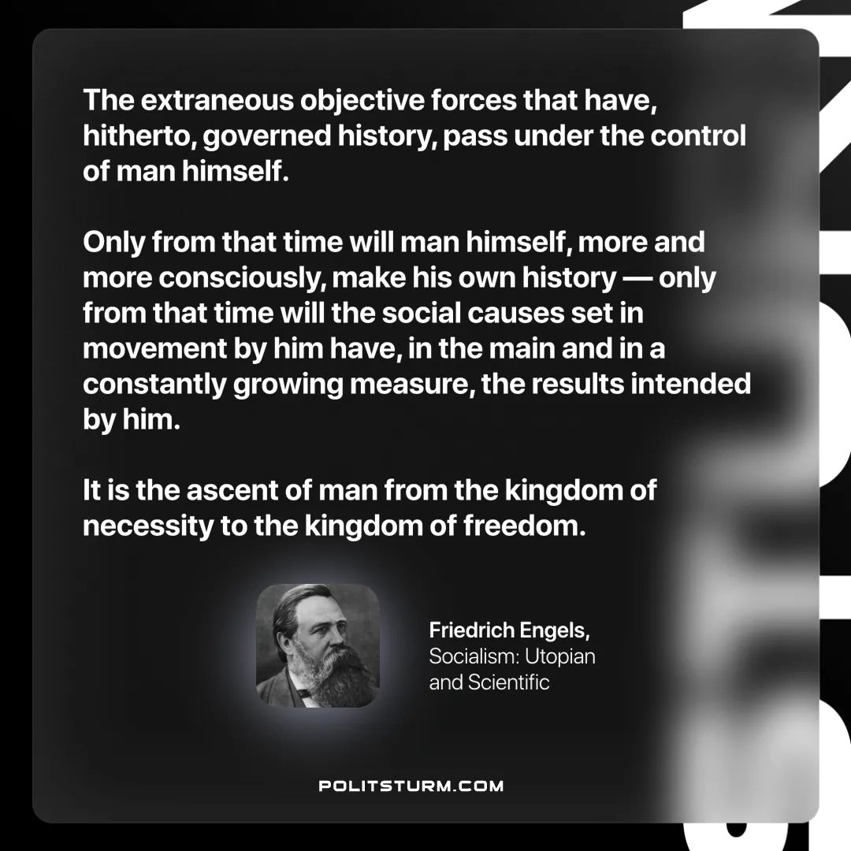

Original article
2024-12-22

“The extraneous objective forces that have, hitherto, governed history,pass under the control of man himself. Only from that time will man himself, more and more consciously, make his own history — only from that time will the social causes set in movement by him have, in the main and in a constantly growing measure, the results intended by him. It is the ascent of man from the kingdom of necessity to the kingdom of freedom.”
Friedrich Engels, Socialism: Utopian and Scientific

Original article

