Dutch Government to Close 3,000 Farms
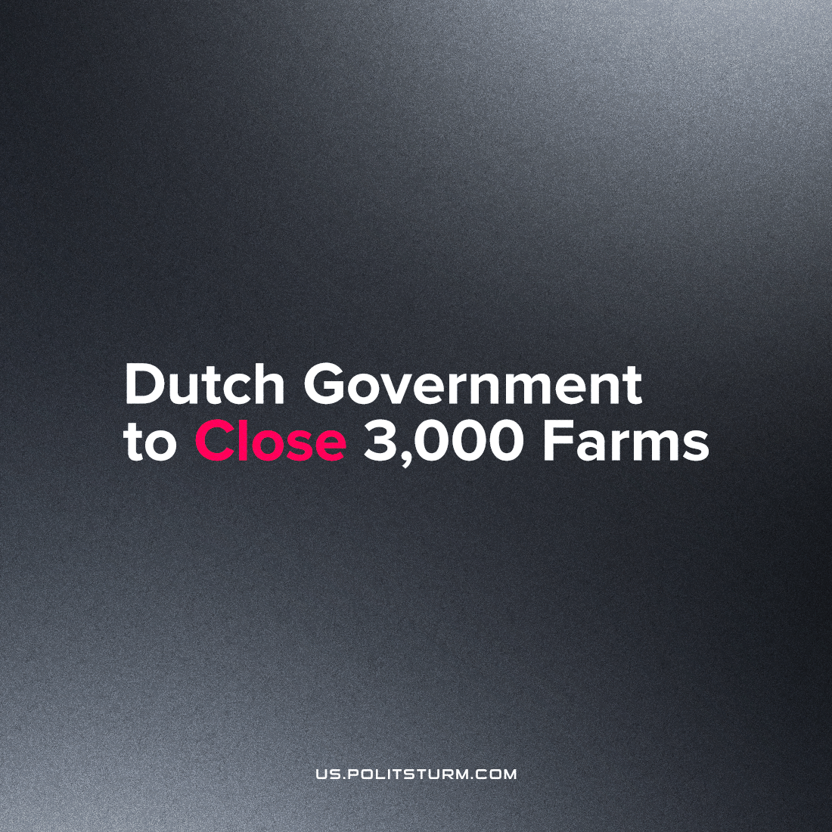

Original article
2022-12-19
2 min read

In June of this year, Dutch legislators, acting on orders from the court, in line with the EU regulatory trend, passed a bill to reduce the country's nitrogen and ammonia emissions by 50% by 2030. This means that about 30% of the country's farmers will be forced to stop production. To respond to the new climate policy, tens of thousands of farmers launched a major protest in the summer of 2022. For months, farmers blocked roads, public transit, and disrupted supermarket supplies to demonstrate to the country the consequences of climate policy for small enterprises.
Despite the enormous manifestations, the Dutch government did not change its chosen course. After sending in the police to resolve the protests, which could not be maintained through to the winter, the state is carrying forced with the closure of around 3,000 farms in pursuit of its goal. According to the Ministry of Environmental Protection, the closures will take place in the form of a "forced buyout".
With such a scheme, farmers can receive compensation for their land and livestock but cannot reject or challenge the offered amount in court. In case of refusal of the deal’s terms, farmers' property may be seized without any compensation. As of December, the government has affirmed 2,000 forced buy-outs.
Climate and Nitrogen Policy Minister Christiane van der Waal-Seggelink says that forced farm purchases benefit farmers as the Dutch government will pay them "much more" than the value of their property. This claim seems dubious, not least because the Dutch government is reportedly looking to acquire €20 million in revenue through the nationalization of farms. Moreover, farmers are deprived of the opportunity to value their farms or appeal the situation in court. Lastly, a one-time cash compensation is unlikely to be adequate compensation for the loss of their entire livelihoods.
At the same time, farm buyouts will affect all agricultural workers. The most vulnerable will be small farmers, who may be thrown down from their position of ownership into the ranks of those who must sell their labor - the working majority. Larger farming capitalists, on the other hand, can survive partial loss of their lands and remain profitable, while the agro-monopolies are not effected at all, and in fact grow in their market-share from this new policy which they've likely endorsed. The desire of the monopoly here is to see food prices increase, while their profits dwindle, which can be accomplished by the mass-clearance of stock, or in this case cutting the nation's number of productive farms by 30%.
The agricultural crisis in the Netherlands is a good example that a climate policy under capitalism does not contribute to sustainable development of society, but instead only concentrates more resources in the hands of a few. In fact, current climate policy is merely a ruling-class tool of the class war. Under the guise of fighting for the environment, bourgeois-democratic governments make decisions based on the interests of big capital requesting higher profits, and destroy their weak competitors. Only a socialist state, acting in the interests of the working majority, can enact a sensible plan for climate policy and an ensured living position for everyone.
Sources: 1, 2, 3

Original article

