Driest Winter in European History Heralds Water Crisis
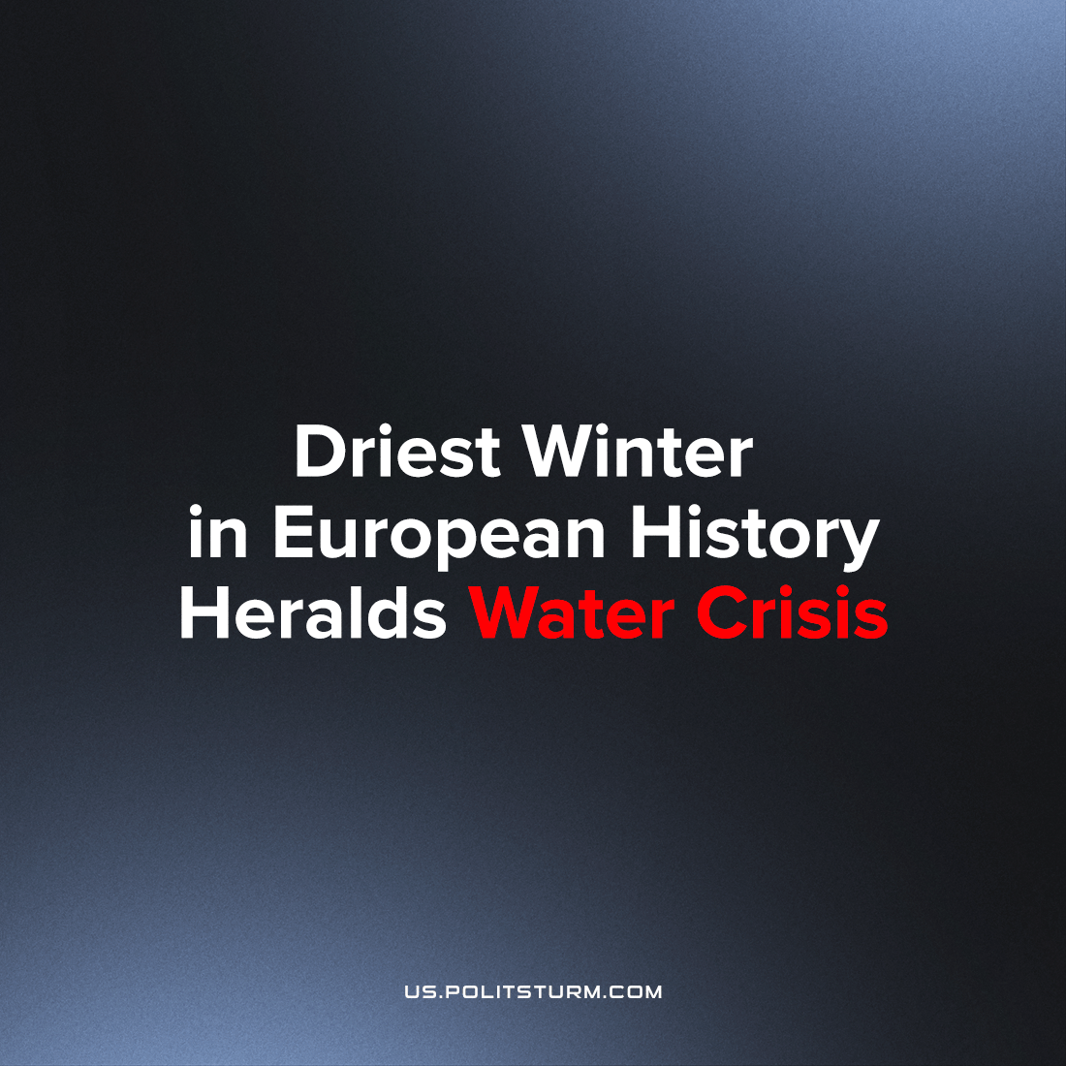

Original article
2023-05-09
12 min read

The crisis of water management is not something that is waiting just out of sight to pounce unexpectedly upon humanity in some likely future: it is unfolding right now. Europe has recently gone through a hidden drought this winter which has been quietly admitted to by various European nations. What has the free market done with its control of the most vital resource of life?
In the mountain peaks of the Alps, precipitation is low and the lack of snow cover has severely reduced the water levels for most of France’s major rivers, drying them out to record lows.
Error loading image
In February this year, it was reported that
‘France is facing drought restrictions after its driest winter for more than 60 years.
Following a month of no significant rainfall, the country is now in a state of alert.’¹
Similarly in the UK, the Environment Agency published on 10 February 2023 a press release on the government’s website that revealed that the National Drought Group was warning that the country was ‘one hot, dry spell away from drought returning this summer.’² Despite the press release stating that in spite of ‘significant improvements following five consecutive months of above average rainfall’ and that ‘total reservoir capacity across the country is at 88 percent,’³ rivers in England were actually recorded as having below-normal levels of water flowing: ‘63% of rivers are currently below normal levels for this time of year. Some storage reservoirs are still lower than anticipated and groundwater levels in Norfolk are only now beginning to rise slowly.’⁴
The press release jumped the gun; on 1 March 2023 the Meteorological Office (“Met” Office) announced that this February was the driest February since 1993 for England, further exacerbating the crisis that England is facing in regards to water. Ireland too, known for being more grey and drizzly than the UK, recorded below average rainfall for all counties in the month of February. ‘The current predicament follows European droughts in 2018, 2019, 2020, and 2022 with Rohini Kumar of the Helmholtz Centre for Environmental Research in Germany stating that:
‘What we are looking at is something like a multiyear drought.’⁵
The pattern repeats itself not just in France, Ireland and England but Scotland, and Wales too, as well as Switzerland, and parts of Italy and Germany.
Indeed, all European nations reported concerningly low winter rainfall and snowfall this year. Considering that the summer of 2022 was exceptionally hot with extreme droughts being reported all over Europe and extensive wildfires occurring in southern Europe, it is clear that this is not a temporary phenomenon but a mainstay. To make matters worse this is only the beginning of the crisis with much worse sure to follow.
The most pressing consequence is for food security. Drought conditions are becoming annually more acute, heralding a new era of mass starvation as imperialist looting by monopolies no longer can ensure that capitalist agricultural production can feed their populations. 2022 saw rampant and acute inflation, exacerbated by the conflict raging currently in Ukraine. As Russian and Ukrainian monopolies are instrumental in the world trade of grain and other agricultural produce, this led to world prices soaring: the drought in Europe contributed to it as did a variety of other factors (the sanctions of Russian gas- necessary for the production of nitrogen fertilisers which are vital to farming- being the most important).
The effects of this are still being felt today: inflation remains stubbornly high with food inflation being the primary driver for it; now that summer is fast approaching and the conflict in Ukraine still ongoing, the chances that food inflation will increase due to a combination of disrupted production and trade in Ukraine as well as crop failures in Western Europe are extremely high: starvation will surely become more common as swathes of people in Europe will be unable to purchase what little food there will be.
Error loading image
It will not be just Europeans that will face worsening conditions due to the climate crisis but all of humanity: the Maghreb region (Morocco, Algeria and Tunisia) have also been facing drought conditions and have recently imposed water restrictions in order to curb water usage and divert it only to the most vital sectors: agriculture and industry. The Tunisian Ministry of Agriculture has banned water from being used for ‘irrigation, watering green spaces and other public areas, and for washing cars,’ as the country faces her fourth year of drought.⁶ Similarly in Algeria, the government reactivated emergency contingency measures to deal with a looming water crisis, following similarly low rainfall the last two years. According to the Director of the Algerian Climate Centre, Saleh Sahabi Abed:
‘The decrease in rainfall in Algeria over the last decade is between 30 and 40%’⁷
The continuous war that the bourgeoisie wages against itself (in addition to the class-war with the proletariat) will in, the near future, be focused on who controls the production and distribution of water resources and thus is able to hold the dominant position over the agricultural and industrial monopolies as they become subordinate to the water monopolies: an unavoidable state given that water is a necessity for life itself.
This however has a negative repercussion on the working-class; the rising importance of water especially as it becomes scarce causes water monopolies to grow in importance and capital concentration. Nations especially vulnerable to this economic struggle are ones with a comparatively large amount of small producers, like Tunisia and Algeria; these small-holders will be unable to compete with large agricultural monopolies and will inevitably be proletarianised: further centralising land, water and consequently output into the hands of fewer owners.
What this means in the long-term is the immiseration of the working-class: as water monopolies battle for the ability to control the production and distribution of water, the resource will become concentrated into fewer hands. This centralisation will allow monopolies to cement the profitability of this endeavour but to the detriment of humanity; the price of water will rise which will mean that industries reliant on it will also face rising costs. This is of no concern for the bourgeoisie, in fact its class interests desire the realisation of this as it would mean greater revenue; for the working-class however, this would mean greater suffering as food and other basic necessities become exorbitantly expensive due to the rise in cost for agricultural and industrial production.
Error loading image
In order to see how this process is playing out , one need look no further than the State of California in the United States of America. One of the largest states in the US (and one of the largest economies in the world) it has had to rapidly curb usage of water as a long period of drought began and looks to remain the case for the foreseeable future. The curtailment of water usage follows what may be one of the worst droughts the region has faced since 800 AD with persistently low rainfall being recorded since the year 2000, being termed a “megadrought” and is set to be an longlasting crisis with severe repercussions for California’s population, economy and the US as a whole.
What makes California an important case-study is how the extreme commodification of water has exacerbated the drought and reveals the capitalist mode of production at the root of this climatic and ecological disaster but that the incessant drive to increase their rate of profit encourages monopolies to further the ecological destruction of natural resources which in turn further exacerbates the crisis: a cataclysmic cycle.
This can be demonstrated in how, even at the height of the drought, private entities were extracting and polluting water in California at an unthinkable scale. Nestlé, one the world's biggest monopolies, was the most high-profile case.
On the 27th of April 2021, Californian water officials moved to stop Nestlé from siphoning millions of gallons of water from the San Bernardino National Forest in order to bottle and sell it as drinking water, at the expense of the environment and local communities. Nestlé has disputed any wrongdoing, claiming that its rights to Californian spring waters date back to 1865; an investigation in 2017, ‘found that Nestlé was taking far more than its share. Last year the company drew out about 58 [million] gallons, far surpassing the 2.3m gallons a year it could validly claim,’ according to the report. In addition, it was revealed that ‘the U.S. Forest Service was allowing the company to pipe water from the national forest using a permit with a 1988 expiration date,’ with no review of the environmental impacts during the state's last severe drought. This in turn led to the Strawberry Creek ecosystem being endangered due to the depletion of spring waters that sustained the area.
This pattern repeats itself even in wetter, more forested corners of the world. In Russia, water is a scarcity for millions. In October 2019, the Deputy Chairwoman of the Camber of Accounts, Galina Izotova, revealed that ‘12 million Russians live without running water.’¹¹ Whilst the vast majority are rural citizens of Russia, it was revealed also that according to 2018 figures ‘1.3% of the urban population’¹² also was without access to running water. The ‘worst situation’ is in the Trans-Baikal territories where ‘there is no running water in every second home’ with the Republic of Altai being in second place: ‘38.8% of families are without water and in third - Yakutia: 30.2%.’¹³
In addition to the lack of basic water infrastructure, the particular situation found in California is more than present in Russia as well.
Russia’s abundant water resources are regularly contaminated by private firms which play roughshod with the country's famously extensive environment. On the 12th of August 2021, scientists at the Siberian Branch of the Russian Academy of Sciences identified a ‘22 kilometre-long section of pollution’¹⁴ in Lake Baikal- the deepest lake in the world. Scientists took water samples near Olkhon Island and found ‘substances of a dark-grey colour with mineral inclusions.’¹⁵ In the samples, the researchers ‘found fragments of phyto- and zooplankton, plant pollen, pieces of ash and particles of various suspensions. But the binding oily substance aroused the greatest interest in the specialists. It, according to the results of tests, is not a natural or artificial petroleum product.’¹⁶ Due to this, this polluting concoction was determined to be of ‘anthropogenic origin.’ At the same time, scientists also revealed ‘an excess of coliform bacteria (a group of E.coli) in the water of the lake, which indicates fresh faecal contamination of Baikal.’¹⁷
This is not even scratching the surface of the depravity of water companies.
In late July of 2019, it was revealed that on average roughly ‘25 to 30% of bottled drinking water are counterfeit’ with the figure reaching as much as 80% in some regions.¹⁸ This inevitably places immense risk to human life as they are drinking water that does not meet state-required quality. Russian workers are thus faced with increasing environmental degradation by the bourgeoisie who, in turn, hoard water resources that much more tightly and exclude the (incredibly basic) right to clean water from the vast majority of the population who are relegated to drinking unsafe and dangerously contaminated water that is advertised as “safe for consumption.”
Error loading image
This process will unfold all over the planet as the climate crisis worsens; indeed even in of the most central core imperialist countries, this process is in full swing.
Southern Water, the company contracted by the British state to manage water in southern England was fined two years ago with a ‘record £90 million for dumping raw sewage’¹⁹ deliberately. This comes as a recent addition to the numerous reports that have surfaced in recent years of how dire water purity is in Britain’s waterways and seas. In January 2022, a Parliamentary Committee found that ‘only 14% of English rivers meet good, ecological status’ with the situation being described as a ‘chemical cocktail of sewage, slurry and plastic’²⁰ polluting practically all major rivers of England. Similarly in Scotland and Wales, warnings of dire pollution are being noted:
‘The number of recorded sewage spills in Scotland's rivers and seas has increased by 40% over the last five years, new figures show.
Scottish Water data shows the equivalent of 47,000 Olympic-sized swimming pools worth of waste has been discharged since 2016.’²¹
Whilst in Wales, Dŵr Cymru’s own figures reveal that in 2020:
‘Raw sewage was dumped in Wales' rivers more than 100,000 times for almost 900,000 hours.’²²
Dŵr Cymru has previously been fined ‘hundreds of thousands of pounds for killing fish, spilling chemicals as well as dumping sewage.’²³
These issues are becoming a growing problem, with sixty-two ‘serious pollution incidents’ being reported by UK water and sewage companies in 2021 – the highest number since 2013.²⁴ After a number of storms, swimmers and surfers noted major sewage-dumping off coastal waters, washing up again on the shores of the UK. This trend is complemented by the fact that the environmental performance of the UK’s water and sewage companies ‘fell to the lowest level on record in 2021.’²⁵ Water pollution in the wide United States isn't any better.
The whole world is ensnared in this toxic regime, where carcinogenic substances have entered the global water cycle, there is no possible escape to some imaginary untouched paradise.
Far from dreading this universal crisis, the capitalists celebrate it and hurry it forwards. Simply, because they profit from the new market situations this crisis creates. It is the monopoly capitalists who expand their ownership of water sources, and it's monopoly industry which sees the profits from the novel world-wide necessity of water filtration to remove those chemicals which they themselves spread to every corner of the world through their negligent and hostile market operations.
The bourgeoisie and their monopolies are deliberately furthering the destruction of the planet and actively endangering the lives of hundreds of millions if not billions of workers across the planet, in every nation. Access to capital is the chief remaining division between people - those who must take on the poisons and misery onto their own bodies, and those who can afford to personally mitigate all the ills of their own system, both in industry and in personal life.
It is apparent from the various case-studies of the direction this process is taking. The various global monopolies within the system of imperialism are destroying water resources via pollution and hoarding, reducing the availability of water resources, aggravating the struggle to amass water resources as the exclusive right of the monopolists, accelerating the monopolization process. As this resource dries up, scarcity will sharply raise the price on the market, enriching the biggest owners, whose monopolies will 'optimize' the profitability of their investments by diverting water to the most profitable avenues in their commercial sales, their great agricultural plantations and their industrial production.
Municipal and regional water processing facilities stagnant from austere state funding, failing to address or seriously treat or prevent their spread of the existing freshwater pollution, until they too are privatized and sold for to monopolies for scrap and allowed to go defunct, further deepening the crisis.
Workers will find unheard-of costs in access to water, with clean water becoming expensive and difficult to access, and those at the bottom of the working class will find it even harder to live - those small producers who need water for their crops and animals will be driven out of business and join the rest of the workers begging for work from the industrial pay-master. As these monopolies centralise their ownership over water, the struggle will enter an apocalyptic stage- imperialist wars will be fought over which nation’s monopolies will control the flow of the planet’s water to one region's profits over another's immiseration.
One of the most important crises that humanity faces is that of the climate crisis and the danger it poses to us and that its irrefutable cause is capitalism; growing instances of extreme weather events are proving, without a shadow of a doubt, that private ownership of the means of production is leading to the real possibility that the Earth will become uninhabitable for humanity and that the bourgeoisie is more than willing to sacrifice the human race (of whom the vast majority are workers) in order that they may gain short-term profits.
The environmental and climatic development on the issue of water access is leading to fierce competition among the bourgeoisie over how best to profit from the situation (at the expense of proletarians). However, as with every aspect of the capitalist mode of production, these contradictions will inevitably lead to ultimate demise of the bourgeoisie’s dictatorship and the victory of the working masses.
There is no reform, no regulation and no moral argument that can persuade the capitalist class to turn the situation around: they know full well what they are doing. Only the workers themselves can prevent this.
The proletariat knows as a matter of their class position that the capitalist order benefits only the tiniest minority of humanity to the detriment of the vast majority of the human race. If proletarians have nothing to gain from capitalism, they have everything to win from socialism. Only an economy wherein private ownership of the means of production and exploitation of man by man is a relic of the past and the planet’s resources are the common property of those that work and create can avert this disaster. The USSR and allied People’s Democracies enshrined their natural lands as the collective heritage of the workers, and it is apocalyptic ecological disaster that is following the total global enclosure of capitalism after the defeat of socialism. The systematic application of scientific knowledge in the socialist Five-Year Plans only allowed all citizens to benefit from raising the whole standard of living and working conditions, but also ensured that socially-owned resources at the basis of production and life were protected and maintained, not simply exploited in a market system seeking unlimited profits.
A better world is a rational possibility. Our technical and scientific level is higher than ever before, we can indeed save the planet - but only with the proletariat at the helm.
Sources: 1; 2; 3; 4; 5; 6; 7; 8; 9; 10; 11; 12; 13; 14; 15; 16; 17; 18; 19; 20; 21; 22; 23; 24; 25; 26; 27; 28
Image sources: 1; 2; 3; 4

Original article

