Does China Benefit From the Conflict in Ukraine?
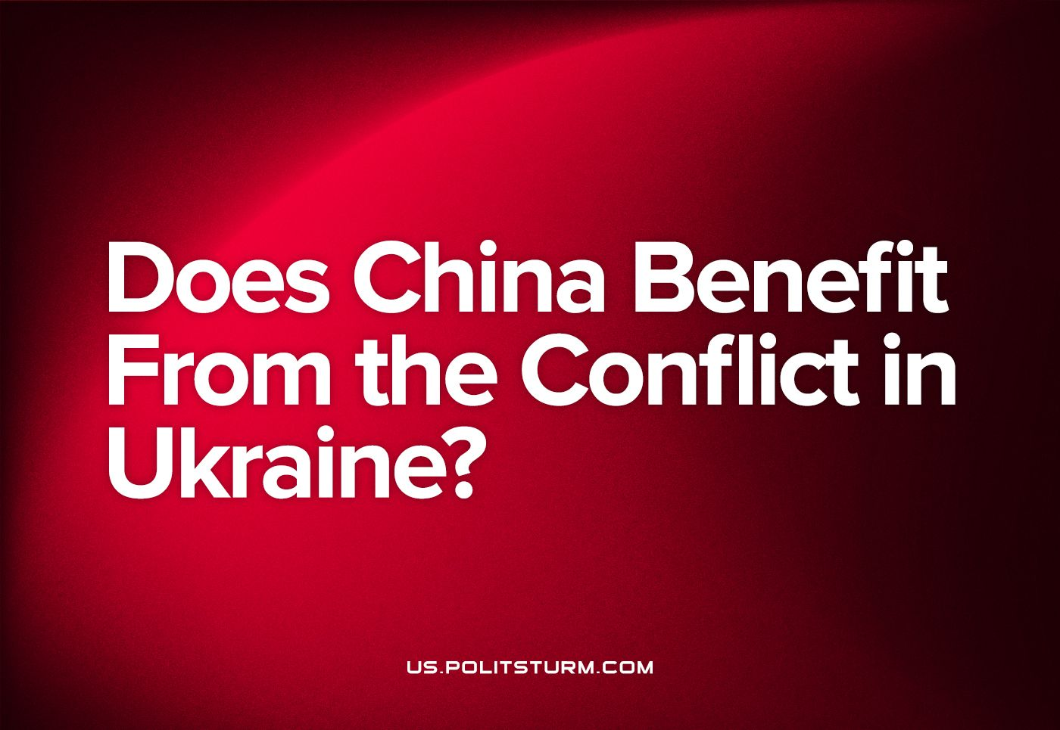

Original article
2023-10-11
9 min read

Since the beginning of the Ukrainian crisis, Russia found itself largely cut off from the markets of countries that support the Ukrainian government. The Russian Federation is forced to rely more and more on China. What are the costs of global isolation for Russia and what are the benefits for China?
This question becomes more relevant given that Russia's influence in Central Asia is now increasingly dependent on China. This became more obvious at the China-Central Asia Summit. The fact that Russian foreign policy falls into dependence on China along with the Russian economy was also shown in the meeting between Vladimir Putin and President of the People's Republic of China Xi Jinping.

I. China buys cheap goods in Russia
China buys Russian crude oil 16-17% cheaper than in other countries. China uses cheap Russian oil to strengthen its negotiating position in the market. For example, a discount on Russian oil allows the Chinese to bring down oil prices in the Persian Gulf. In addition, China is actively trading in Russian oil.
“In 2022, Chinese companies not only increased the export of Russian oil, but also actively traded it, mixing it into other brands. China's oil storage facilities are filled to the brim with cheap supplies from Russia in order to make good money when prices go up again” says the head of the China Economics and Politics Sector of the Center for Asia-Pacific Studies of the Institute of World Economy and International Relations of the Russian Academy of Sciences.
In addition to oil, Russia has increased gas supplies to China. In 2022, Gazprom's supplies via the Power of Siberia pipeline increased by 1.5 times. The export of liquefied gas from Russia to China increased by 43.9%.
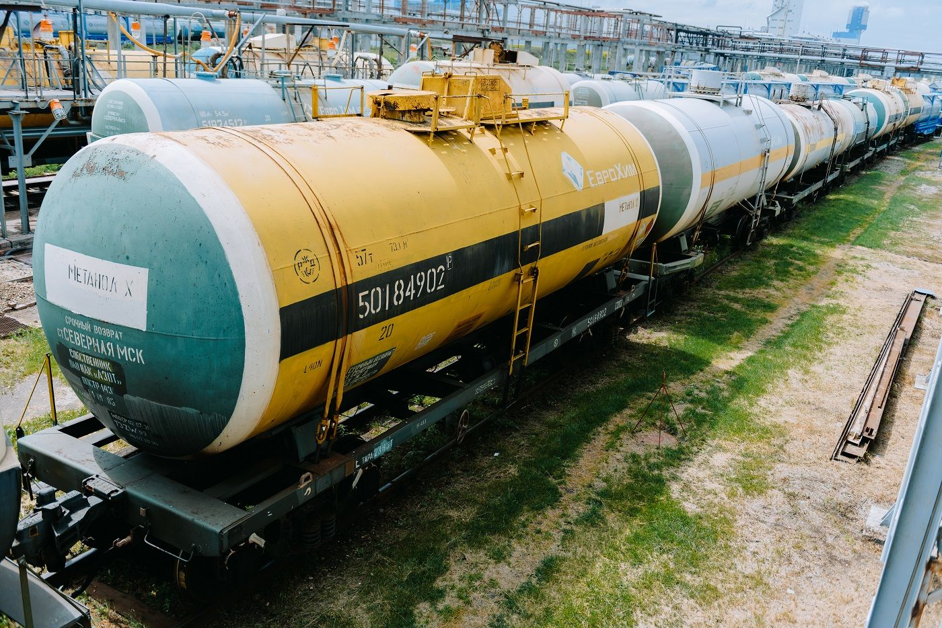
Also, gas and oil are used as raw materials for plastic and other commodities produced by the chemical industry. Russia cannot sell such products due to the closure of European markets and the fall in domestic consumption. Because of this it is necessary for the Russian capitalists to give big discounts in order to sell the goods at least to China. This already accounts for almost 40% of Russian methanol exports, which have to be sold for next to nothing:
“Now companies are trying to sell the maximum volumes to China, even at the minimum price, in order to prevent a complete shutdown of production, as storage capacity is limited, and restarting production is a costly undertaking.” - the sources of "Kommersant” claim.
Russia also supplies steel to China at the price it costs for Russia to produce it. China produces more steel than it consumes, so Chinese traders simply resell Russian steel all over the world, including Western countries.
Other Russian goods have also significantly lost market opportunities. China can also buy them at a significant discount. If these goods are not needed in the Chinese economy, they can be resold. With Russian goods no longer being shipped to foreign markets and global production declining, it is even more profitable.
II. China sells its goods to Russia at a high price
The most noticeable shift in the Russian market has occurred among cars. Of the 14 remaining passenger car brands, 11 are Chinese. Also, European cars are actively imported through China under a “parallel imports” scheme.
And this is despite the fact that the Chinese automobile business is in no hurry to capture the Russian car market, but is already trying to get as much money from it as possible. The price of some Chinese cars in Russia is three times higher than those of the same model sold in China.
In addition, due to the ongoing work stoppage, some of the Russian car factories survive only by re-assembling Chinese cars that were dismantled during transportation — the body, engine, suspension and wheels are removed from finished cars and after being delivered from China to Russia, they are screwed back in.
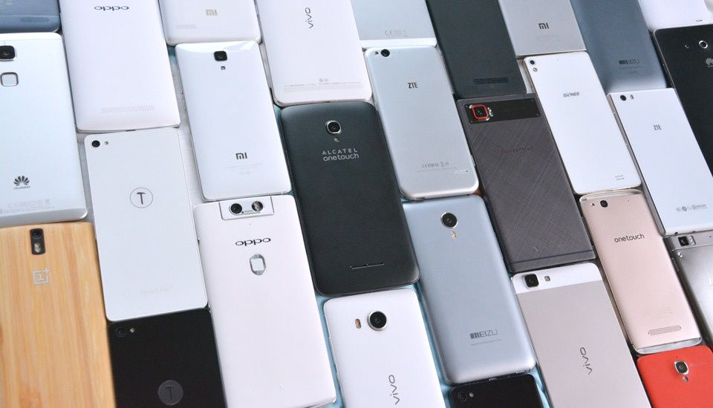
Also, Chinese manufacturers have occupied the Russian market of electronics, household and special equipment.
a) In 2022, Chinese Xiaomi phones have risen from second to the first place in sales charts. Chinese Realme phones moved from fourth to second position, increasing its share by almost 2.5 times. In fifth place, for the first time, was the Chinese brand Tecno. The share of Chinese phones in the Russian market in general has grown from 50% to 75%, while Chinese laptops have captured 40-45% of the Russian market.
b) The Chinese TV manufacturer Haier has increased its share by more than 1.5 times and strengthened its position in the top five TV sellers. Also, Haier products became the best-selling washing machines and refrigerators.
c) The share of Chinese construction equipment increased to 70% in 2022 compared to 40% in 2021. In 2022, Russia especially noticeably increased its purchases from China of the following goods:
— Trucks by 3.5 times;
— New rubber tires and tires by 2.1 times;
— Excavators and loaders by 2 times;
— Pumps and compressors, including turbochargers required for automotive engines by 19%;
— Faucets, valves and gates by 19%.
Much of this trade is made in Chinese Yuan. The share of CNY in Russia's trade has grown from 0.5% to 16% in two years.
III. What are the benefits for China?
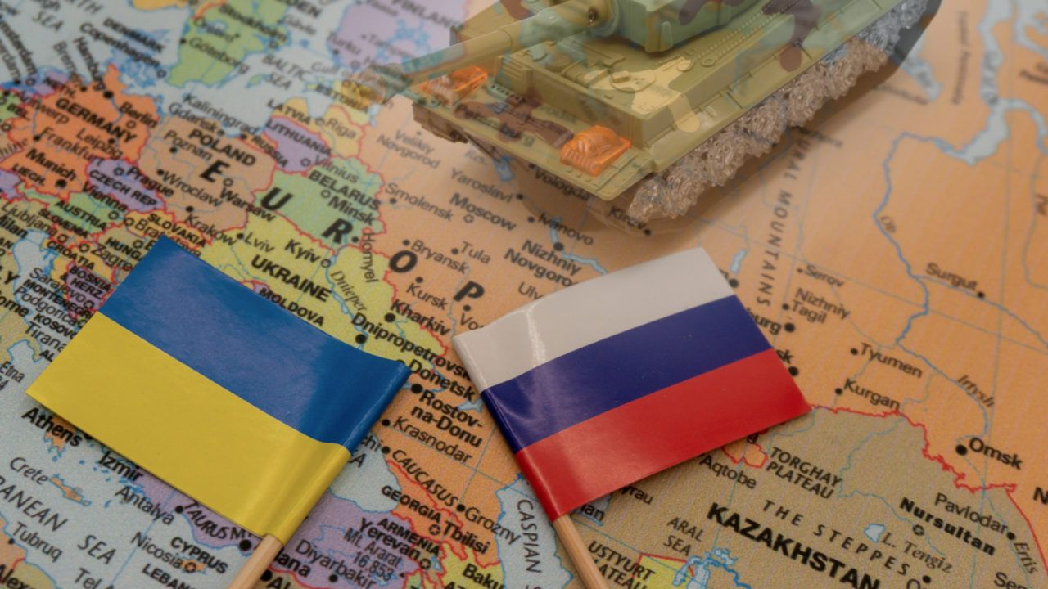
Economic benefits are largely turned into political ones. China received cheap raw materials and profitable markets, while countries unfriendly to China lost them. Thus, the economic potential of the PRC has grown comparatively over the NATO bloc in the upcoming military confrontation.
Marxist-Leninist theory indicates that military conflicts like the Ukrainian crisis temporarily resolve the accumulating contradictions of capitalist society, such as the crisis of overproduction. China is lucky that at the moment the contradictions are being resolved not next to China in the Taiwan Strait but at the expense of an increasingly lagging behind Russia.
Also, now the PRC military has the opportunity to observe the confrontation between Western weapons and Russian ones, and the technologies of the latter are very similar to Chinese. Russia, mainly thanks to large Chinese military orders, retained its military industry in the 90s and 2000s. Throughout the 1990s and early 2000s. China's share averaged 40-45% of Russian arms deliveries abroad, and in some years, for example, in 2000, this figure reached 60%. Russia has also paid for the PRC's loans and imports with the transfer of military technology.
Among other things, if Russia emerges victorious in the ongoing hostilities in Ukraine, China will expand its ability to dictate to Ukraine the conditions for participation in the One Belt, One Road project. The main advantage of the trade route, which could advance through the territory of Ukraine, is that in this case fewer borders are to be crossed compared to the route in Central Asia. At the same time, the port-city of Odessa is of great importance, since the land and sea routes of the Belt and Road project meet here.

Sources:
RBC — Western experts assessed the dependence of the Russian economy on China — from November 15, 2022
FBA "Economika Segodnya" — Nothing personal, just business: China in 2023 will increase the import of Russian oil — from February 12, 2023
RBC — Russia came out on top in gas supplies to China — March 20, 2023
Kommersant — Methanol stuck in Russia — from September 26, 2022
Kommersant — Methanol embarked on a new path — from March 31, 2023
Kommersant — Loss of European Values — from April 25, 2023
Politsturm —The collapse of the Russian car industry — from April 24, 2023
Carnegie endowment for international peace — Watch and learn. What China Wants from Russia — from March 21, 2023
TASS — Household appliances and electronics from China were the leaders in sales in Russia in 2022 — from January 13, 2023
RBC — Which goods from China Russia began to buy more in 2022 — from November 22, 2022
Kommersant — Steel does not bend under sanctions — from January 31, 2023
Kommersant — Steel does not boil, does not melt and does not pour — from September 12, 2022
Commission.europa.eu — EU sanctions against Russia due to the invasion of Ukraine — from May 20, 2023
Kommersant — Not all of Asia is happy with Russian coal — from September 5, 2022
Forbes.ru — How South Korea is seeking a balance between China, Russia and the United States — from May 5, 2023
RBC — Russia's trade with China ahead of schedule set a new annual record — from November 7, 2022
Politsturm — Why do Russian capitalists need Ukraine? — from December 19, 2022
Bloomberg — The US Hasn't Noticed That China-Made Cars Are Taking Over the World — from January 26, 2023
Carnegie endowment for international peace — Armed friendship: how Russia and China trade arms — from November 2, 2017

Original article

