Disney Employee Food Pantry Struggles With Rising Costs
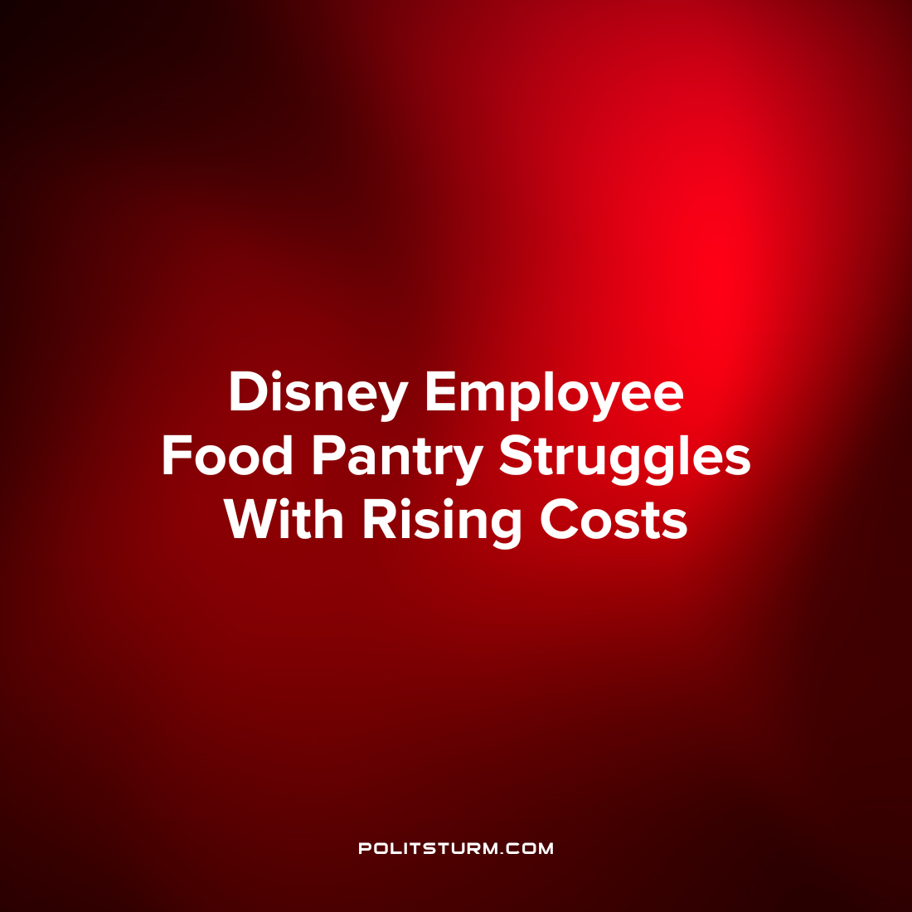

Original article
2022-08-12
1 min read

As inflation continues to increase food prices across the nation, food banks are tightening their budget in the face of rising costs. This is the case with the Cast Member Pantry, a food bank established for the benefit of Disney employees “who are experiencing financial hardship” and was established in the face of massive employee furloughs in 2020.
The organization delivers groceries to employees in need and each grocery delivery consists of $50 worth of food donations. Each delivery consists of breakfast foods, snacks and non-perishable dry food items which can be delivered on a monthly basis.
Up until the current time, the pantry has been able to provide food to all employees in need, however, rising food prices and falling donations could change this. In fact, food prices increased 13.1% over the last 12 months which is the largest increase in food prices since 1979.
Under the capitalist economic system the most vulnerable wage workers receive a wage that is barely above subsistence level. Disney wages are insufficient to provide the workers with an income to cover all necessary expenses and therefore workers must rely on public charity to survive. Disney, by contrast, saw its revenues increase 26% in the third quarter of 2022 and CEO Bob Chapek remarked that Disney had “an excellent quarter”. While the capitalists reap profits from their private ownership over the means of production, it is the workers who suffer and are relying on charity to survive despite their hard work.

Source: 1 2 3

Original article

