Disney Announces 28,000 Employee Layoffs
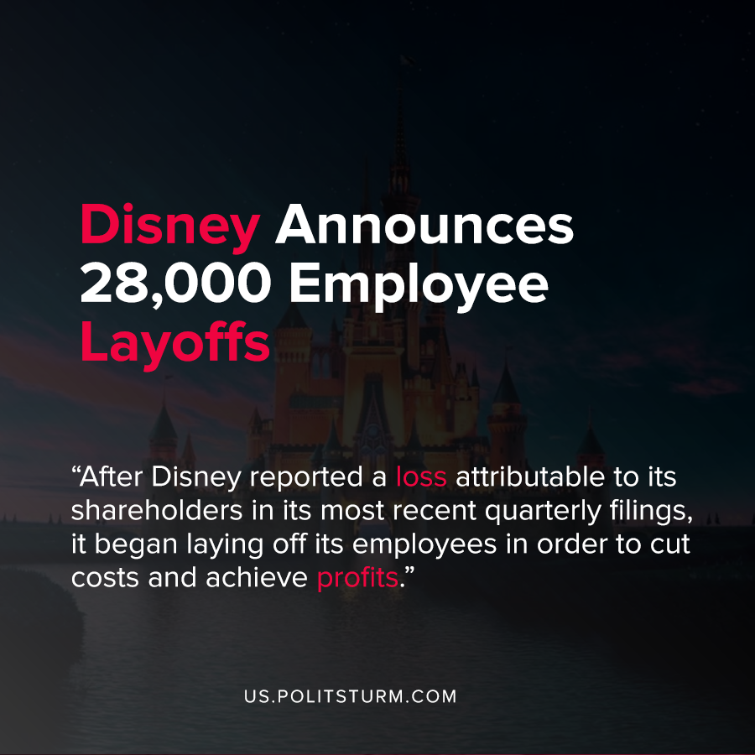

Original article
2020-09-30
1 min read

Disney Parks, Experiences, and Products Chairman Josh D’Amaro announced that the company will be laying off 28,000 U.S. employees. In the rationale for the move, the company stated that COVID-19 had a prolonged impact on their business and California was unwilling “to lift restrictions that would allow Disneyland to reopen”.
D’Amaro stated that the layoffs were necessary and that Disney would “emerge a more effective and efficient operation when we return to normal”.
After Disney reported a loss attributable to its shareholders in its most recent quarterly filings, it began laying off its employees in order to cut costs and achieve profits.
Under the capitalist economic system, profit is the motivating factor as the entire economy is predicated upon the extraction of profit to the owners of the means of production. During economic crises, workers lose their jobs as effective demand plummets and unemployment soars.
The layoffs demonstrate that corporate executives will lay off thousands of workers in order to obtain profits for the shareholders. It also demonstrates through the attempt to shift blame onto California legislators they place profit above public health and safety during a pandemic. As long as the capitalist economic system exists and the means of production are privately owned, workers will suffer from its negative consequences such as exploitation and unemployment.
Source: 1 , 2

Original article

