Dimitrov on the Characteristics of Fascism
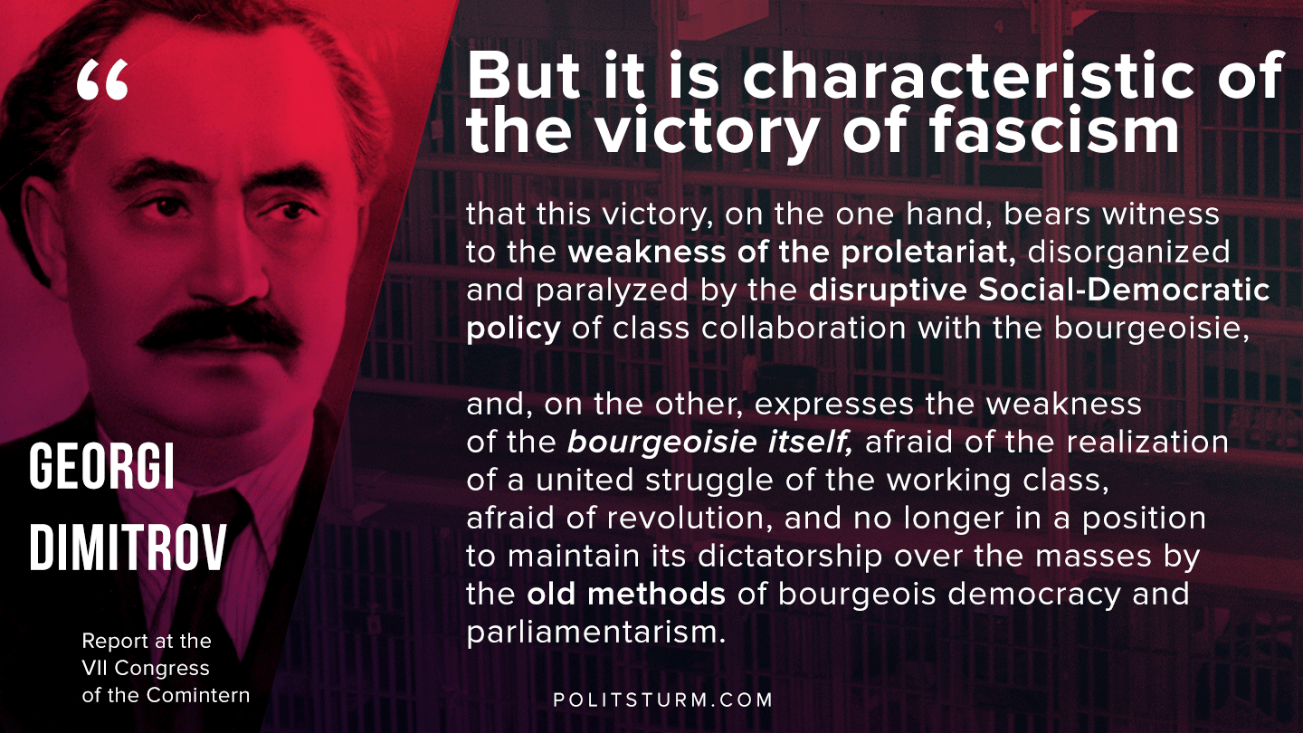

Original article
2020-06-13
1 min read

But it is characteristic of the victory of fascism that this victory, on the one hand, bears witness to the weakness of the proletariat, disorganized and paralyzed by the disruptive Social-Democratic policy of class collaboration with the bourgeoisie, and, on the other, expresses the weakness of the bourgeoisie itself, afraid of a united struggle of the working class, afraid of revolution, and no longer in a position to maintain its dictatorship over the masses by old methods of bourgeois democracy and parliamentarism.

Georgi Dimitrov
Report at the VII Congress of the Comintern

Original article

