Depleted Uranium Ammunition Sent by Britain to Ukraine
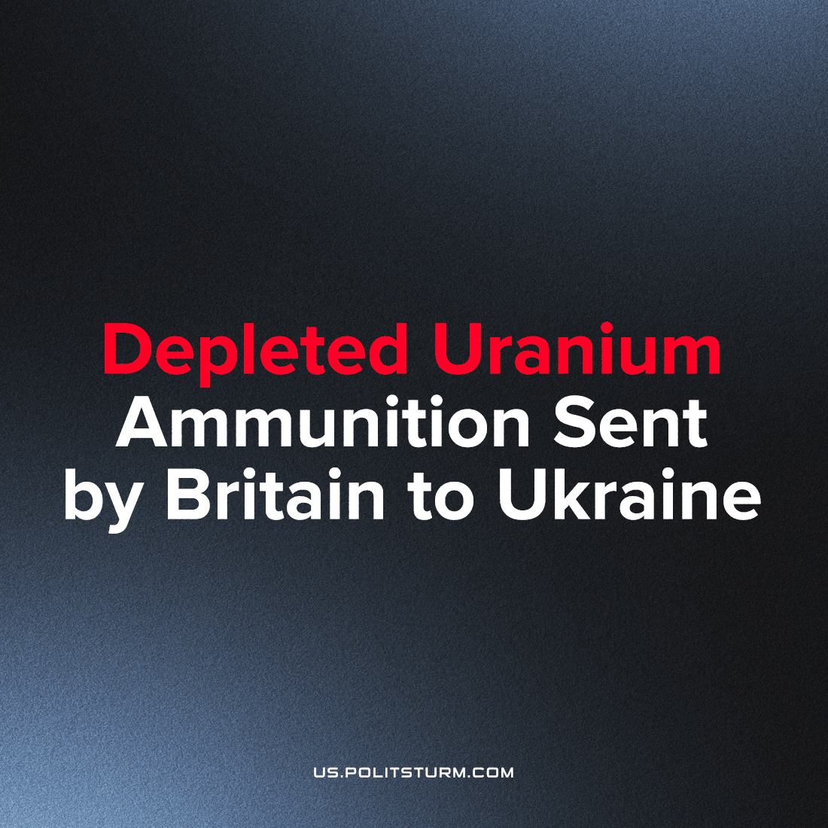

Original article
2023-03-22
4 min read

The UK has confirmed that along with the Challenger 2 tanks it is sending to Ukraine, it is also sending depleted uranium rounds. These munitions were created in the 1970s by the US in order to counter the newest generation of Soviet tanks. Depleted uranium is a by-product of Uranium enrichment and an extremely dense material and therefore very effective at penetrating armoured targets. However, it is also poisonous and radioactive, leaving behind environmental damage and a wake of civilian deaths and misery for decades in areas unfortunate enough to experience its usage.
Its first major usage in combat was in the Gulf War by coalition troops, and it was used again during the 2003 invasion of Iraq. Immediately thereafter, Iraq saw a significant growth of horrific birth defects, miscarriages, infant mortality, cancer rates and other illnesses caused by the usage of these weapons (in addition to the hundreds of thousands of civilians killed directly by US-UK forces) in those areas where numerous shells were fired in major battles.
According to a 2010 study, the Iraqi city of Fallujah (which saw heavy fighting) suffered 38 times increased rates of leukaemia and 10 times increase of breast cancer, lymphoma, and brain tumours compared to before the war. For comparison, the survivors of the atomic bombing of Hiroshima suffered a 17 fold increase in leukaemia. A 2016 study of children's birth defects in the city of Nasiriyah listed anencephaly, lower limb anomalies, hydrocephalus, spina bifida, and multiple other serious anomalies which are fatal or permanently disabling.
While the US denies any effects on the people of Iraq and Kuwait from the 2,000 tonnes of uranium waste left over from nearly 1 million 30mm rounds used in the Gulf War, even American soldiers who faced friendly fire with these weapons or otherwise spent time in proximity to where they were used have suffered similar adverse effects from the comparatively short time that they were exposed to them. But it is the people of those nations who live on the battlegrounds of imperialism who live with constant and growing consequences - now Ukraine will join them.
Error loading image
Error loading image
Depleted uranium weapons were also used against Serbia as part of NATOs aggressive bombing campaign. In addition to killing thousands of civilians directly by deliberately targeting civilian infrastructure and institutions, depleted uranium bombs have left a similar legacy of cancer and misery in Serbia in the decades since, poisoning the rivers and toxifying the groundwater. According to the former director of the Institute for Oncology and Radiology of Serbia and current Health minister, Danica Grujičić, “Serbia is [in 2021] now first place in Europe in mortality from cancer” – higher than areas affected by the Chernobyl disaster for comparison.
The Soviet Union had a large stock of depleted uranium as well as the capability to produce and use depleted uranium ammunition, however it never did. Modern Russia, however, does use these munitions. In response to these new British armaments in Ukraine, Putin has said that Russia will be “forced to react”. It is unclear whether Russia is already using depleted uranium ammunition in Ukraine, or if this means they also will do now but it is clear that these new weapons will cause even more misery and death for decades for those unfortunate enough to live in areas where they are used by either side.
Capitalist states act in the interest of the monopoly-capitalist class, who direct them to capture and exploit ever yet more land, resources, labour, and markets. Politicians, corporate board members and lobbyists intermingle and swap roles, filling their pockets with donation funds and gifts in exchange for billions in profits for the monopolies in government contracts, grants, and subsidies. Apathetic towards the ordinary worker they send to die, capitalists and their representatives simply pursue growing profits. The British capitalist politicians shed crocodile tears for the plight of the Ukrainian people, but they are fully aware they will be poisoning Ukrainian people in this war profiteering 'for democracy'. Such criminals and liars that have gleefully inflicted and benefitted from this anguish before, they have no qualms repeating a profitable decades-old business model.
The British workers’ movement is responding to the crisis of capitalist imperialism spontaneously in its advance, however they are unserved by a genuinely communist party that can consciously guide the labour movement in accordance with their objective interests as revealed by Marxist-Leninist theory. It is only by independently realising their interest as a class, and struggling for it, can war be meaningfully opposed. If this were the case, the British dock and rail workers might refuse to transport these toxic weapons in solidarity with their brother and sister workers on the receiving end (as their industrial brothers did in Greece and Italy). And ultimately, the workers can and should fully realise their interest as a class by the establishment of socialism which is the only end to the inhuman wars of imperialism.

Greek Rail Workers led by the Communist Party of Greece (KKE) Refuse to Transport NATO Weapons.
Sources: 1, 2, 3, 4, 5, 6

Original article

