Denmark’s “Red” Coalition Wins in Snap Election
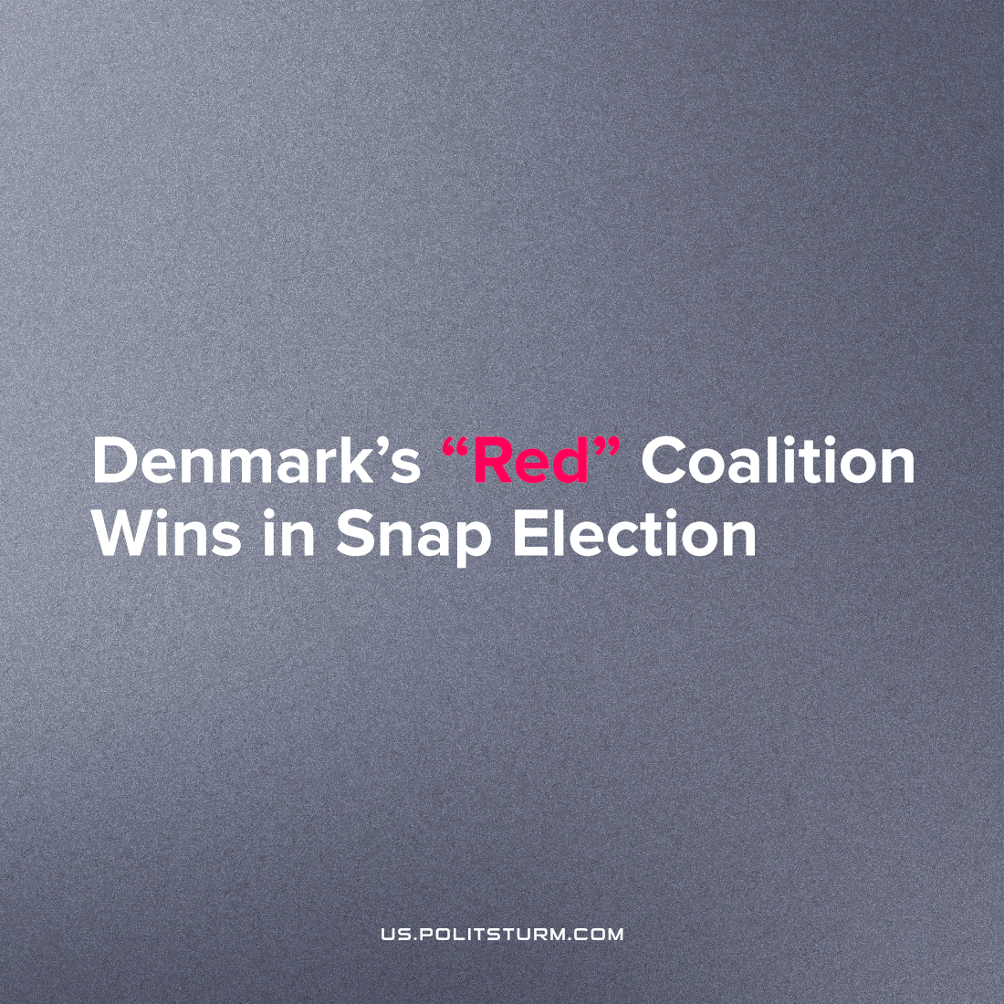

Original article
2022-11-26
2 min read

As a result of early parliamentary elections in Denmark, the “red” coalition of the Social Democratic Party, the Socialist People’s Party, the Radical Left, the Single List, the Green Party, and the Alternative Party, have won. Social Democratic Party leader Mette Frederiksen will remain as prime minister, a post she has held since 2019.
Out of 179 seats in parliament, the “left” bloc won 90, while the right and centre coalitions won 73 and 16 seats, respectively.
Even though Danish politicians and voters call the Frederiksen party “red”, the prime minister has long ceased to defend the interests of the working class even in words. Instead of class struggle, Frederiksen and her associates promote a “broad front” policy. It is important to mention that after the announcement of the election results, the leader of the Social Democrats assured: “We are the party for the whole of Denmark, for small villages and big cities. Today we are the only nationwide party.”
With these statements, Frederiksen exposes the political opportunism of her party in particular and of social democracy in general. Obviously, one party cannot represent the whole country’s interests while different classes remain with conflicting interests. With honeyed words about “popular unity”, the social democrats of Denmark and other countries convince the working class to unite with their exploiters and work together for a better ‘national’ future. In this way, the newly re-elected so-called ‘Left’ coalition installed a xenophobic, harshly anti-immigrant policy.
The proletariat cannot unite with the bourgeois class because their class interests are completely opposed to the interests of the ruling owners. Only through the class struggle, the working class can truly defend its interests and provide itself with a decent life.
Let’s remember that the reason Denmark is holding early parliamentary elections was the scandal surrounding the mass killing of minks. After scientists found a new strain of coronavirus in a mink, the Danish Prime Minister ordered the elimination of all minks in the country, which led to the killing of 17 million animals. The capitalist leaders of this red coalition only follow the mad path laid out by the markets.
Sources: 1, 2, 3, 4

Original article

