Childlessness Tax, Housing Crisis, Education Collapse: Is State Demographic Policy Failing in Russia?
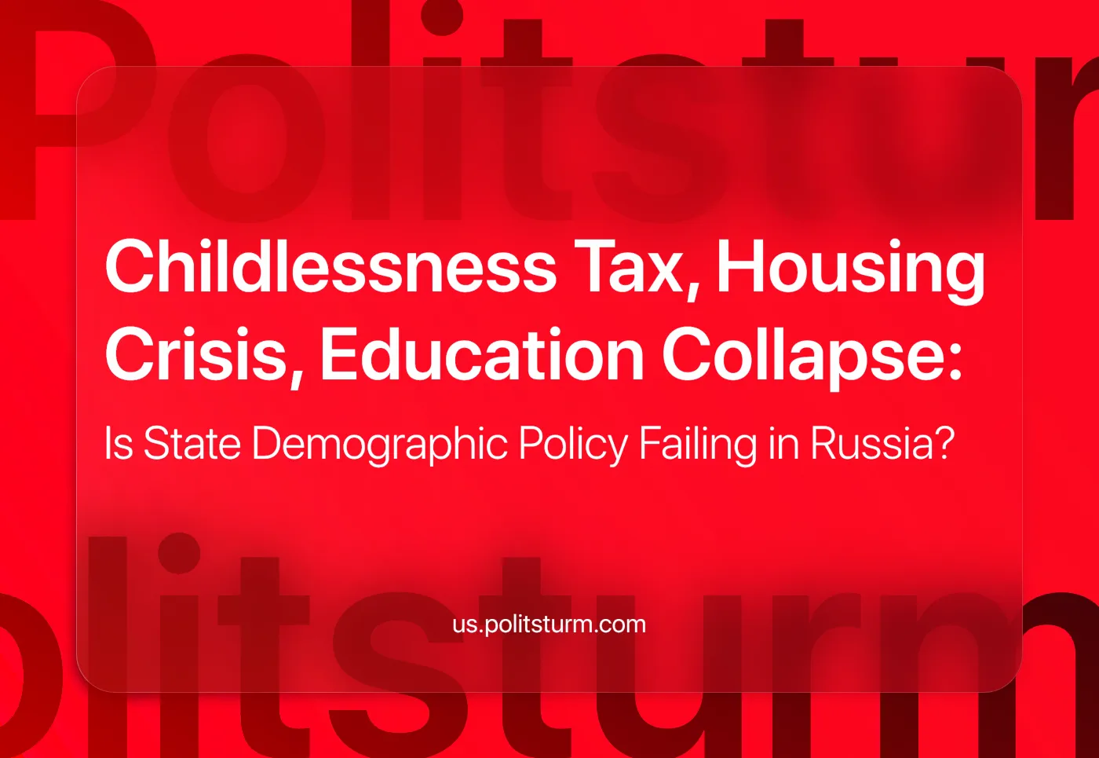

Original article
2025-01-04
19 min read

Russian society is facing a number of contemporary challenges that affect every ordinary citizen in one way or another. Every year, more and more original "solutions" to these problems emerge from the mouths of officials and are broadcast on television screens. However, a superficial examination of the matter reveals that it is impossible to eradicate these pressing problems. Let us try to understand why.

I. The Birth Rate Issue
The most acute problem of the Russian state is the decline of the population. The solution requires a special strategy. According to Rosstat (the governmental statistics agency in Russia), more than 300,000 people died in the first half of this year [17]. The timeline of actions aimed at implementing the Family and Demographic Policy is extended until 2036. The main direction chosen is the creation of a single standard, which will determine the social well-being of the family, health, family values, and management methods [1].
Instead of making concrete proposals to overcome the crisis, some deputies are busy promoting themselves. For the sake of hype, political scores, and career advancement, populist ideas such as banning the promotion of childfree propaganda, discussing a tax on childlessness, and discrediting women's rights are emerging.
The initiators of the law banning the "childfree" movement were Vyacheslav Volodin, speaker of the State Duma, and Valentina Matvienko, speaker of the Federation Council. Violators face fines of up to 5 million rubles ($48,580) [7].
At the same time, the Russian State Social University (RSSU) developed the parameters of a childlessness tax for men and women. The first vice-rector of the university, Yomart Aliyev, suggested increasing property tax, inheritance tax, and income tax as part of this initiative. That would mean that individuals without children should contribute more to society’s welfare. A similar measure in the USSR is cited as an example.
According to Gayane Shtoyan, lawyer and advisor in the family law and estate planning practice of BGP Litigation: "The law was discriminatory based on gender. Women were taxed only if they were in a registered marriage and had no children, while men were taxed regardless of their marital status." [8].
Alexander Iltyakov, Deputy for Civil Society Development, equalized discrimination against both sexes. In an interview with KP-radio, the "servant of the people" accused women who terminate pregnancies of playing God on earth, imparting religion and sin into state affairs.
The military conflict in the west of the country is also blamed on the “weaker” sex. Those who discourage childbirth should be punished by law. In short, "pray to God and be happy while the womb is working, give birth, woman" [12].
Yury Obolonsky, Executive Director of the National Committee of Parents and Advisor to the President of the Association of Honorary Doctors of Russia believes that it is necessary to use artificial intelligence for social protection. He argues that AI is essential for ensuring a "fair and efficient" distribution of aid, compensating for potential biases or inconsistencies in human decision-making [12]. However, as discussed in our previous article on AI, we consider such statements overly simplistic and impractical, as the problems with modern social production lie in our social relations, and therefore cannot be addressed by AI alone. He believes that this is the only way to ensure an equal distribution of aid.
A popular topic is the legal ban on abortion. The Russian Orthodox Church advocates the complete abolition of the procedure in private clinics. The state urges that a woman be persuaded to give birth [1]. Doctors who support this position and help women continue pregnancies can receive a "Bethlehem certificate". The incentive should be a sum of money equal to the cost of an abortion.
Boris Lordkipanidze, obstetrician-gynecologist, reproductologist, and doctor of medical sciences, spoke from the opposite point of view. He believes that the abortion issue is populist and does not represent a real way out of the demographic hole.
"We need to influence through the mind", says Irina Smolyarchuk, director of the Anti-Crisis Psychological Center and a psychoanalyst. She believes that the low birth rate is not the result of economic contradictions in society. She blames the prosperity (or lack thereof) of the country, where people prioritize chasing success and career over starting a family. However, this view overlooks the economic challenges that often accompany career-focused lifestyles, such as financial insecurity and work-life balance issues, which are key factors in the decision not to have children.
The problem of Russia's extinction has been thoroughly taken up from all sides, but each of the "saviors" steals the show. In such conditions, there can be no unity of opinion and no common effective policy. Obviously, politicians know that no one will implement their useless ideas, so they compete with each other in absurdity.
Russia is experiencing a deep crisis of the market system, incapable of providing citizens with the conditions for reproduction. This isn't the fault of anyone's management, but a consequence of the very nature of capitalism, where human life and welfare are secondary to profit.
The constant decline in the population's real income, and the decline in health and education, which we will mention later, force families to refuse to have children. At the same time, political leaders do not hesitate to use the demographic crisis to divert attention from real problems in order to increase their popularity.

II. The Healthcare Issue
It is difficult to think about children when you are not sure you can receive medical care. Six months ago, Altai hospital workers recorded a video message to the president. They complained about low salaries. In June, deputies proposed to increase the size of payments to ambulance paramedics to 30 thousand rubles ($290), and doctors — up to 50 thousand ($485). They promised to introduce additional payments of 15 thousand rubles to drivers, as well as to include part-time workers and managers among the recipients of additional payments [3]. According to official data, the salaries of medical workers do not reach the national average of 70-80 thousand rubles ($680-$777) [21].
Shortly before that, the Ministry of Labor of the Russian Federation announced that in 2025 they will start testing a new system of remuneration for medical workers. Three regions will be chosen for the pilot project, but it is not specified yet [2]. It is likely that one of them will be the Altai region because Vladimir Putin signed a decree on the introduction of the system in April this year, following the appeals from medical personnel in this area.
According to the Ministry of Health of Bashkortostan, a federal subject of Russia, the situation is much better. The ministry reported a 25% increase in salaries for emergency medical workers. They receive incentive payments for the efficiency of their work. Drivers also received financial support in the amount of 12 thousand roubles from the budget. Earlier, the region's paramedics had repeatedly appealed to the President of Russia for lack of social benefits [4].
However, workers should not rely on the mercy of the head of state. They will not change the laws of the economy. Small wage increases are mercilessly devoured by inflation. The population has already felt it in the form of new price tags in the shops. Comparing the income of average citizens to the profits of the wealthiest strata of society further highlights economic disparity [22].
Unscheduled inspections of hospitals where abortions are performed have been added to the list of healthcare problems. The initiative came from the State Duma deputy Tatyana Butskaya, who believes that the existing moratorium on inspections should be lifted. Thus, medical organizations will observe the "week of silence", i.e. the mandatory period that a woman has to wait before receiving an abortion and rectify the lack of psychologists on staff. Their task is to counsel pregnant women, discourage abortion and “save children's lives” [10].
Some regions have gone further in implementing the new abortion policy. In Tatarstan and the Khanty-Mansi Autonomous Okrug (regions), doctors politely ask women not to have an abortion. In others, they give women a gift for refusing an abortion, such as baby blankets/bodysuits and greeting cards at their first consultations.
The Federation Council, the upper house of Russia's Federal Assembly, went even further, proposing to show films about the dangers of abortion. The Sakhalin Health Ministry was forced to clarify its position after a video about abortion, which graphically depicted the procedure itself in order to intimidate schoolchildren. The Ministry disassociated itself from the content. The video’s content raised concerns, and the ministry had to explain that it was not involved in its production or distribution.
Healthcare has become a commodity to be bought and sold. It has become a part of the market economy, where the goal is profit, not the well-being of the people. The undervaluation of medical workers' labor, reflected in low public clinic salaries, drives them to appeal directly to the president. Local salary increases fail to yield significant improvements because the real purchasing power decreases due to inflation and rising prices, which reveals the economic oppression of workers in this sector.
Not only in Russia but even in the seemingly developed USA, people are suffering from worsening conditions. American doctors are sounding the alarm. They complain about the same problems as their Russian colleagues. This reminds us once again that we must not confuse cause and effect. The fault lies not with any authority or individual, but with the economic system itself. As long as capitalism maintains its world domination, healthcare in any country will deteriorate and decline. Only the commercial sector will develop [23].

III. The Education Issue
The current State's care for adults and children is obviously expressed in the impoverishment of the educational sphere. It would be a mistake to blame women for not wanting to bring children into the world that schools cannot open up, show, and explain. The teachers themselves, even if they wanted to, would not be able to do this, working from morning to night for a salary slightly higher than that of a janitor.
Teachers are ageing and leaving schools, and not enough young people are entering the profession to fill the growing shortage. Worse, the qualifications of the new replacements are suffering. With low salaries, the workload is growing: teachers are forced to work 1.5 times, or even more, beyond their usual workload. This points to inadequate funding, huge overwork of Russian teachers, and inevitable negative consequences for the quality of education [6].
Here are the reasons that keep young specialists from working in middle and high schools: high qualification requirements, increased level of conflicts with management, parents and children themselves, bureaucracy, and the difficulty of imposing two or more classes of children on an elementary school teacher.
Teachers' salaries are so low that they look like a mockery. The average salary of a Russian teacher for 2023 is only 28 thousand rubles ($270) before taxes. In 2024, the average salary of teachers will be 30% below the national average. In some regions, it is even lower. The seemingly "high" salaries reported in official statistics are achieved at the expense of all allowances, extra payments, vacation pay, bonuses, and double shifts, of course [5].
The desire to minimize the "unnecessary" costs for the powerful group of owners led to the crisis of educational and medical institutions. Big business did not want to support the social rights and guarantees inherited from the Soviet past and use its profits for the maintenance and reproduction of the very same labour force that is the root of their wealth.
The shortage of teachers is now estimated at 550,000. All the facts presented here show that school education is in a dire state. Turning education into a service has become the first priority measure to minimize costs and develop the private education sector. Private schools get everything, while state schools get the rest. The very fact of low wages with high workload reflects the exploitation of workers in this sector, similar to everywhere else.

IV. The Housing Issue
Families who intend to have children must have a roof over their heads. This is a basic human need. The desire to have children goes unfulfilled because young families are not provided with their own housing. This puts Russians in the most cruel dependence on the employer. The high probability of losing one's job, and with it the ability to pay the rent, puts the whole family at risk of ending up on the street.
According to Deputy Prime Minister Marat Khusnullin, the Russian authorities do not intend to expand preferential mortgages for the time being. In Russia, "preferential mortgages" refer to government-subsidized housing loans with reduced interest rates, often targeted at young families, first-time buyers, or individuals in specific professions. The programs of preferential mortgage loans will work on a temporary basis until inflation is reduced [15]. However, in light of recent events, we should not expect inflation to come down.
It now takes two to three times the average salary to service a mortgage. Mortgages were already unaffordable. The increase in the key interest rate to 21% and the subsequent abolition of preferential mortgages have put them out of reach for the vast majority of citizens. Residents of the North Caucasus, for example, have the highest payments, above the average salary. This amount is somewhat lower in the other regions, where deductions average half of total income [16].
Housing has ceased to be a basic right of the worker and has become an expensive commodity. Subject to market laws, the price is determined not by the needs of workers, but by the profit requirements of the construction business, banking sector, and the state, which only protects its interests.
Ordinary people have little choice: to die in the streets, homeless but with pennies to their name, or to have a home but no money, not even for food. The fear of such a fate paralyzes protest strikes and other manifestations of workers' struggle for their economic rights.

V. Alternative And Solution
The state requires the population to procreate without providing the conditions under which a child would be a joy, not a burden. There is no reliable, affordable, quality medicine. Educational institutions are deteriorating to the point where in the near future only the children of rich parents will study. The majority of the poor are forced to feed the already bloated banks. A local official from Ekaterinburg captures this attitude with the dismissive remark, "Keep giving birth — we need welders and painters."
The state appears to be moving toward a model reminiscent of pre-revolutionary Russia. The masses of impoverished peasants and enslaved workers were forced to have children, playing roulette with fate. Without access to proper healthcare, many children died young; those who survived could only partially help their parents in old age, as their contribution was limited by their own hardships. People in that distant era had no mortgages, but they also had no access to medicine and education, no housing, and no personal freedom.
The policy of every capitalist state is an attempt to shift the responsibility for every crisis onto the shoulders of the workers. This is why populism is so often used, patriarchal-religious dogmas are perpetuated, and control over women is strengthened.
The only possible solution to this crisis is the transition to a socialist society, which will create the conditions for solving the demographic problem. The authorities like to remind us of the restrictions on abortion in the USSR, but they forget to mention the living conditions of Soviet citizens. The inhabitants of that country were familiar with the modern problems of mankind only from the cartoons of the magazine "Krokodil" (the first Soviet satirical periodical, which appeared in 1922), a fact that now seems to be a fantasy.
After gaining full power, the workers and peasants abolished private property. In doing so, they ensured a fair distribution of wealth and eliminated the division of society along material lines. A prosperous demography is only possible in an environment where the right to work, education, health care and housing is guaranteed to everyone. Fundamental changes such as free mass housing, affordable education, and medicine already provide a solid foundation for population growth.
In such a society, it is possible to build health care for the needs of ordinary people, not for the profit of entrepreneurs. The socialist state provides free and accessible health care and education for all, and the work of teachers and health care workers is respected and well paid.
The institution of primary, secondary, and higher education is removed from market control and fully funded. Having abandoned profit as an end in itself and having taken on the task of educating the young generation, the state changes the role of the teacher. From now on they are responsible for young minds, and their work is highly valued by society from the position of educating a new generation of creators.
Someone will rightly ask: "Where is the state going to get the money for these social transformations, my fellow communists? If the state goes down this road today, it will go bankrupt.” The treasury does not appear out of thin air; it is filled by the labor of the workers. The qualitative difference from the present situation is that, in the absence of private property, the results of labor are for the benefit of the workers themselves. Under those conditions, it is impossible for a bunch of parasites to enrich themselves at the expense of the workers, who have become masters of their state.
Sources:
[1] Nakanune.RU — "Strategy of Family and Demographic Policy: From Round Dances to Social Assistance" — November 19, 2024.
[2] Medical Russia — "The new system of remuneration for healthcare workers will be tested in only three regions in 2025" — November 22, 2024.
[3] Medical Russia — "Doctors and paramedics from small towns have collectively addressed the president" — November 22, 2024.
[4] Medical Russia — "The Ministry of Health of Bashkortostan reported a 25% salary increase for emergency medical workers" — November 20, 2024.
[5] Nakanune.RU — "Become a Teacher! For 28,000 rubles a Month" — November 20, 2024.
[6] Nakanune.RU — "Teachers are aging and leaving, and there is no one to replace them" — November 15, 2024.
[7] RBC — "The State Duma passed a law banning 'childfree propaganda'" — November 12, 2024.
[8] Forbes — "RGSU developed parameters for a childlessness tax" — October 5, 2024.
[9] Medical Russia — "King Herod killed infants" — February 1, 2024.
[10] Medical Russia — "In Russia, it was proposed to introduce unscheduled inspections of medical institutions where abortions are performed" — October 30, 2024.
[11] Medical Russia — "The Ministry of Health of Sakhalin stated that it has no relation to the video about abortions shown to schoolchildren" — September 29, 2024.
[12] Medical Russia — "The deputy who spoke about 'baby factories' claimed that the war is due to those who perform abortions and suggested that women who want to 'live for themselves' instead of giving birth should 'live in a coffin'" — November 19, 2024.
[13] "The Economist" — "A government official from Yekaterinburg demanded that women give birth to welders and painters" — November 19, 2024.
[14] "Moscow Komsomolets" — "Financial analyst named the real percentage of price growth for food in Russia" — November 18, 2024.
[15] "Solidarity" — "Russian authorities do not plan to expand subsidized mortgages" — November 13, 2024.
[16] "Moscow Komsomolets" — "Regions of Russia with Unmanageable Mortgage Payments Named" — November 21, 2024.
[17] Rosstat — "Natural Population Movement by Subjects of the Russian Federation for June 2024" — August 9, 2024.
[18] Politsturm — "Neural Networks: Progress or Threat?" — July 18, 2024.
[19] Politsturm — "Why Are Salaries Rising?" — October 5, 2024.
[20] Medical Russia — "Three More SMP Departments Address Putin Regarding Social Payments" — April 4, 2024.
[21] Politsturm — "Mishustin: The Average Salary in Russia is 73,000 Rubles" — April 12, 2024.
[22] Politsturm — "Income Inequality is Growing in Russia" — September 9, 2024.
[23] Politsturm — Why Do Young Americans See Medicine as a Profession, Not a Vocation? — November 29, 2024.
[24] Politsturm — "Who Has the Lowest Salaries in Russia?" — September 2, 2024.
[25] Politsturm — "The Key Rate is Planned to be Increased to 52%, but This Will Not Save Us from Inflation" — September 30, 2024.
[26] Politsturm — "Mortgage: Profit for the Rich, Bondage for the Working Class" — August 7, 2024.
[27] Politsturm — "Food Prices in Russia Have Increased by 50–100%" — November 28, 2024.
[28] Politsturm — "Entrepreneurial Income of Russians Reached a Record High Since 2014" — March 19, 2024.

Original article

