"Democratic Socialist" Elected Officials in Los Angeles Carry Out Capitalist Agenda


Original article
2023-07-18
3 min read

In 2022, the Democratic Socialists of American chapter in Los Angeles, California supported the election of Hugo Soto-Martinez to the city council seat for the city's 13th district, on a broad of progressive platform. This campaign organized around the use of the city's funds for social programs, typical of the social democratic program, as well as policies support for homeless and undocumented people.
One of these policies centered a controversial law which criminalizes those occupying public space, particularly street-vendors, exploited small-proprieters who sell commonly food and water, as well as the homeless sleeping on the street.
Soto-Martinez stated he would not permit police to enforce code 41.18 in his district, often stating his support of street-vendors as part of his campaign - propagandizing off the fact his own parents lived by street-vending. [1] Many progressives celebrated the transitory victory for street vendors, but the councilmember's promise has not turned out to be true. [2]
LA police are currently arresting street-vendors in this area by using this law, as shown in the video below. This code broadly empowers police on an outline that "sitting, sleeping, and placing personal property within 500 feet of parks and recreation centers — including schools and daycares" is banned. Last year, 853 people were arrested under this code.
Unsupported element
Now, DSA-LA's candidates Soto-Martinez and Nithya Rayman have voted to transfer $550,000 from one of the city's budgeted "food aid" funds, giving the funds to a police cadet program in North Hollywood. [3] Even DSA-LA is now working to reverse the hangover of 2020's 'Defund the Police' demands for moving city funding toward social service programs.
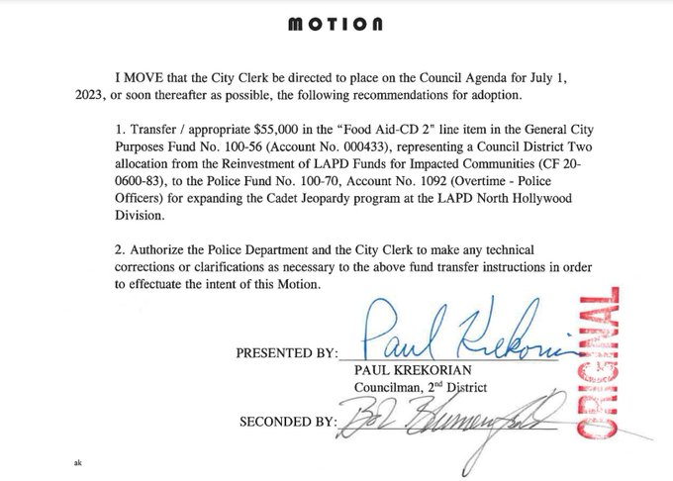
This is coming at a time when federal cuts have removed over 1 million citizens of LA from accessing national food programs. [4] When questioned about their recorded votes on the budget move, councilmember Soto-Martinez lied. He claimed he was not available for the vote, when in fact he was present in council chambers, that their votes were accidental, and yet did not invoke their ability to recast their vote in such cases.
For these officials, the highest goal is to maintain the appearance of progressive alignment, while also protecting their working relationship with the police, bourgeois politicians and capitalist exploiters. The greatest defeat for them is not the passing of reactionary laws, or their own failures to oppose them, but to be revealed in front of the public for the positions and laws they do support. This is the reason they carry out their policies under the cover of deceit - which is fundamental to the nature of social-democracy.
Soto-Martinez was caught in an earlier scandal when his campaign employee, Janet Hurtado, rigged an internal DSA election in her favor by voting at least 75 times from a single residence. [5] All this only shows that the DSA in general, and particularly the most influential elements in DSA-LA, are open tools of capitalist forces who rely on the support of upper segments of the working class most aligned with Capital's interests and ideology. As an official of a bourgeois legislative body, we can only imagine the kind of back-door negotiations Soto-Martinez had with LAPD to cause the reversal of so many of his progressive policies in their favor.
Sources: 1, 2, 3, 4, 5

Original article

