Decline Of Labor Unions in America Causes a Lack of Participation in Liberal Democracy
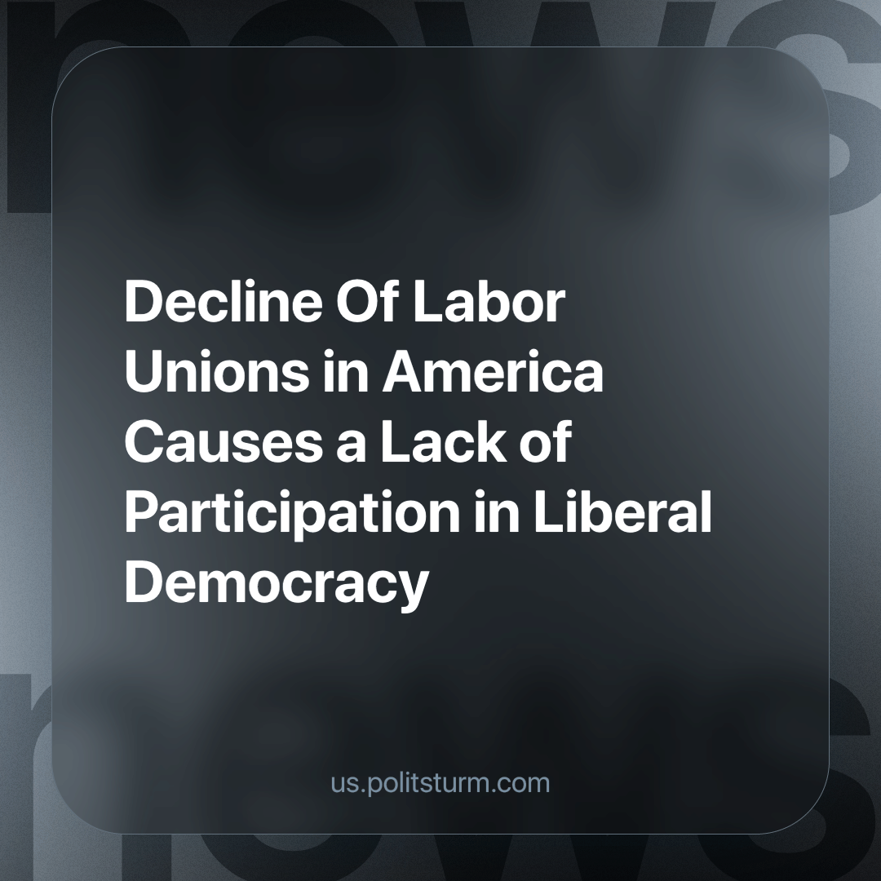

Original article
2024-03-17
2 min read

An analysis by the Economic Policy Institute (EPI) has found a profound correlation between labor unions and participation in elections. The study included 17,935 voting drop boxes during the 2022 midterm elections. The analysis factored out socioeconomic status and other interfering variables to conclude that only a 1% increase in union density was associated with a 9.8% increase in voting drop boxes per capita. Extrapolating the data further suggests a linear relationship between voting drop boxes per capita and the percentage of union density among workers. This analysis has conclusively shown that unions influence participation in liberal democracy.
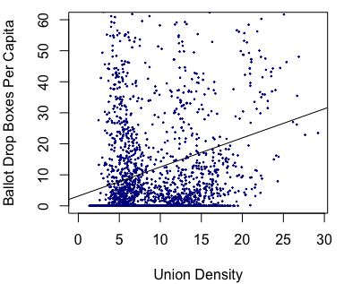
Despite the union's correlation with a strong liberal democracy, the United States Bureau of Labor Statistics has found that the share of workers in unions has declined from 11.3% to 11.2% in only a year. This has been part of a continuous trend where the labor movement in America has stagnated since the 1970s. This stagnation has contributed to the decline of wages and increasing income inequality; furthermore, the lack of unionized workplaces has increased harsh working conditions. The same labor unions have historically defended and expanded voting rights across America. The recent declines in union membership are exemplified in states like Wisconsin, where their governor, Scott Walker, banned collective bargaining rights for all public sector workers.
The continuous backslide of liberal democracy leads us to the question: why are unions also declining, although they correlate with a "strong" liberal democracy? Liberal US politicians continuously wax lyrical about "saving American democracy" – so why don’t they advocate for trade union membership and an expansion of trade union rights? The reason why union membership is on the decline is due to capitalists forcing workers to abandon unions as a tool to better their livelihoods and lack of class consciousness. The capitalists use threats, violence, and propaganda to stop these unions from growing and expanding. These capitalists want to maximize their profits and to do so, they must keep wages that eat into their profits low. For this, they must keep the workers out of the unions in order to reduce their ability to collectively bargain for higher wages as much as possible, no matter the unintended consequences.
So far, in the United States, the capitalists have been winning since the 1970s. Forcing the number of workers in the unions to lower steadily year after year. Therefore, it is in the interests of the workers to join unions and turn the tide against these capitalists, who struggle to even maintain their system of liberal democracy. Preventing this realization is the propaganda from capitalists, who have made it so workers struggle to see the reality of capitalism and their social position within it. The unconscious worker, deluded by propaganda may instead advocate for the capitalists by contributing to the attack on unions by the capitalists by argumentation with his fellow co-workers or even by informing the capitalists of their attempts to organise hoping for a raise. It is the communist’s task to make sure this propaganda does not seep into the minds of the workers, causing class collaboration with the exploitative capitalists, instead revealing the true nature of the capitalist system and the position of the workers as a class within it.
Source:
1

Original article

