Debts: How to Free Americans From the Debt Problem?
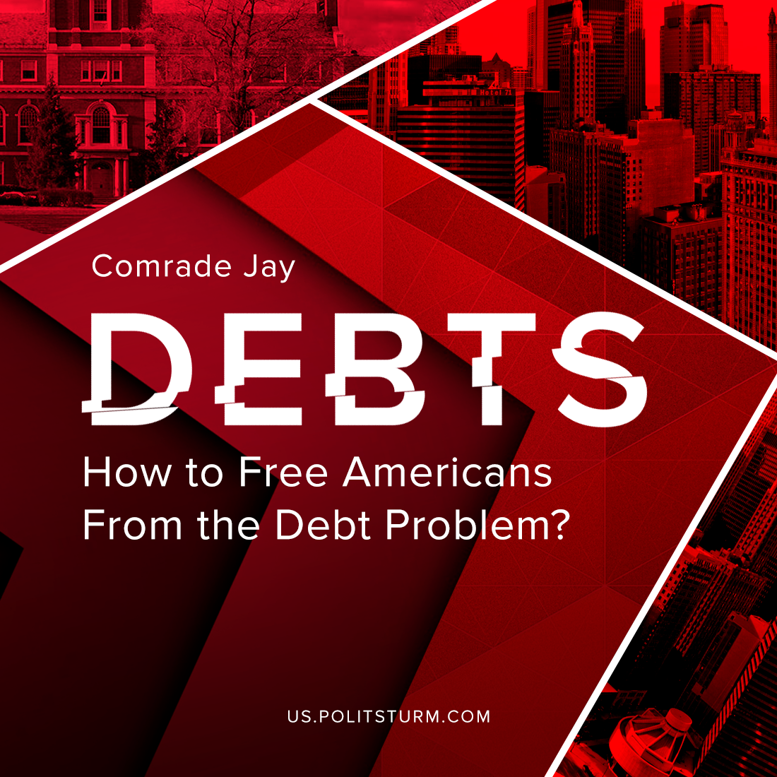

Original article
2021-09-02
6 min read

According to the New York Federal Reserve, American consumer debt reached a total of $14.56 trillion dollars after the fourth quarter of 2020. Personal debt in the United States continues to grow in four key sectors: housing, which includes mortgage and rental debt; auto loans; credit cards; and most pernicious, student loans. The average student loan debt in the United States now figures to be above $39000.¹
U.S. household debt comprises 78.16% of its national gross domestic product. The average American holds over $90,000 worth of personal debt.² A debt that millions struggle to just service, much less overcome.
Due to the suppression of wages and the rising costs of basic needs such as food, housing, medical care, etc., millions within the American proletariat continue to incur loads of debt in a desperate attempt to meet those basic needs.
For the finance capitalist lenders, however, the debts of others are an investment tool predicated upon the risk of the speculation that the debtors will continue to work, collect wages, and then pour a large percentage of those wages into the maw of a loan system which will never be satisfied. In other words, the debts of the proletariat represent a present and future source of income for the opportunistic and predatory finance capitalists.
While the capitalist class, most notably within the American finance industry, live in material comfort and security provided by the upward redistribution and extraction of wealth from the working class, those who struggle to survive under the crushing burden of debt and lack, suffer in material, mental, physical, and emotional ways.
These consequences of indebtedness include home foreclosures, evictions, repossessions, stress, anxiety, fear, panic, and depression.³ It goes without saying that these consequences have a direct negative effect on social and domestic relationships. The consequences of debt, therefore, have a deleterious effect upon the social conditions in U.S. such as crime, substance and domestic abuse, suicide and despair.
In the capitalist system those who buy debt as an investment assume a risk that is based on nothing else than speculation and the hope that the system will remain stabilized and that the debts can continue to be serviced. And when this chimera begins to fail, it is mitigated by the United States government through large infusions of cash, tax breaks, and interest free loans with generally lenient terms of repayment. Capitalism and the modern state formation evolve together in a symbiotically dialectical process. The U.S. government exists to protect its interests even at the cost of the health of its workers and citizens. It is not surprising, then, that there are few, if any, options offered by the government of the United States to significantly alleviate the personal debt of the individual. There is virtually NO direct debt relief or elimination programs in place by the government for the individual.
Social programs such as the Supplemental Nutrition Assistance Program, Medicaid, Children’s Health Insurance Program, subsidize housing programs, welfare and supplemental security income, while helpful, are not aimed directly at the elimination or relief of personal debts. Even these necessary social programs are always at risk for being reduced and prohibitively restricted.
The U.S. government does not extend any straight-forward debt bail-out programs to its citizens.
The individual debtor is a casualty while corporate or financial debtors are rescued from and relieved of their debts, if only to further exploit the working class.
At best, the U.S. government will offer relief in the form of more loans, if only at a lower interest rate; that so-called relief, is in the form of increased or persistent debt.
By contrast, in a socialist society, housing, utilities, health care, food, transportation, jobs, education and the like would be regarded as a social right, a public good, administered through a centralized and planned economy for the health, well-being, and fulfillment of the person and not as commodities, means of profiteering, exploitation or social control. For example, the citizens of the Soviet Union had rights that no state in the modern world can provide, such as the right to have a job, the right to have a free education and the right to have free healthcare for all the population. To be sure, the socialist countries’ range of goods was smaller than the American one but, as practice shows, this problem can be solved under socialism, while capitalism can never provide the majority of the population with the basic social needs and confidence in the future.
A primary question, therefore, concerns a strategy whereby people are liberated not only from the personal and social constraints and destruction of indebtedness but from the very root cause of this exploitation and suffering. Such a strategy involves three necessary and interdependent approaches.
First, it is necessary to educate the working class on the true nature of antagonistic social and economic relations between the bourgeois Capitalists and the proletariat illustrated and articulated most clearly by Marxism-Leninism. Such education and agitation of the working class is crucial in raising the class consciousness of its collective political and economic potential and power.
Second, such potential and power cannot hope to be effective without organizing the working class into political and militant formations that become capable of mass resistance and political action through a strong, disciplined revolutionary Communist party grounded in fundamental Marxist-Leninist theory and praxis.
Third, such a political formation must assume its place at the front of the struggle toward the eventual proletarian overthrow of the capitalist system and the establishment of a society whose labors, production, and distribution would be based on the needs and well-being of the people and the environment instead of being exploited and driven along by the motive of individual profits.
SOURCES:
¹ https://www.debt.org/faqs/americans-in-debt/
² https://www.bankrate.com/personal-finance/debt/average-american-debt/
³ https://www.debt.org/advice/emotional-effects/
ADDITIONAL RESOURCES:
https://www.theatlantic.com/business/archive/2015/02/the-mental-and-physical-toll-of-student-loans/385032/
https://www.bills.com/debt/debt-relief/government-debt-relief
https://www.axios.com/federal-student-loan-debt-crisis-29d731e2-a2fd-4e8d-af84-34f50f1d1588.html
https://www.cnbc.com/2019/12/30/student-debt-totals-increased-by-107percent-this-decade.html
https://fred.stlouisfed.org/series/SLOAS
https://fred.stlouisfed.org/release/tables?rid=14&eid=8016#snid=8014
https://www.forbes.com/sites/zackfriedman/2021/08/07/is-student-loan-cancellation-coming-next/?sh=7a8610cff098
https://www.cnbc.com/select/average-american-debt-by-age/

Original article

