Debbie Lesko on the 'Billion' Migrants Apprehended at the Border
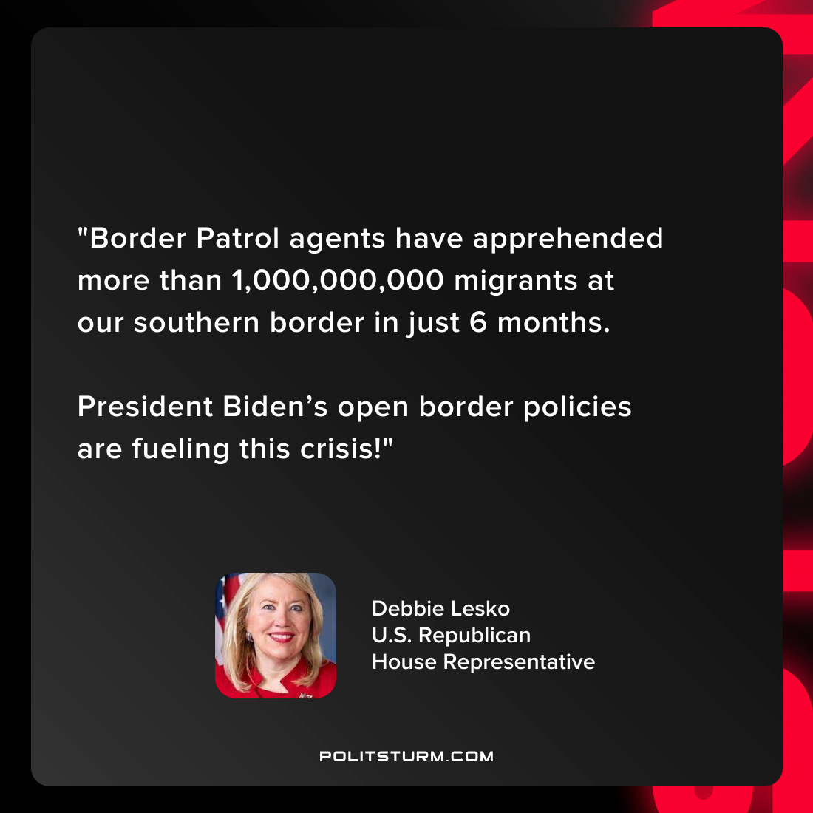

Original article
2022-04-27

“Border Patrol agents have apprehended more than 1,000,000,000 migrants at our southern border in just 6 months.
President Biden’s open border policies are fueling this crisis!”

Debbie Lesko
U.S. Republican
House Representative

Original article

