Dangerous Chemicals Found In Fast Food
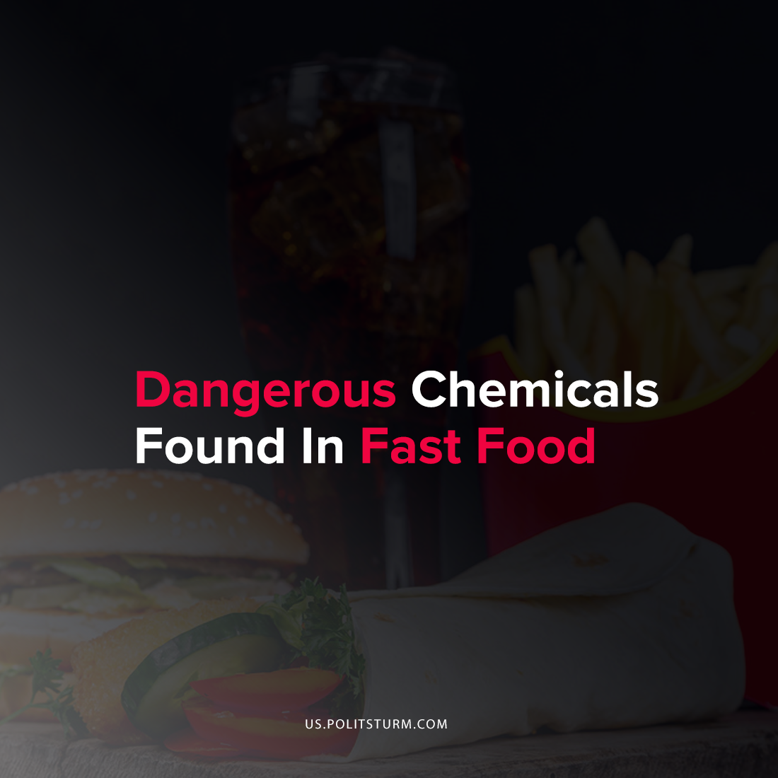

Original article
2021-10-30
1 min read

Recent findings suggest chemicals linked to disease and child maldevelopment are found in various brands of fast food.
Recent investigations of examples of common food items from restaurant chains including McDonalds, Taco Bell, Burger King, Dominos, Pizza Hut and more have found high numbers of phthalates – a toxic chemical found in plastics.
This is due to the fundamental role of these chemicals in the current manufacturing of food-use plastics, called plastisizers, which range from PVC to various other plastics which have long been identified as having a medically consequential neurotoxicity.

“Phthalates have been shown to leach into food from plastic equipment like tubing used in commercial dairy operations, lid gaskets, food preparation gloves, conveyor belts, and food packaging materials. As such, consumption of fast food and other dining-out sources, as well as lipophilic foods such as dairy, can be important dietary sources of phthalate exposures”
The effects of phthalates are under-researched, but reports from such medical research sources as the American Public Health Association suggest potentially severe effects for the development of children because the chemicals cause “adverse cognitive and behavioral outcomes in children, including lower IQ and problems with attention, hyperactivity, and poorer social communication.”
They have also been linked to early death and reproductive disorder in adults, with the chemicals effectively clogging the endocrine system.
While these plastics-based chemicals are now ubiquitous in industrial products, ranging from worn particles of linoleum flooring, to household cleaners, the APHA and the Journal of Exposure Science and Environmental Epidemiology agree that these restaurants and the related food production systems are critical sources for the consumption of phthalates in the American population.
The standards and pressures of the fast food industry operate under the principle of profit maximization for the capitalist class. Despite the obvious negative ramifications for public health that are associated with the sale of their commodities, the capitalists will continue to profit despite any impact that the consumption of their products has on the larger society.
Sources: 1, 2, 3, 4

Original article

