Cuba’s Miguel Diaz Canel Replaces Raul Castro as President
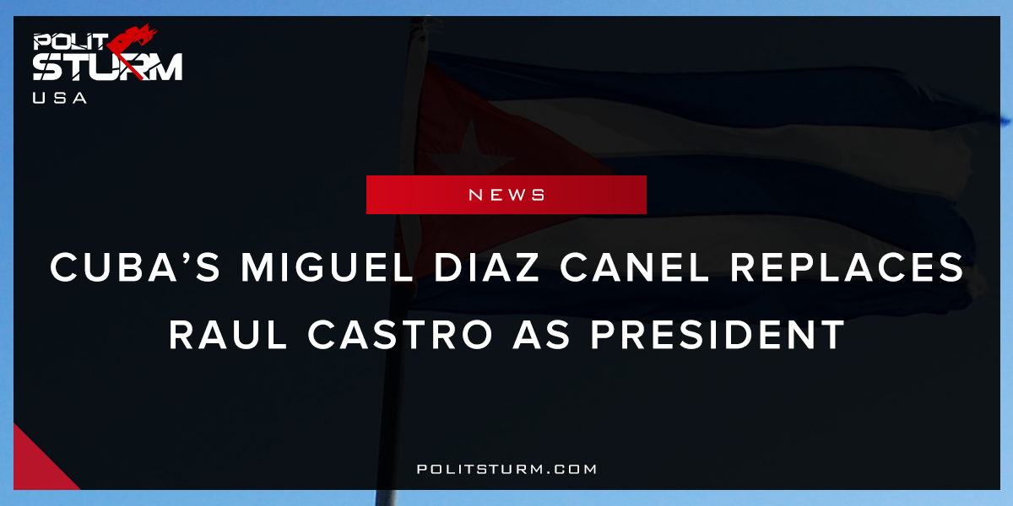

Original article
2018-04-20
1 min read

On April 18th, Members of the National Assembly of Cuba voted to nominate 57-year-old Miguel Mario Diaz-Canel Bermudez for the position of President of the Council of State, representing the head of state and government. He was then sworn into the position on April 19th with 99.83% of the vote (one dissenting vote). He will be replacing Raul Castro, brother of revolutionary Fidel Castro, who held the position since February 24th, 2008. For the time being, Raul Castro will remain in the position of First Secretary of the CPC.
Born in the province of Villa Clara and educated in Electrical Engineering, Diaz-Canel began work as a party member in the early 1990s, moving from Second Secretary of the Young Communist League Central Committee to First Secretary in Villa Clara. He is currently a sitting member of the CPC Politburo and First Vice President of the Councils of State and Ministers. He is considered to be a key ally of Raul Castro, praised by him for his “ideological firmness.” Miguel Diaz-Canel will be the first leader of the country not coming from the Castro family. At the same time, Diaz-Canel comes from a generation of Cubans born after the revolution.
Of the issues currently affecting the Cuban people, the economy will most likely be first on the agenda. The Cuban economy has been suffering since the fall of the Soviet bloc, its largest trading partner, at the end of the Cold War. The Helms-Burton Act, signed by then-President Bill Clinton, strengthened the sanctions strangling the vulnerable economy. Raul Castro’s response was to push for unprecedented reforms in an effort to jumpstart economic growth that took certain state-owned property and put it into the hands of workers cooperatives. Today, the Cuban government is at a turning point that could lead it to caving into imperialist demands which makes the moves of the incoming President will prove pivotal for the future of the small island country.

Original article

