Cuban Government Sets a List of Maximum Prices for Basic Goods
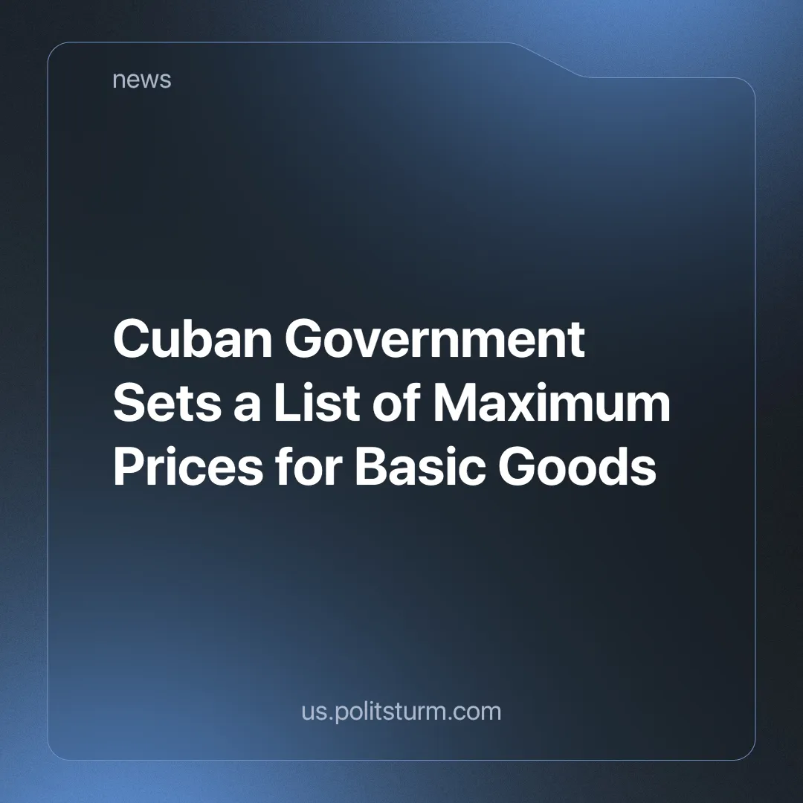

Original article
2024-09-10
3 min read

In early July, Cuba's Ministry of Finance and Prices set maximum retail prices for a list of goods, including powdered milk, chicken and cooking oil [1]. In the same decision, they eliminated import duties on these products. The measure was aimed at curbing inflation in these products and limiting retailers' profit margins to 30%. As soon as it was announced, it was met with fierce criticism from Cuban workers.
The announcement of the decree in the Cuban press was met with a wave of negative commentary about the lack of purchasing power of minimum wage workers and pensioners. In the middle of the month, the Cuban news portal Cubadebate shared several testimonies in its own report on the results of the decree [2]. The most common complaint among readers was the scarcity of regulated products in stores since the decree was announced, with one testimony in the article revealing that store owners prefer to hide such goods in order to sell them on the black market. Chicken and powdered milk were the scarcest products in the list, but cooking oil suffered a different treatment. It was not usually hidden from the buyers, but its retail price was raised to the maximum [2], although the Ministry warned against this [1].
“The experience is very bad. I'm from Artemisa, San Cristóbal. Before, in the mypimes [the acronym for Micro And Little Enterprises - note from PS] the 10 pound package of chicken was available at 3,800 CUP. Now all the mypimes hid the chicken and sold it illegally at 4,000 CUP per package. The same happened with the other products: oil, milk, etc. disappeared from the shelves one day for another. [...]
I recently went to buy a product here in Pinar del Río. When I got to the particular store, the cartel announced a price, and when I went to pay, the cashier told me that this price is only for the inspectors, the actual price of the product is different. So you're looking everywhere for some supposed inspector who's willing to do his job, because many are bribed by the seller himself. [...]
If you are really serious, you should improve everything. In the city of Sancti Spíritus, I went to several places yesterday: there was no chicken in any of them. I asked some of the sellers and their answer was this: ‘We have it in the freezer and we don't want to sell it because we don't agree with these limited prices’. Then I ask the government, what are they going to do with it?” [All translated by Politsturm]
Cubadebate, Tope de precios: De cal y de arena, [2].
Wherever the artificially scarce products were found, the stores sold them under their own conditions, either by repackaging them to sell less than the listed amount at the maximum price, or by evading the price inspections. The retailers used two main methods to evade inspection, either they closed the stores before the arrival of the inspectors or hid the prices to tell the inspectors and the customers a different one. In the first week of the decree, the inspectors found violations of the decree in 40% of the visited stores [2]. In August, the violations of the measure rose to 60%, and the government had to impose fines on the owners and force such stores to sell the products they hid at the regulated prices, although the staff to carry out the inspections and enforce this was insufficient. Another method that the ministry created to enforce the decree was to set up a telephone line for customers to denounce violations of the decree [3].
In openly capitalist countries, we are familiar with the package downsizing of some companies (decreasing the amount of food in a packet for the same price) and with the traditional speculative attitude of retailers and proprietors towards any worrying news. Regarding the black market of basic goods, this mostly occurs during times when particular goods are rationed or appear as an informal market of some products that are discarded because they are about to rot. Considering this, the situation isn't completely strange to us, it's just another natural consequence of the market and private property, which is exactly what the Cuban government has been promoting in recent years since the collapse of the revisionist USSR and the crisis in Venezuela.
Of course, it's easier to regulate the distribution of goods with a state monopoly, and even easier when that distribution is not in the market but in a planned industrial economy, but Cuba preferred to keep tourism and monoculture as its economic base instead of industrializing the country when they had the chance. Now, as with the U.S. embargo on the island, they will use the speculation of retailers as the main justification for the poor living conditions of their workers, hiding their own negligence, until this liberalization reaches a point of no return, when state regulation becomes completely useless.
Sources:
[1] Oscar Figueredo Reinaldo — “Entran en vigor precios minoristas máximos para productos de alta demanda (+PDF)” [URL:http://www.cubadebate.cu/noticias/2024/07/08/entran-en-vigor-precios-minoristas-maximos-para-productos-de-alta-demanda-pdf/] — July 8, 2024.
[2] Cubadebate Editorial Team — “Tope de precios: De cal y de arena” [URL: http://www.cubadebate.cu/especiales/2024/07/17/tope-de-precios-de-cal-y-de-arena/] — July 17, 2024.
[3] Filiberto Pérez Carvajal — “Precios abusivos: ¿Qué pasa en Ciego de Ávila?” [URL: http://www.cubadebate.cu/especiales/2024/08/07/precios-abusivos-que-pasa-en-ciego-de-avila/] — August 7, 2024.

Original article

