On the Capitalist Reforms in Cuba: The New Concessions of the Cuban Government
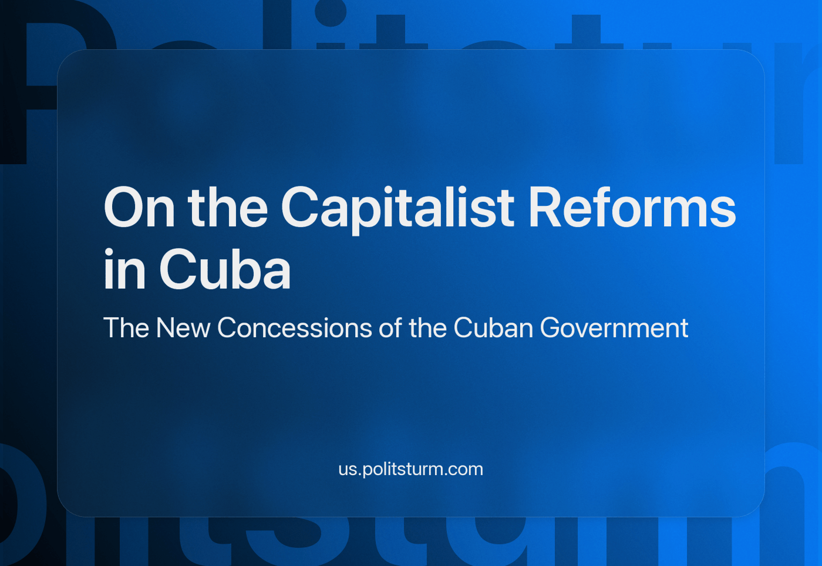

Original article
2024-03-20
8 min read

In December 2023, the Cuban government announced a series of economic reforms referred to as “projections to correct distortions and push the economy forward again”.
In most official press materials related to the “projections”, they claim that they are allegedly not a pack of capitalist measures. We will analyze them in more precise terms to expose their true nature.

The Context of the Reforms
Before we examine the set of reforms, we need to provide some historical context for the Cuban economy. In 1916, 61% of the Cuban economy was based on the production of sugar, other foods and beverages, and tobacco; the sum of the non-agrarian industrial production was less than 16%.
A qualitative analysis by Dr. Gonzalo Rodríguez Mesa shows that before the Cuban Revolution, the only export produced with modern equipment was nickel; the non-exporting industries only produced for internal final consumption, either with the participation of foreign capital to produce them in the island or acting as national intermediaries in the import of machinery. Dr. Rodríguez points out that most of the small production was dedicated to the transformation of agrarian raw materials with obsolete equipment [2].
After the revolution, the goal was formally settled on the “accelerated industrialization of the country, based on the development of heavy industry, the diversification of agriculture, and the growing substitution of imports by national productions”. Despite this intention, by 1975, the production of consumer goods (including sugar and tobacco, but now also textiles and clothing) still formed up to 60% of national production; this figure was lowered to 57% by 1985.
The priorities in the period between 1961 and 1992 were electrification and the distribution of industrial infrastructure across the country. By the twilight years of the USSR Cuba exported over half of their products to, and imported most of the raw materials, machinery and final products from the socialist bloc of countries [2].
After the collapse of the USSR and its allies, Cuba suffered a deep scarcity of fuels and raw materials. This “special period”, as Cuban historians call it, was when the island had to close most of its industries and use the sale of that machinery to boost the remaining sugar and tobacco production, to refocus on nickel exports, and to build the tourism industry as another pillar of the economy. Rationing and scarcity of basic goods were characteristic of these years.
Currently, the Cuban government is trying to overcome this situation through the participation of foreign capital in order to replace obsolete machinery, increase energy and raw material efficiency, migrate to renewable energy sources, and establish a renewed light industry, making better use of the highly trained Cuban workforce [2]. The Cuban government had also been favoring the establishment of special economic zones, mixed-capital enterprises, and private businesses of single individuals and groups.
The government insists that the growth of private companies is not a signal of capitalism at all. The Minister of Economy and Planning of Cuba Alejandro Gil Fernández said in 2021 that the growth of the private sector “is for the perfection of the economic model because we need to reach an efficient economy” [3]. The President of Cuba said, regarding the new reforms, that “there’s no crusade against the private sector”, making it clear that this trend continues [1].
So, the growth of capitalism in Cuba is a trend that has been affecting the country’s economy for several decades. Are these reforms pushing it forward or help maintaining the socialist elements in the Cuban economy?

The Effect of the Reforms
The most important measures discussed last December can be grouped as first, a rise in the salaries of healthcare and education workers; second, some policies related to basic goods in the form of changes in foreign trade duties (in the line of an import substitution policy) and the ‘liberalization’ of food production; and third, the reduction of fuel, energy, and transport subsidies [1].
1. Healthcare and education salaries. The Minister of Economy and Planning declared that “these measures are taken to protect the social conquests of the Revolution” [6], this relates mainly to the rise in wages for the education and healthcare sectors. But another side of this part of the reform could be inferred from the development of the Cuban healthcare industry since the “special period”.
In a press article on the 10th anniversary of the Cuban Medical Services Commerce Company (CSMC) it’s said that in 2020 the export of medical services accounted for 50% of the total services exports of Cuba and services, in time, summed up to the 80% of the total exports [4]. Furthermore, the President of Cuba this March in the Ministers Council called for the government “to keep powering the export of services within the economy of knowledge” [5].
Despite big words about Cuban ‘generosity’ in terms of providing medical services and sob stories about Cuba helping everyone around “for free”, the reality is way simpler: the government trying to find a place in the international capitalist market. The Cuban state is becoming a big outsourcing intermediary for medical services and there is a possible extension of this export system to other activities, for which the education system must be extended and adapted.
The rise of salaries there is supposed to attract more people in those spheres, therefore expanding Cuban profits and securing a place in this particular sphere of the international capitalist market, since the blockade prevents Cuba from getting in other spheres.
2. Reducing foreign trade duties. The foreign trade duties, as President Díaz-Canel explains, will be cut down to 50% for the import of raw materials and intermediary goods, increased for some “selected final goods”, kept low for the import of food and cleaning goods by individuals, and adjusted for food producers trying to match their income on a case-by-case basis [1].
As we said in the beginning, this is coherent with the policy of import substitution that is oriented toward rebuilding the national light industry. What is curious is the decentralized and heterogeneous character that is being evidenced in food production and in the provision of other basic goods, revealing the actual extent of the market in the Cuban economy.
This is also done for the sake of opening the country to foreign capitalists, creating and developing the “national market”.
3. Reducing fuel, transport, and energy subsidies. Two reasons are used to justify the reduction of fuel, transport, and energy subsidies. The first one is the supposed neutral impact of eliminating the subsidies because the funds already come from the national economy and could be used for other purposes; this reasoning is also used for other reductions in subsidies for basic goods.
The second reason is the lack of a mechanism to recover the foreign currency used in the purchase of fuel that will be sold in Cuban pesos. In regards to the other basic goods, it’s being said that it would be better to subsidize only their purchase by “people in situations of vulnerability” [6].

The Character of the Reforms
The ministers of Economy and Planning, Alejandro Gil Fernández, and of Finances and Prices, Vladimir Regueiro Ale, in a national TV interview last December mentioned inflation as a driving cause of the reforms. On one side, they said money emissions are being used to compensate for the difference in the purchase and sale price of fuel, generating a fiscal deficit they want to reduce with the reforms.
On the other hand, they said the private sector is speculating with the prices of basic goods, so the government is reinforcing control over these prices and will establish a table of their absolute maximums, but that this “is not about regulating everything in a system that becomes unmanageable and that limits the very dynamic of price agreement” [6].
From this, we can draw some revealing conclusions. Firstly, these problems and solutions are characteristic of capitalist economies; the regulation of the economy through taxes, subsidies, and price controls only makes sense when the market is the driving force behind it. Mismatches and planning errors are corrected, in a socialist economy, by the modification of both the plan and the very flow of products in kind.
Some people unfamiliar with history may start defending these policies, arguing that, for example, the USSR used capitalist measures during the NEP period in the 1920s.
Among the problems facing the Soviet Union during the years of the NEP was the general backwardness of the economy, weakened by destructive wars, the disruption of trade relations within the country, the reduction of large-scale industry, the presence of a huge number of peasants who cultivated their land individually, and the lack of sufficient funds to create an industrial base for socialism.
Using market instruments, the Bolsheviks were able to solve these problems and preserve Soviet power, preserving not only the “social” but also the economic and political gains of the revolution. Large industry remained in the hands of the workers, and the kulaks in the countryside were taxed in every possible way. The USSR managed to prevent the creation of a big bourgeoisie and prevented small and middle capitalists from getting into the governing bodies of the country. The USSR did not become part of the world capitalist market.
During the 1920s, a system of five-year plans was prepared and adopted, and the collectivization of peasants began, marking the successful building of socialism in the 1930s.
Having restored the domestic market, adjusted the economy, and collected funds for the socialist offensive, the Soviet Union did not turn the accumulation of funds into an end in itself, as the opportunists are now doing in China, Vietnam and other pseudo-socialist countries. This is one of the mistakes of opportunism: sacrificing the final goal to the successes of today, turning “the accumulation of funds for the construction of socialism” into the main goal instead of the construction of socialism itself. We discussed this topic in more detail in our video.
However, in Cuba, we see only the continuing advance of capitalism, the actual integration of the country into the international market and the restructuring of the economy to meet the needs of this market. What are the concrete gaps that are stopping Cuba from building socialism and how is this reform helping to fill them?
What first comes to mind is the lack of heavy industry, but then we must remember that the production of means of production was only a formal goal for the Cuban state since 1961 and that they are now focusing on light industries and services instead, just the favorite sectors of liberal economists because of their higher profitability.
“If this were true, it would be incomprehensible why our light industries, which are the most profitable, are not being developed to the utmost, and why preference is given to our heavy industries, which are often less profitable, and sometimes altogether unprofitable. […] Obviously, if we were to follow the lead of these comrades, we should have to cease giving primacy to the production of means of production in favour of the production of articles of consumption. And what would be the effect of ceasing to give primacy to the production of the means of production? The effect would be to destroy the possibility of continuous expansion of our national economy, because the national economy cannot be continuously expanded without giving primacy to the production of means of production.”
I.V. Stalin, Economic problems of socialism in the USSR, 1952.
The insistence on the “non-neoliberal”, as they call it, the character of the reforms is the surreptitious way the Cuban government accepts their underlying capitalist logic. Obviously, the “projections” don’t fit completely within the typical measures taken by the “Chicago boys” that advised Pinochet, or by Thatcher and Reagan, or by any US-allied government from 1990 to this year, which are the classic examples of the umbrella word of “neoliberalism”.
Regardless, the term “neoliberalism” — ignores the differences among these reforms in each country and at the same time it separates them from classic liberalism as if they are not an organic product of regular old liberalism taken to its logical conclusion, but something externally imposed.
But, despite some differences, parts of the pack of reforms resemble indeed the mainstream policies from other Latin-American governments in the last 2 decades, as the displacement of subsidies from the offer of some products to the “vulnerable” (poor) people or the continuation of the emphasis of the economy on services. The rest of the reform is clearly inspired by the Keynesian policies of the mid-past century, as the import substitution is intended to develop the light industry.
The declarations from Cuban officials reveal that they think there can be good capitalism and bad capitalism and that they accept the liberal thesis on the impossibility of a centrally managed economy and on market competition as the only way to achieve efficiency in production. Plus, let’s not forget about private property enshrined in the Cuban constitution in 2018. While it’s easy to introduce capitalist elements, it’s difficult to get rid of them.
Therefore, we can see that these reforms constitute ais just the continuation of the same defects that caused the current situation on the island: the uncritical acceptance of the economic thesis of the imperialist powers they depend on, first the “international division of labor” and now “market socialism”, with poverty and decentralized foreign trade.
Sadly, the only thing we can expect from the reinforcing of Cuban dependency on Chinese and Russian imperialism is the crumbling of their current state capitalist system as it falls deeper into recession [7][8] at the hands of the same small business owners they swear are not capitalists. Of course, this will only happen if a sound communist core of workers doesn’t stop and reverse this process first, and then consolidate and expand the gains of the Cuban Revolution.
1. https://www.cubadebate.cu/noticias/2023/12/30/consejo-de-ministros-analiza-importantes-topicos-de-la-vida-economica-y-social-del-pais/
2. http://www.cubadebate.cu/especiales/2019/01/04/a-60-anos-del-triunfo-una-industria-en-constante-revolucion/
3. http://www.cuba.cu/economia/2021-09-01/las-mipymes-privadas-no-significan-un-retroceso-al-capitalismo/57201
4. http://www.cubadebate.cu/noticias/2021/10/13/comercializadora-de-servicios-medicos-cubanos-celebra-su-decimo-aniversario/
5. http://www.cubadebate.cu/noticias/2024/03/11/chequean-cronograma-de-medidas-para-corregir-distorsiones-y-reimpulsar-la-economia-video/
6. http://www.cubadebate.cu/noticias/2023/12/27/proyecciones-del-gobierno-para-corregir-distorsiones-y-reimpulsar-la-economia-video/
7. https://riktpunkt.nu/2024/03/femdubblade-bensinpriser-i-kuba/
8. https://riktpunkt.nu/2023/12/kubas-ekonomi-fortsatt-i-recession-bnp-sjonk-med-1-2-procent-2023/

Original article

