Criticism of The Theory of "Post-Industrial Society", Part 1
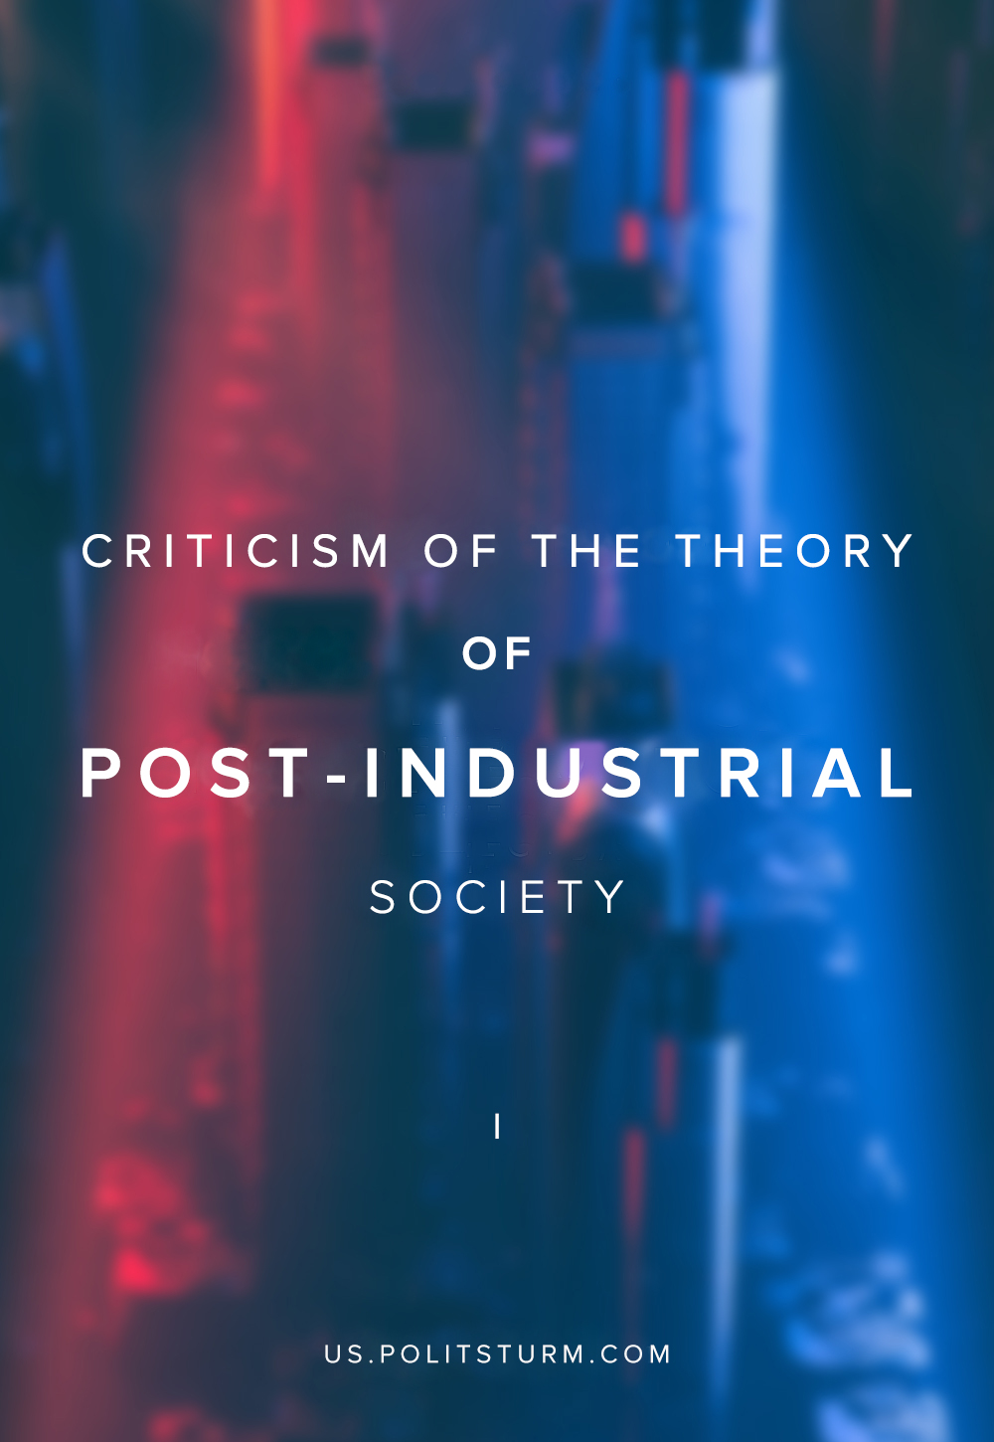

Original article
2019-07-06
12 min read

There are various approaches to the periodization of socio-economic development. The purpose of periodization is to identify the patterns of the development of society. At the same time, special criteria are distinguished by which it is possible to divide the history of society into stages.
The Marxist theory, which made the struggle between two opposing classes paramount, with its sharpness and straightforwardness caused every attempt to create such a periodization that would explain the course of history in a bourgeois way.
The collapse of socialism at the turn of the 1980s – 1990s gave them a second life: the very fact of a return to capitalism is used as an argument against Marxism. It has become fashionable to say that Marx was wrong. Using the outflow of capital to the countries of Asia that began in the 90s and the decrease in the number of industrial proletarians, capital lackeys tried to prove that Marxism was outdated and irrelevant.
In place of the Marxist theory, the bourgeoisie advanced (and promotes to this day) the theory of post-industrial society, founded by the American sociologist Daniel Bell (1919-2011). This theory uses as the main criterion for distinguishing historical periods the degree of development of the industry. It turns out that any society in the framework of this concept goes through three historical stages: pre-industrial, industrial and post-industrial.
Error loading image
This article will discuss the general provisions of the theory of post-industrial society and expose its shortcomings and errors.

The Theory of “Post-Industrial Society”
The concept of a post-industrial society originated in the 20th century as a response to the “imperfection” of the Marxist formational theory. Daniel Bell in the book “The coming of post-industrial society” criticizes Marx’s formation theory primarily because the “prediction” made by Marx about the victory of socialism in developed industrial countries did not translate into reality, and socialism came in the “backward” countries. Studying the experience of advanced western countries, Bell’s followers tried to prove the crisis-free development of capitalism and the absence of class struggle.
The concept of post-industrial society rightly noted that the state of the productive forces of society should somehow determine its stage of historical development. If the low development of productive forces or their absence at all is a criterion of the first pre-industrial stage of the history of mankind, then the development of productive forces, which makes it possible to move away from gross physical labour, fits into the second industrial stage. The further development of the productive forces should theoretically lead to the formation of some post-industrial stage, as the apogee of human development.
If with the first two stages everything is clear and understandable, since the history of mankind can be entered into this model according to the specified criterion, then it is more difficult with the post-industrial society. What is going on in the foundation of a post-industrial society? Why would some countries today be called post-industrial?
The main features of the post-industrial society that Bell highlights are:
- prevalence of services;
- demand for highly specialized professionals;
- information as the main production resource.
As a result of automation, robotization, and improvements in technological processes, the productive forces have improved so much that they almost do not need labour. Today, the oil tanker is served by a team of just 30 people, and the production of a middle-class car takes 10 working hours. In the USA in 2006 only 2% of workers were employed in agriculture and 17% in industry. Due to the development of the productive forces, the labour force gradually leaves industry and agriculture. Industry is slowing down in development, because the existing development is already enough, and it covers the needs of society. In the foundation of the post-industrial society lies precisely this process.
Having determined the basic prerequisites of a post-industrial society, we will consider their consequences. Where do the rest of the workers go, namely 80%? They flow into the service sector.
Error loading image
Daniel Bell believed that information and knowledge became the main resource in the post-industrial society. “Nowadays, knowledge is becoming a source of value …” says Bell. There is a departure from commercial interests. In a postindustrial society, the centre of growth of civilization is the intellectual development of man, his professionalism. Bell identifies the concept of “class of professionals” or “creative class” – highly competent employees, experts, technocrats. In 1990, Alvin Toffler for the first time would call this class a cognitive. We already have written about this “invention”. Nevertheless, the class of professionals is the dominant class in a post-industrial society.

Class Structure of “Post-Industrial Society”
The stratification of society, described by the likes of Bell and other bourgeois sociologists, may have different criteria: based on the division of labor, on the place in the management of society and so on. Bell describes the structure of the post-industrial society as follows:
Error loading image
Despite its cumbersome and exhaustive nature, this structure is devoid of a criterion by which antagonistic classes could be distinguished. Here it is important for us to note that in the theory of post-industrial society the factor of class struggle is not considered as a factor of historical development in general. And this is understandable, since the very concept of “post-industrial society” is another attempt by the bourgeoisie to escape from Marxism and Marxist political economy. Bell justifies a departure from class problems with the following argument:
“To the extent that the investment process has been routinized and the “class conflicgts” encapsulated so that the issue of class strife no longer acts to polarize a country around a single issue, those older problems of an industrial society have been muted if not “solved”.
The classes identified by Bell do not reveal the social forces that lead to the historical movement. In “The Coming Post-Industrial Society,” Bell points out that a certain class of professionals will become the dominant class. Bell, however, does not consider how this class achieves its dominance. With Bell everything happens by gravity, without any struggle. Simply developed productive forces without any involvement of the class of professionals themselves lead this class to power and push back the previously dominant capitalist class, inherent in the previous “industrial society”. Describing his stratification, Bell simply breaks up society according to different criteria. What does this reveal to us? We do not recognize neither cause nor effect, why one class dominates, and the other does not.
And now we come to Bell’s most wonderful revelation. To the question “how will the capitalists give up their dominant position in society?” He gives the following answer:
“In late capitalism, says Sombart – his model was the cartelization of German industry in 1920s – the major desire is for stabilization. The striving for profit grows less intense (“witness such symptoms as the fixed dividend rate, the reinvestment of surplus – in the United States, for example, some concerns provide 30 to 35 percent of their new capital in this way”), the market mechanism is superseded by the price regulation by combinations or even by the government, the cyclical oscillations of the economic system become attenuated, and the interventions of government become more and more decisive. The features that gave capitalism its distinctiveness have begun to atrophy. If capitalism, as Sombart put it, could be characterized by three constituent elements, spirit, form, and technology, the spirit was now gone and only form and technology remain.”
Since Bell does not distinguish antagonistic classes, then the transition to the much-desired post-industrial phase must be explained with the help of the spirit, or rather not at all.
Error loading image
It becomes clear how the theorists of post-industrial society prove the absence of class struggle. On the one hand, they claim that the class struggle has exhausted itself, and on the other hand, they distinguish dozens of social classes according to various criteria that have nothing to do with historical development. They are not looking for internal struggling forces in society, which lead to the historical movement, because they fear the very notion of class struggle as part of Marxism which they hate. They describe history only by the level of development of the productive forces, but ignore the social processes accompanying this development.

The Contemplation of the Theory of “Post-Industrial Society”
The post-industrial society, according to the description of its theorists, possesses a number of characteristics: the domination of professionals, a departure from commercial interests, the concentration of all the forces of civilization around human development, his knowledge and professionalism, which arise through the development of productive forces. In reality, the productive forces are developing at a frantic pace: even the spirit of capitalism has left us, and the characteristics of a post-industrial society will not come about.
Industrial development did not save a person from need and economic dependence, did not create the conditions for his intellectual growth. The post-industrial society, which prioritizes the intellectual development of man, in fact rests on social relations.
Marx and Engels also viewed the development of the productive forces as the main criterion by which certain stages of human history can be distinguished. But their theory is not limited to this criterion. Another equally important criterion in the formation theory are production relations. Marx and Engels discovered the tremendous importance of industrial relations, not only as a factor in determining the state of today’s life, but also as a factor in history.
All the wonderful characteristics of a post-industrial society are somewhat similar to the characteristics of a communist society. But only in some aspects. The importance of the education of a person, his professionalism is described, social relations are described, based not on predatory extraction of profit from everything that is possible, but on the development of people. However, as we see, the reasons for the emergence of such a society are not described.
The concept of post-industrial society reveals a hole that is not filled with anything. The criterion of production relations, determined by the class struggle, has been dropped. If you do not take into account the role of practice, change by the subject of the object, then we will not be able to understand the reasons why the post-industrial society with all its wonderful characteristics does not occur, despite the strict presence of the highest industrial development – the main criterion. This is the contemplativeness of this concept. Theorists of a post-industrial society study society, ignoring the active contribution of this society to the historical process. It is as if society is a passive, limp mass filling the vessel of industrial development and in no way influencing it.
The concept of a post-industrial society is another attempt to crush the Marxist understanding of the development of society and make it “obsolete.” But, as we have seen, this attempt failed. After all, even if the masses are inspired by the ideals of the information society, they still must grapple with social relations based on the dominance of private property. And if they begin to do this, it means that they will begin to interfere in history, will become a factor in history. But it is precisely this that distinguishes Marxist theory from the concept of a post-industrial society.
In the theory of scientific communism, the laws of social development are explained, and the transition from one formation to another is considered in detail. The theory of post-industrial society does not take into account all the reasons necessary for the transition from one period of human history to the next.
“Well, and what about de-industrialization and the growing number of people employed in the service sector? After all, supporters of a postindustrial society rely on these trends!” – reader can say. Is it really so and what became of the proletariat and the bourgeoisie in the new conditions? We will speak about it in the next part of the article.

Original article

