Upcoming Elections in the UK and the Decline in Turnout Across Europe
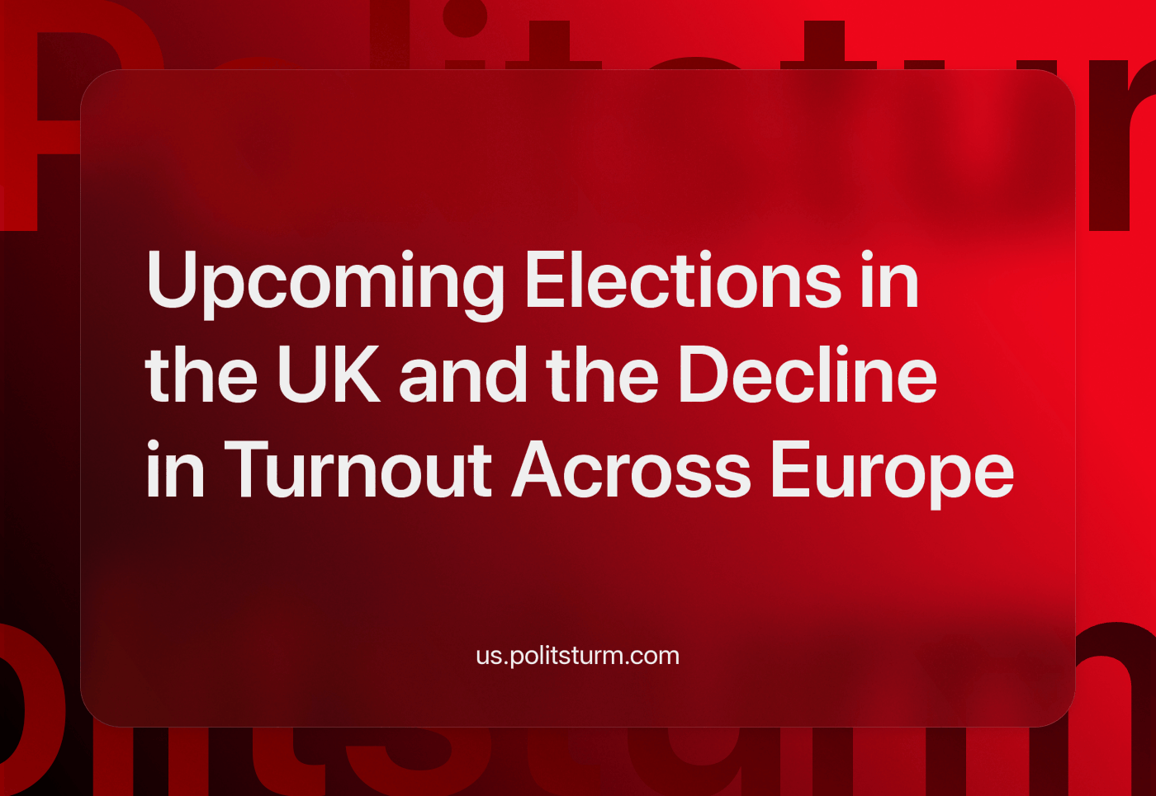

Original article
2024-04-30
16 min read

On the 2nd of May in England and Wales, elections for mayors and local councils will take place. Enthusiasm for liberal democracy in Britain and across Europe is generally low and declining, as the people feel they are offered no real choice as we have explained previously. The same trends can also be observed in Russia.
This crisis of liberal democracy is demonstrated aptly by the declining turnout figures. For clarification, turnout is defined as the percentage of those who are registered to vote who actually voted in a given election. We shall focus on Britain in particular as the birthplace of liberal democracy, but compare these figures with European countries in general.

Electoral Turnout in Britain
For the upcoming Metropolitan, London Borough and Unitary Council Elections in Britain, turnout will likely be very low. The Electoral Commission has run many adverts to attempt to boost turnout.
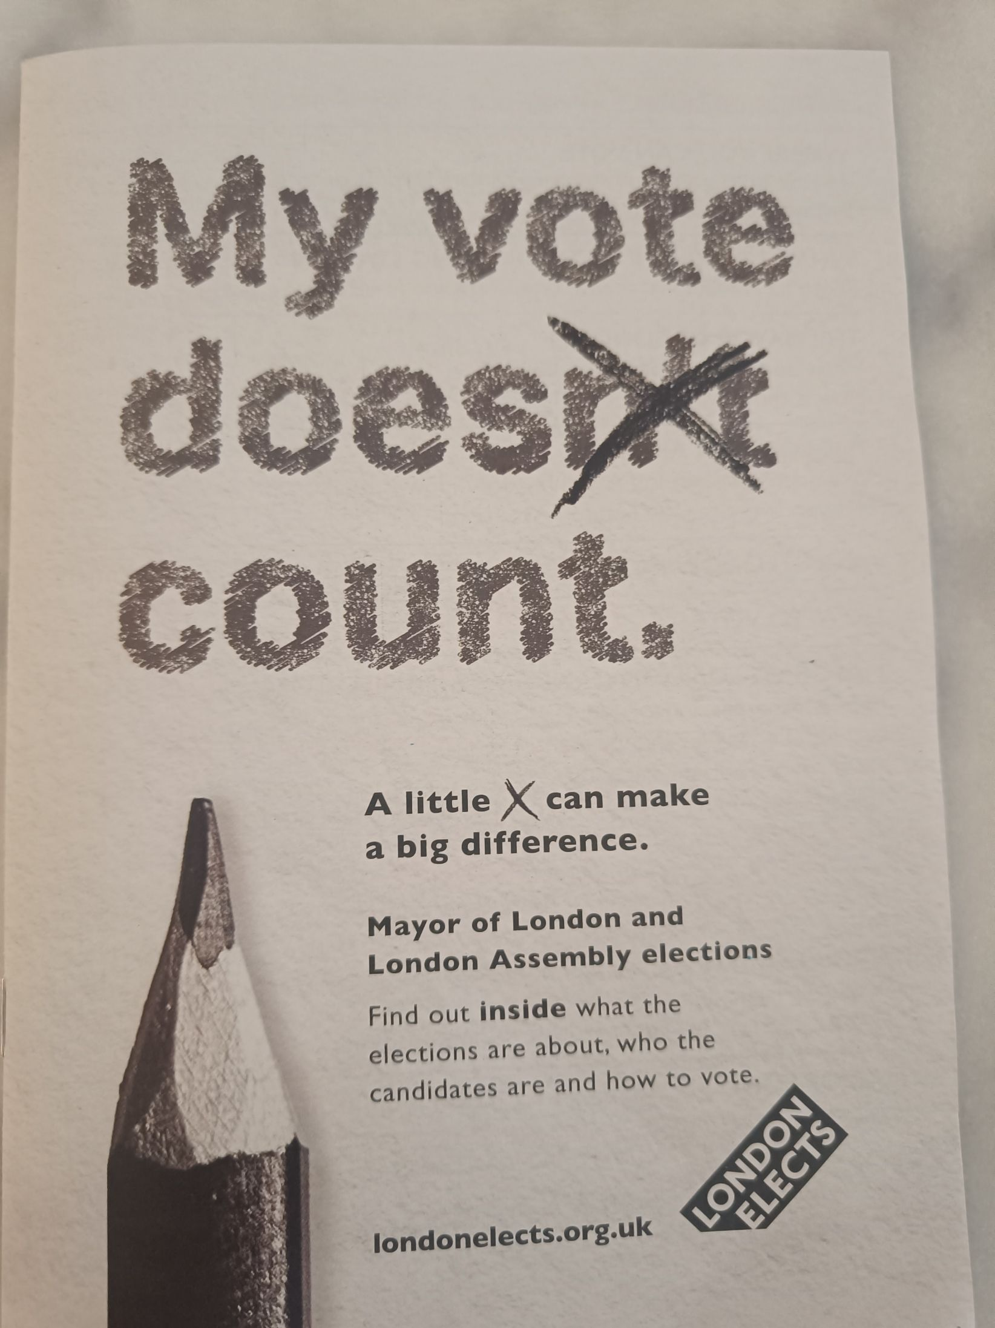
The Electoral Commission has seen fit to mail a 40-page booklet to registered voters in London to encourage them to vote.
We have graphed historic turnout data for these upcoming local council elections as well as other similar ones since the 1970s [1].
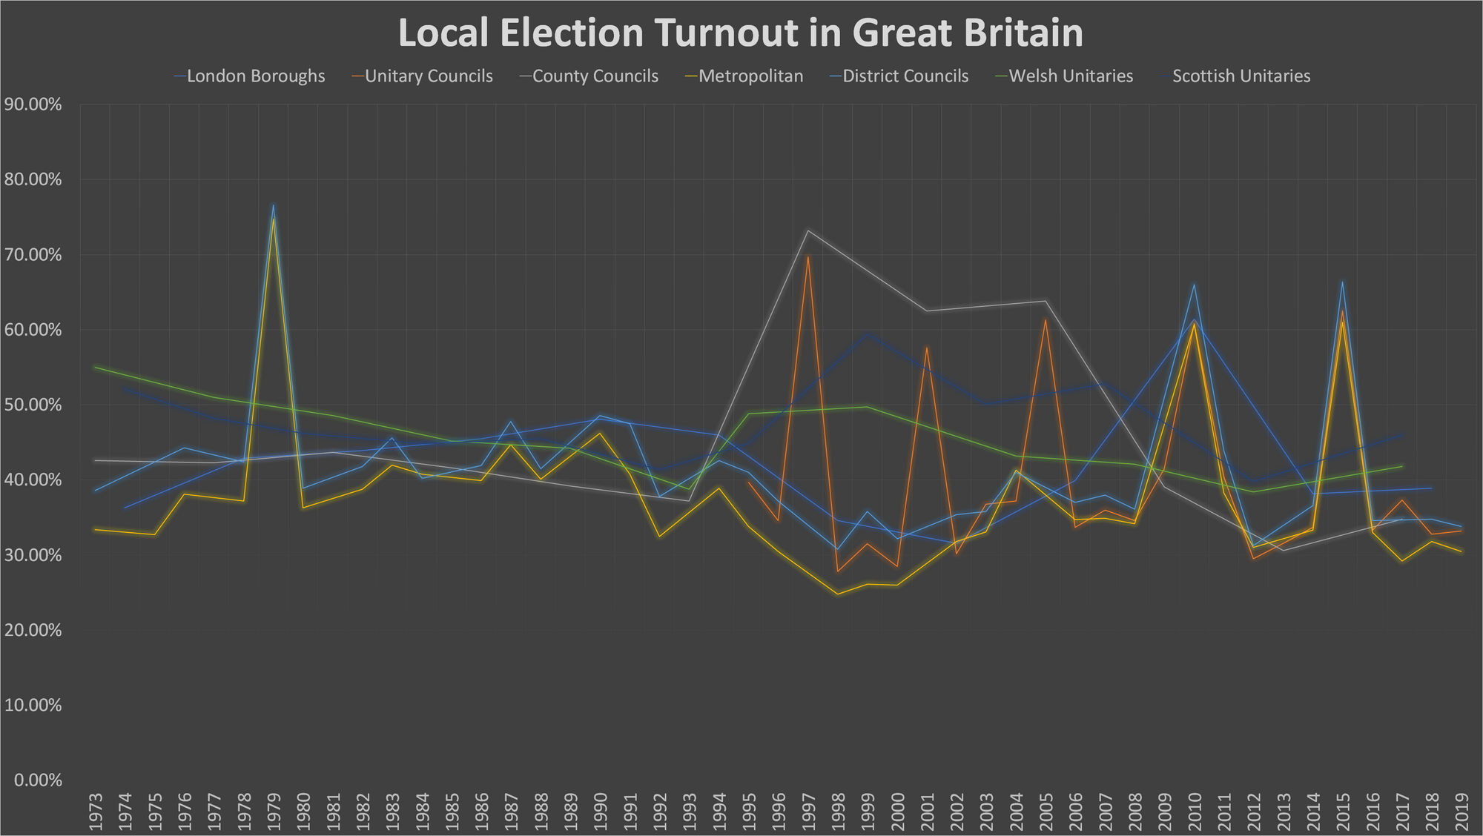
As we can see turnout is historically pretty low and this trend is only continuing. We have done the same for the British General Elections [2]
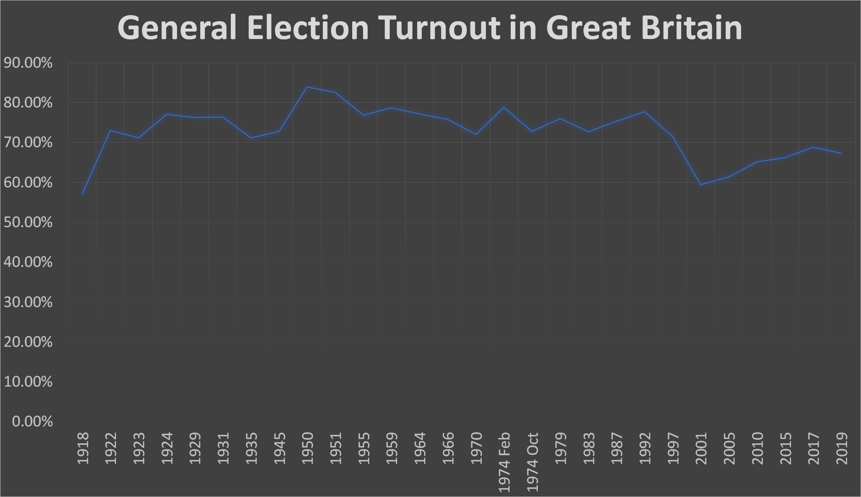
While a lot higher, the turnout is still fairly low recently, dropping to levels almost comparable to 1918. This is significant as in 1918 Europe was undergoing a revolutionary wave after the First World War and dissatisfaction with the political status quo in Britain was extremely high. In fact, just one month after the 1918 British General Elections, the newly formed government used soldiers and tanks to quell mass protests and strikes in Glasgow.
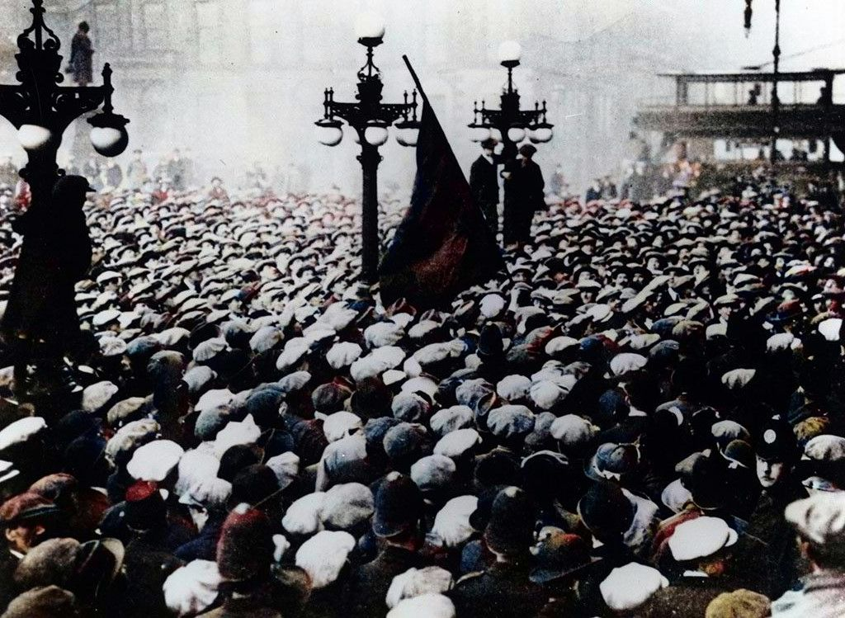
The Red Banner is raised on the banks of the river Clyde, Glasgow
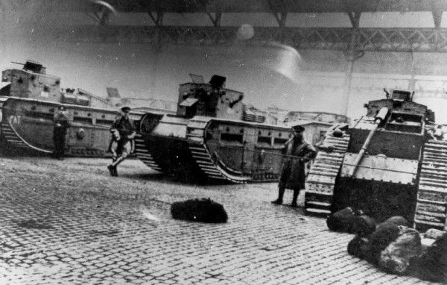
The tanks used against Red Clydeside
It is clear from these statistics that electoral apathy in Britain is high and rising, but how does Britain compare to the rest of Europe in this respect? We have graphed the turnout of the last parliamentary election in many European countries [1].
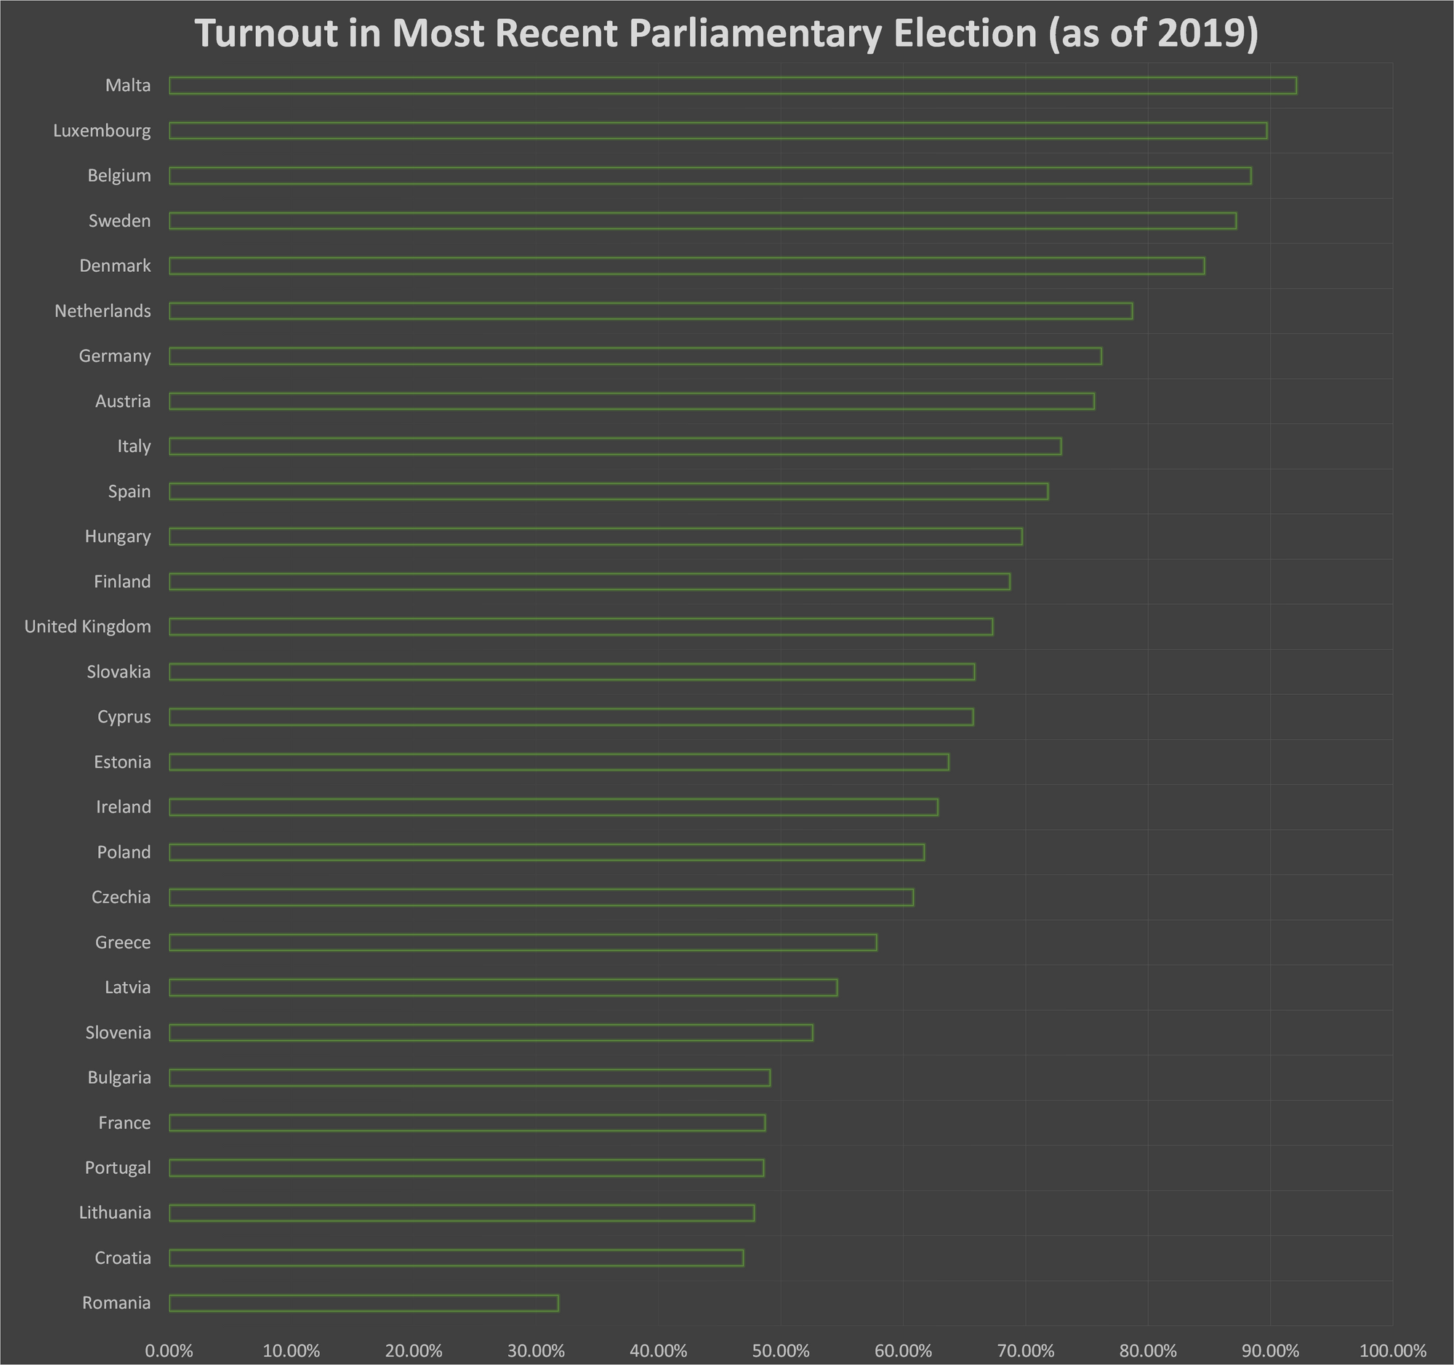
As shown, Britain's statistics are almost the median for Europe. Only a few countries have a relatively healthy turnout above 80%.

Why is Turnout so Low?
Recently in Britain, new voter ID laws have been introduced to supposedly prevent electoral fraud, and the monopoly media outlets are citing this as the reason for the low turnout last year when these laws were introduced [3][4]. However, as these sources acknowledge only 14,000 people (out of nearly 49 million registered to vote [5]) were prevented at the polls by these new laws. The turnout in 2023 was 32% [6] which is not significantly lower compared to previous years as shown in the previous graph on local election turnout. Non-voters were polled and as can be seen, ID-related reasons were only a factor in 7% of them not voting [7].
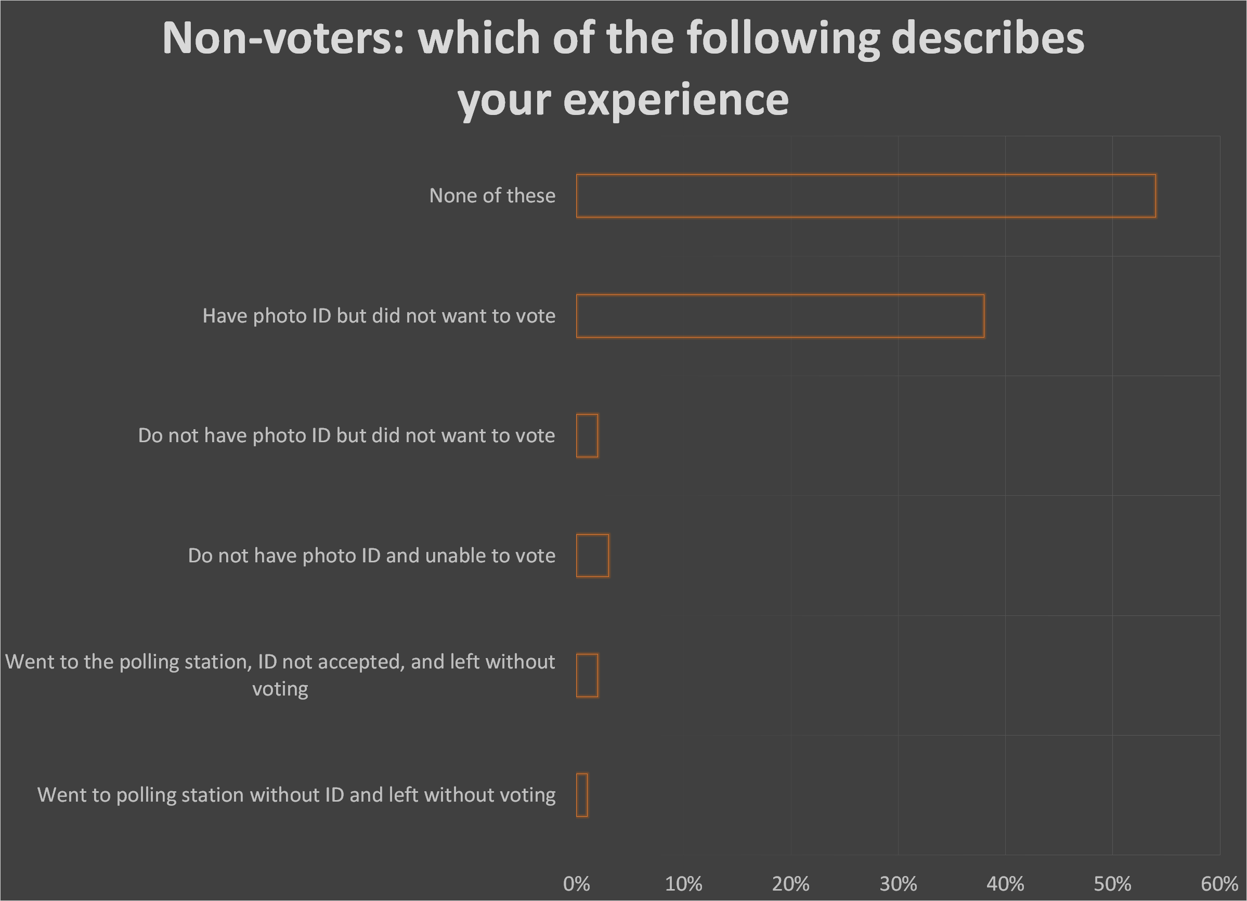
So, what is the real reason? We believe it to be apathy and the growing sentiment that no matter who is elected and no matter what they promise, the most important things to the working majority remain the same (i.e., the rising cost of living, crumbling infrastructure and social services, militarism and imperialist war).
This belief is evidenced by a study by the Institute for Public Policy Research that demonstrated that in 1987 (when total turnout was 75.3%), the difference in turnout between the poorest income group polled by a study and the richest was 4%. However, in 2010 (when total turnout was 65.1%) the difference in turnout between the richest and poorest was 23% [8]. Similarly, there is a large turnout difference between the youngest voters and the oldest.
And there is truth in this widespread sentiment of apathy amongst workers in Britain. So long as state power remains in the hands of the capitalists, society will be governed in the interests of capital. And for capitalists to maximise their profits, they must minimise their expenses, especially the remuneration given to their workers.
In our current epoch, where science, technology and labour productivity has reached incredible heights and every worker possesses the capability to create far more than only the equivalent for the essential goods needed for their sustenance - clothing, shelter, and nourishment - but also a substantial surplus. This surplus produced far exceeds the mere necessities that each worker requires for him or herself. However, due to the private appropriation of these resources by the capitalists, they are instead amassed to an exorbitant extent by a select few of the wealthiest billionaires. That is why the prices of commodities continue to rise and wages effectively continue to shrink.
“Hence there is immanent in capital an inclination and constant tendency, to heighten the productiveness of labour, in order to cheapen commodities, and by such cheapening to cheapen the labourer himself” – Marx, Capital Vol 1
The utter paucity of the local councils in attempting to instigate real change was demonstrated by the Trotskyists of the Militant tendency within the Labour Party who were elected in the 1980s to Liverpool City Council. Local councils are given a budget (raised by the central government, tax on business and tax on residences), however, this is normally not enough to even maintain existing social services and infrastructure, let alone enact change.
When Militant took power in Liverpool, they attempted to run an illegal deficit budget to build new houses, parks, sports centres and nurseries. After a struggle with the central government, they lost. While many of the infrastructure projects they instigated were indeed completed, the cost for them was balanced by a £30 million loan whose repayment was offloaded onto the Liverpudlian taxpayer. Additionally, the elected councillors were charged a total of £348,000 as fines for their breach of the law which was repaid with Labour Party and Trade Union donations.
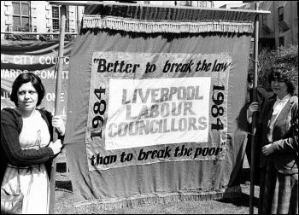
A demonstration in favour of the actions of the Liverpool Militant Councillors
So even with illegal action and left-wing councillors, the most that could be achieved through these councils was the construction of much-needed infrastructure (whose cost was ultimately offloaded onto the taxpayer anyway and was subtracted from future council budgets). It serves no purpose for the working class to elect various fragmented parties, each claiming to represent divergent perspectives, to impotent councils endowed with limited resources, merely to decide which infrastructure or social service to marginally delay the process of decay for.
As for General Elections, Members of Parliament and the parties that they belong to are bought and sold by various lobby groups and large donors. There is a large financial obstacle in the form of campaigning costs for any ordinary person to be elected as an independent.
The essence of capitalist democracy is “deciding once in three or six years which member of the ruling class was to misrepresent the people in Parliament” – Marx, the Civil War in France

Electoral Turnout in the USSR
So electoral turnout in Britain in particular and most other capitalist countries in general is quite low, and we have demonstrated that this is due to the feeling that no matter which politician is acting as the people’s representative, the most important issues for the people remain the same or worsen.
Many British workers (and indeed workers throughout the world) will put this down to commonly heard platitudes such as “power corrupts” or “all politicians are bastards”, however, we will advance the thesis that it doesn’t have to be this way. The causes we have outlined as most important to the voter that does not change no matter which representative of capital is in charge (i.e., increasing poverty, decaying social services, militarism) are endemic to capitalism itself and necessary for the ruling interests in this system. So, in a socialist society, where these things are no longer the constant issues faced by the common worker, and instead they are free to participate in the political life of society and shape their own destiny, we would expect voter turnout to be high.
So, if we take the Soviet Union (the birthplace of Soviet democracy) as an example, was this indeed the case? Did the Soviet reality hold up to our theory and analysis? We have compiled electoral data for Supreme Soviet elections (which were elected directly by secret ballot with universal suffrage) since the body’s creation in 1937 [9]:
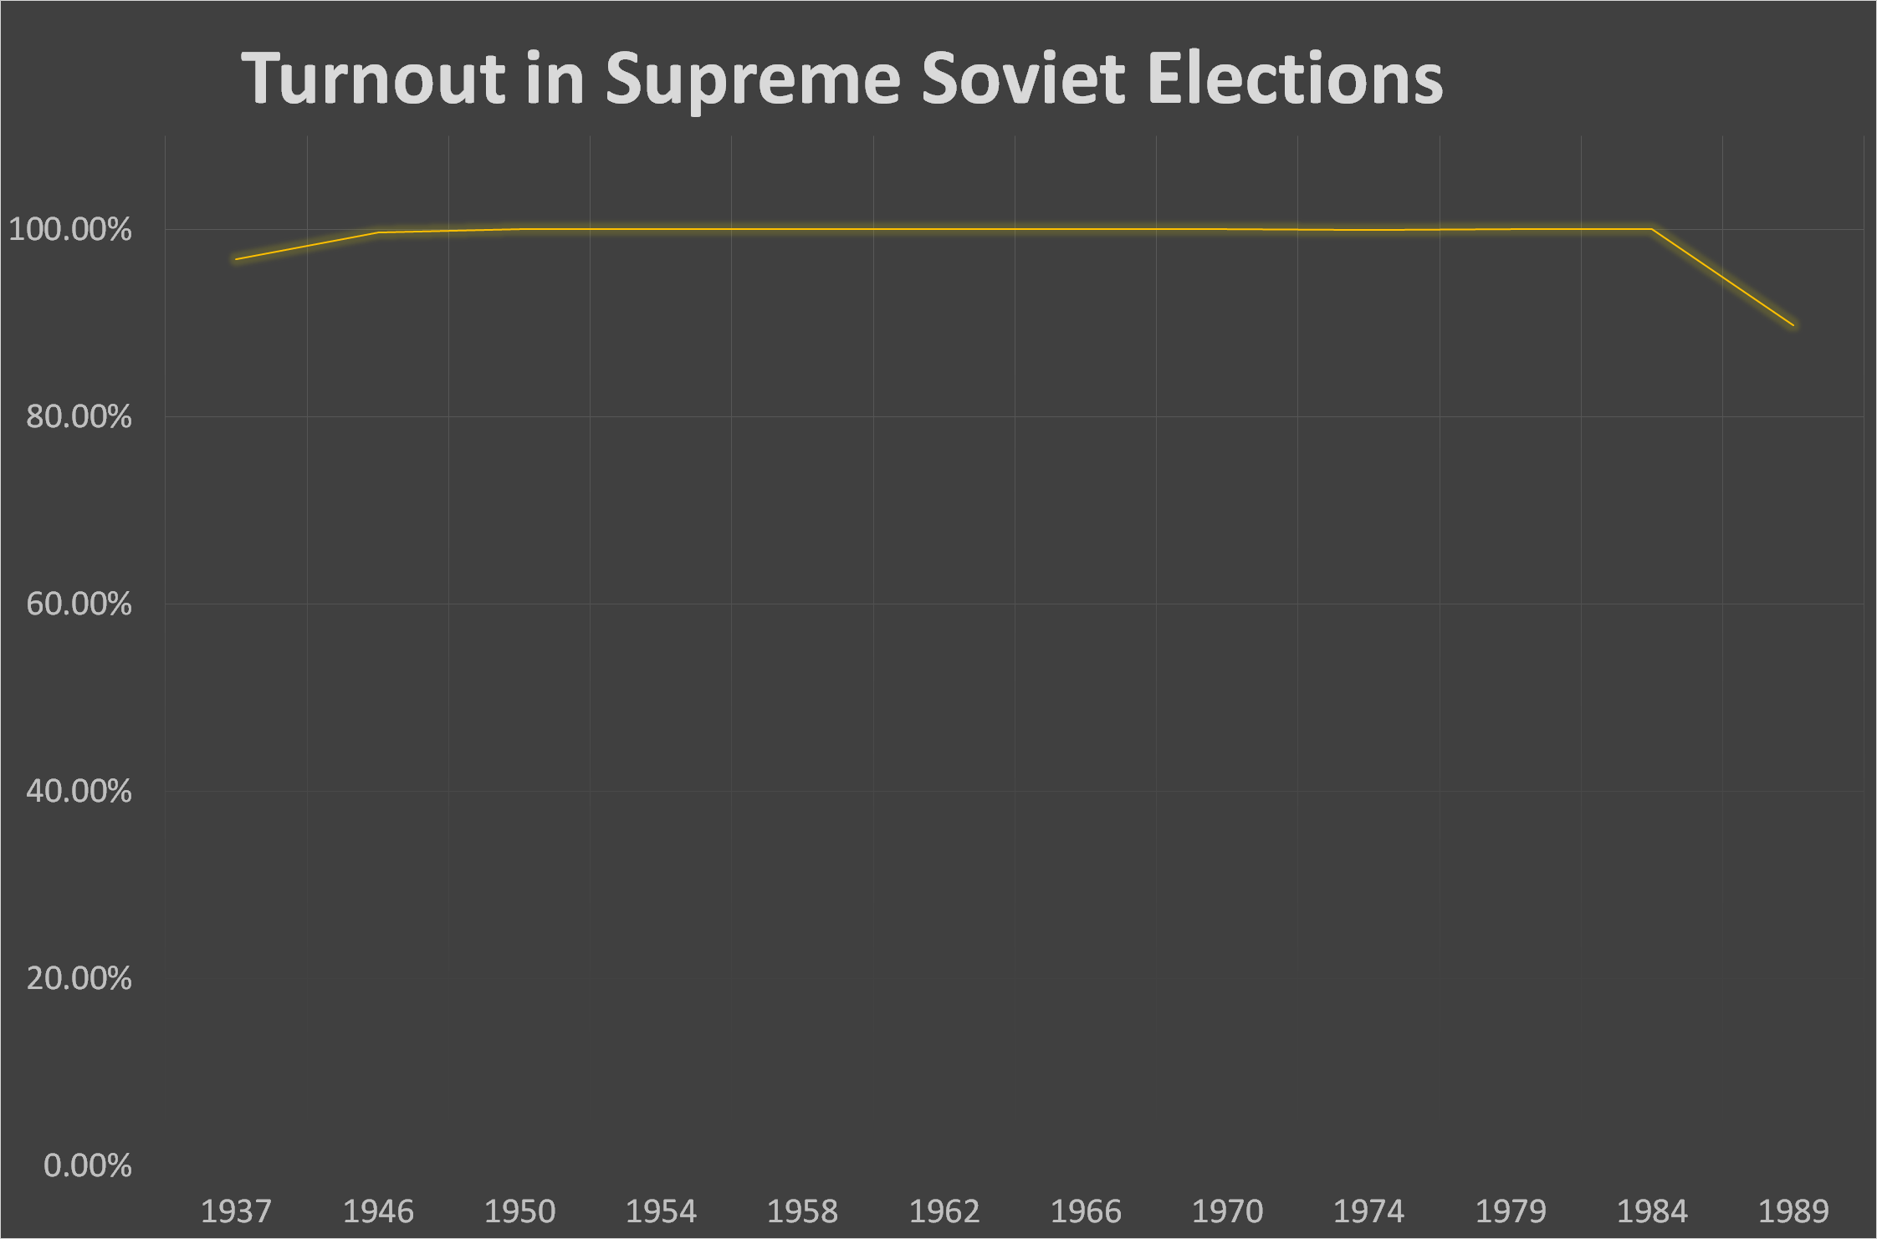

Why Was it so High?
An election turnout of nearly 100% is unfathomable to many of those who have lived only in capitalist countries and are so degraded by wage slavery that they dare not dream of a better world. Similarly, the capitalists have spread and continue to spread all sorts of lies about Soviet power as they do not want workers to realise what they can do without them. They would claim that the figures are fabricated, or that people were forced to vote by the government. Neither of these claims is true as even anti-communist scholars are forced to acknowledge:
“It should be remembered that the usual 99.9% turnout at Soviet elections is not due to formal compulsion, but to a combination of sense of duty and social pressure.” - Everett M. Jacobs, Soviet local elections: What they are, and what they are not [10].
To examine why turnout was so high, it is necessary to briefly explain what Soviets are. Soviets (meaning workers’ councils in English) were bodies initially formed by workers in factories and played a leading role in coordinating strike action and fighting for the political demands of workers, however, they would also later be formed by and represent conscripted soldiers and peasants. The network of Soviets in structure resembled many other democratic working-class organisations worldwide.
At the local level, the Soviets were directly elected. At the national level, the supreme authority was a Congress comprising delegates from all local Soviets. An Executive Committee was elected by the Congress to coordinate the work of the Soviets between sessions and implement general instructions [11]. The Soviet State and its Union Treaty was founded and signed by a Congress of the various Soviets of the former Russian Empire.
Crucially Soviet Power meant political disenfranchisement for the capitalists, landowners and their lackeys as they had lost the right to vote. For the vast majority of the Soviet population (regardless of their nationality, ethnicity or sex) – the workers, the soldiers, the peasants and the working intelligentsia - there was an unprecedented realisation of actual democracy: revolutionary democracy.
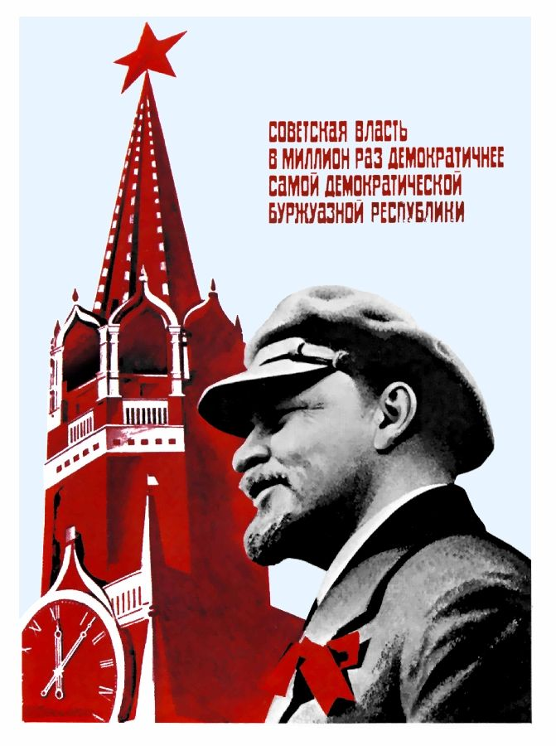
“Soviet power is a million times more democratic than the most democratic bourgeois republic.” - Lenin
So, with this in mind, we can delve into a number of the mechanisms of Soviet Democracy that continued to ensure high voter turnout.
Firstly, all candidates had to be nominated by a labour collective. Even Brezhnev, for example, in order to be nominated as a candidate for the Supreme Soviet, had to address labour collectives, listen to their concerns, and receive orders from them.
Secondly, extensive efforts were made to inform and mobilise citizens to participate in the electoral process. Large posters were displayed, notifications were sent by mail multiple times, and communist agitators visited households to ensure that everyone knew when and where to vote.
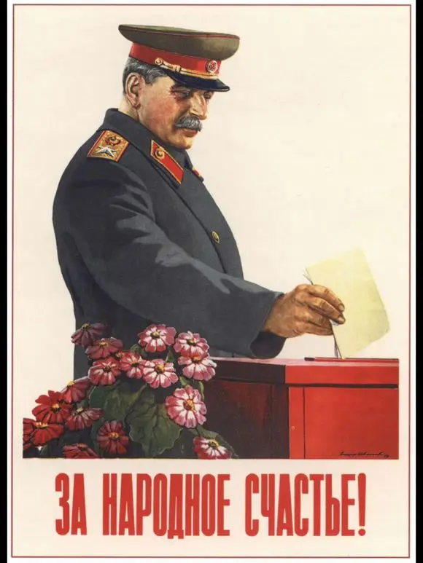
“[Vote] for the Peoples’ Happiness!”
Thirdly, the inclusivity of the electoral process contributed to high turnout. Voters had the option to cross out all proposed candidates and write in their own choices, without their ballot being considered spoiled. The will of the people is more important than bureaucracy.
Additionally, the electorate had the right to recall deputies if they were not satisfied with their performance. For example, in 1931, 10.1% of all deputies were recalled from the village councils, and in 1932 the figure was 17.0%. Sometimes this could be much higher in specific regions – in the Leningrad region it reached 59%. The most common reason for recall in those years was “inactivity” (79.8% of cases), however being a “class alien element” or “enemy of the people” (3.3% of cases) and “distorting Marxism-Leninism” (15.5% of cases) were also reasons [12].
Sometimes, however, there were cases when residents of a household agreed and refused to go to the polls, for example, until their house was completely renovated. This was an emergency for the Soviet government. Such cases were reported to the very highest organs of Soviet Power. The residents' demands would normally be fulfilled immediately. As a result, even today in former Soviet countries you can still sometimes hear from older people that they will not go to the polls because this and that has not been done.
As for why most people voted for the “Unbreakable Bloc of Communists and Non-Party People” without crossing out names or writing in their own candidates, this can be explained by the political consciousness of the USSR. The Communist Party was deeply ingrained in Soviet society, and its policies and ideology of Marxism-Leninism were seen by most Soviet people as aligned with the interests of the working class. Additionally, the non-party members included individuals who were approved by labour collectives and deemed capable of representing the people effectively. Therefore, many voters likely felt that the candidates presented by the "Unbreakable Bloc" adequately represented their interests and concerns, leading to their support in elections.

What can we learn
As we have demonstrated, democracy is not some absolute ideal to aspire to, rather it is something tangible. Nor is it something that exists above or outside of society, but something intricately interwoven inside of it. As a result, democracy only exists concretely for a certain class – the ruling class. The legitimacy and popularity of the elections mean the legitimacy not only of the entire existing socio-political system but also of the ideological course and policies of the ruling class.
Democracy in capitalist countries serves the interest of the capitalist class, and despite their best efforts in most countries around the world, they have alienated a large chunk of the workers. So long as capital exists, the irreconcilable contradiction between capital and labour also exists, as the former can only exist by the exploitation of the latter. Democracy under capitalism is in reality the dictatorship of the interests of capital.
Under socialism, democracy is for and by the workers – a dictatorship of the interests of the proletariat. As such it involves the broad masses of the workers and working people. Many of the steps which the USSR took, democratic when considered from the point of view of the vast majority of the people, were sheer outrages to the owners of property, against whom such measures were taken. And this piece is merely scratching the surface of the merits and features of Soviet democracy and does not touch on the role of Trade Unions (98% of Soviet workers were unionised in 1977 [13]) and other bodies within Soviet society (like women’s organisations), that allowed Soviet workers to have a say within their workplace and all other areas of their life.
It may seem to some like we are excessive in our praise of Soviet democracy given its ultimate fate, however, this is untrue. We have stuck to largely quantifiable or otherwise demonstrable facts, as it is important to have an accurate assessment of Soviet democracy in order to truly realise why and how it was overthrown and to improve it for future socialism.
In order to regain what was lost and build an even better socialist democracy in Britain, the former Soviet Union and the rest of the world, we need Communist Parties to guide the workers along this route. However, in the majority of countries, the work of founding a real Communist Party has yet to be completed. We are involved in this work. Join us if you wish to contribute.
Sources:
[1] https://assets-learning.parliament.uk/uploads/2021/12/Turnout-at-Elections.pdf
[2] https://researchbriefings.files.parliament.uk/documents/CBP-7529/CBP-7529.pdf
[3] https://www.bbc.co.uk/news/uk-politics-65988959
[4] https://www.theguardian.com/politics/2023/sep/13/uk-election-watchdog-issues-damning-verdict-on-voter-id-impact
[5] https://www.ons.gov.uk/peoplepopulationandcommunity/elections/electoralregistration/bulletins/electoralstatisticsforuk/december2021
[6] https://www.electoralcommission.org.uk/research-reports-and-data/our-reports-and-data-past-elections-and-referendums/report-may-2023-local-elections-england
[7] https://www.electoralcommission.org.uk/research-reports-and-data/our-reports-and-data-past-elections-and-referendums/voter-id-may-2023-local-elections-england-interim-analysis
[8] https://blogs.lse.ac.uk/politicsandpolicy/look-beneath-the-vote/
[9] Elections in Europe: A data handbook by Dieter Nohlen & Philip Stöver
[10] https://www.jstor.org/stable/149653
[11] Soviet Democracy by Pat Sloan
[12] https://e-notabene.ru/hr/article_19603.html
[13] Workers' Participation in the Soviet Union by Mick Costello

Original article

