Major Corporations' Response to Trump Tariffs
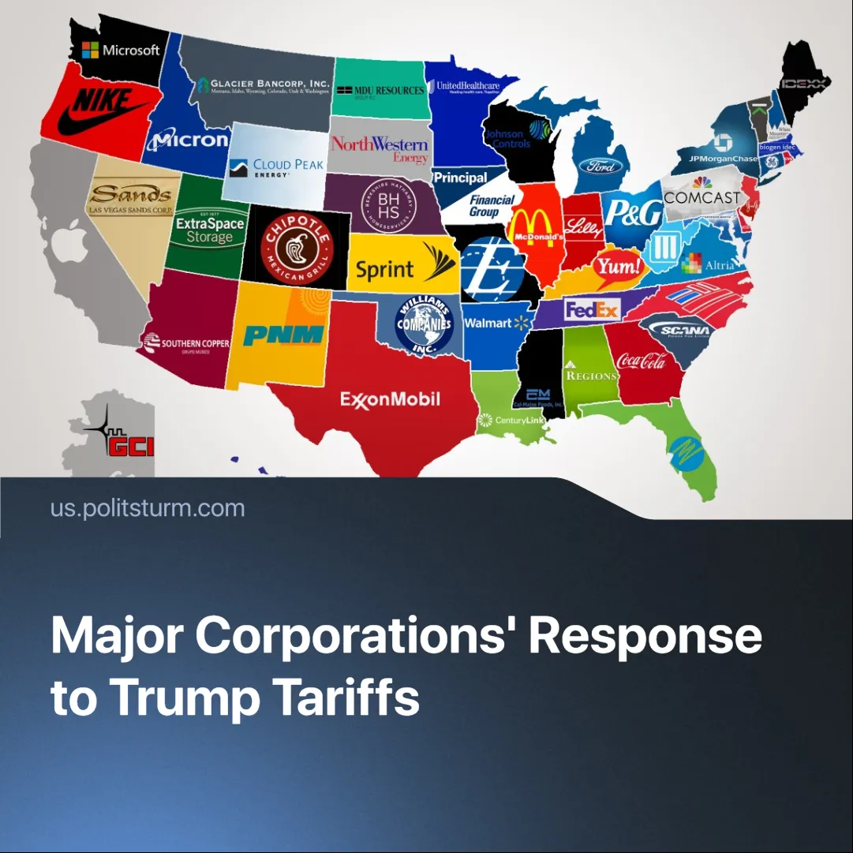

Original article
2025-04-25
2 min read

Major monopolies across global industries are reeling from the effects of Trump’s tariffs, exposing the deepening crisis of imperialism.
Details: Following Trump's announcement of sweeping tariffs on foreign goods-including steel, aluminum, and electric vehicles, major corporations are now reacting to the consequences, and developing strategies in responses.
►Industries across the board are reacting by lobbying for favorable trade policies, restructuring supply chains, cutting costs, making price adjustments, and rapidly reviewing procurement strategies.
➤ CEOs of Walmart and Target stated, “We had a productive meeting with President Trump and look forward to further discussions on trade.” Both warned that “The tariffs will raise prices on imports for American consumers.”
►Prices in the U.S. have increased by an average of 2.3%, triggering heightened stock market volatility. In response, many companies are shifting their supply chains to the U.S. or to countries less impacted by the tariffs.
►Walmart announced it will “maintain flexibility” to invest in lowering prices as tariffs kick in, meaning the price of goods will not be offset up the tariffs. If prices drop below a certain threshold, it may create opportunities for investors to buy stock, hoping for a rebound. Amazon plans to cancel imports from China and increase reliance on third-party sellers, who already account for 60% of the products sold on its platform, while Costco intends to substitute alternatives for tariff-affected goods.
Context: Trump introduced these sweeping tariffs to boost domestic consumption, encouraging Americans to buy U.S.-made products. The move was framed as a counter to foreign tariffs and “unfair trade practices,” intended to protect national security and promote “economic nationalism.”
► While he claims the tariffs defend domestic industries, they have triggered global market instability and widespread backlash from world leaders to everyday people.
► Large corporations now find themselves caught in a contradiction: while they depend on long-term global supply chains, they are increasingly pressured to reshore production to the U.S., which currently lacks the industrial infrastructure to support its protectionist measures.
Important to Know: Capitalists oppose tariffs not out of concern for ordinary people, but because global market stability is essential for the smooth flow and maximization of profits under capitalism. In practice, tariff disruptions expose the inherent instability at the core of the capitalist system of accumulation.
► The tariffs conflict reveals deeper contradictions between national and international capitalists' interests during the imperialist stage of capitalism. U.S. manufacturing industries such as steel and semiconductors have emerged as the primary beneficiaries, while sectors like electronics and heavy machinery continue to struggle.
► Major corporations are lobbying both Republican and Democratic parties, strategically shifting between cooperation and confrontation to safeguard their economic interests. The Democrats’ responses vary: some denounce Trump’s chaotic tariffs, while others—including the supposedly “progressive” Bernie Sanders—support tariffs under the banner of “fair trade.”
► These rising tensions underscore the growing instability of the global capitalist system and signal an impending redivision of the world in pursuit of expanded monopolization by competing imperialist blocs
Conclusion: Major corporations are doing everything in their power to mitigate profit losses. As monopolistic competition intensifies, small and medium-sized businesses will bear the brunt—many pushed to the brink of bankruptcy or collapsing altogether, dragging their owners into the ranks of the working class. Meanwhile, workers will face the harshest consequences through soaring inflation. deepening economic instability, and potential conscription into military conflicts, sacrificed for the profits of capitalists.

Original article

