Corporate Universities Scam Thousands
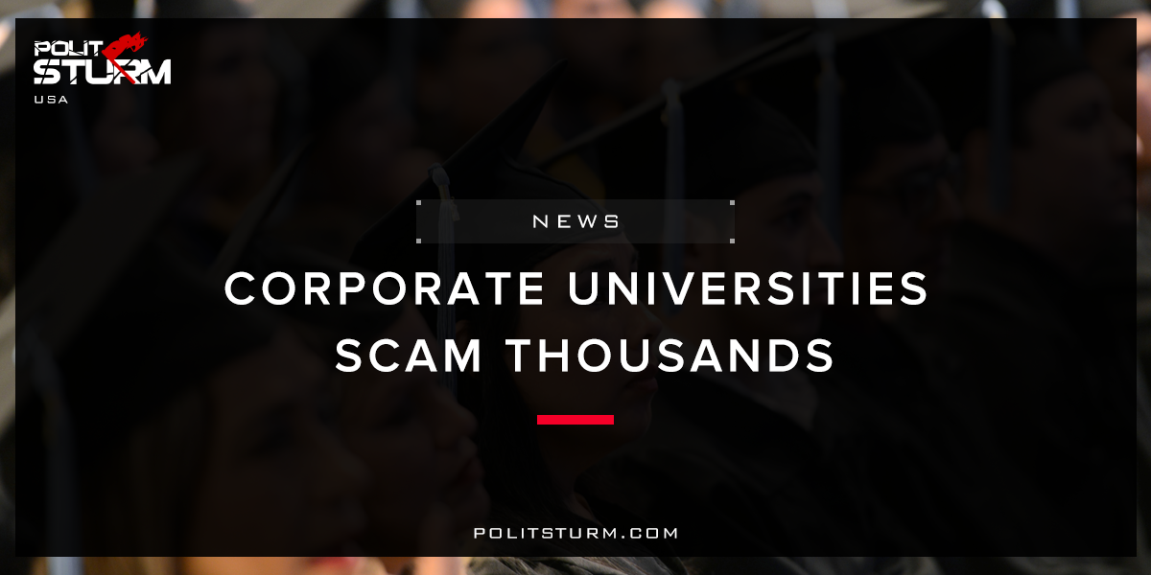

Original article
2017-11-22
2 min read

Amy Kennedy-Palma was a single mother working as the office manager for an ATM installation company in 2012 when she decided to go back to school.
“There wasn’t a whole lot of room for advancement, and of course wanting to look out for the future of my son, I wanted to go back to school,” she said.
Kennedy-Palma researched programs at the local community college in Battle Ground, Washington, located just 35 minutes north of Portland, as well as programs at Washington State University.
“What was really difficult for me at the time,” she says, “being a working single parent, I took all the overtime I could possibly get. I needed to work and therefore needed a program with flexible hours because I couldn’t sacrifice my paycheck.”
That’s exactly why Everest College, a for-profit school owned by Corinthian Colleges, appealed to Kennedy-Palma. It allowed students to complete the bulk of their work online, requiring students to be present in classes for only four hours each week.
Little did she know then that five years later she would be entwined, along with tens of thousands of other student loan borrowers like her, in one of the biggest scams in the history of higher education – one that saddled students with hundreds of millions of dollars of debt and one that elevated obscure higher education regulations, like borrower defense-to-repayment, to national prominence.
Politsturm: The American education system is exactly what you get when you allow capital to exist alongside institutional education. The purpose is no longer to educate the populace and do what is best for the community. The purpose is to maximize profits for the private owners of capital. Workers and students such as Amy Kennedy-Palmer are just trying to achieve a good life and they are taken advantage of by private companies such as Corinthian Colleges Inc. . During its operative years the corporate elites and stockholders benefitted enormously until the company went bankrupt in 2015.
When education is made a commodity, investments flow directly into the educational institutions. For profit companies hire faculty, admit students, and teach classes.In order to achieve a profit, the company spends a massive amount in marketing towards students who are the customers. For every dollar the company spent in 2012 on “educational services”, it spent 40 cents on marketing. The company knowingly targeted low-income, single-parents to sell their “educational service” and realize a profit.When the school went bankrupt those same vulnerable individuals face the negative consequences of a worthless degree and insurmountable debt. This thievery is how the capitalist economic system operates. The bourgeois exploiters get rich off fraud while the workers and students are robbed blind.
Sources: 1, 2

Original article

