Corporate America Lobbies for Tax Cuts
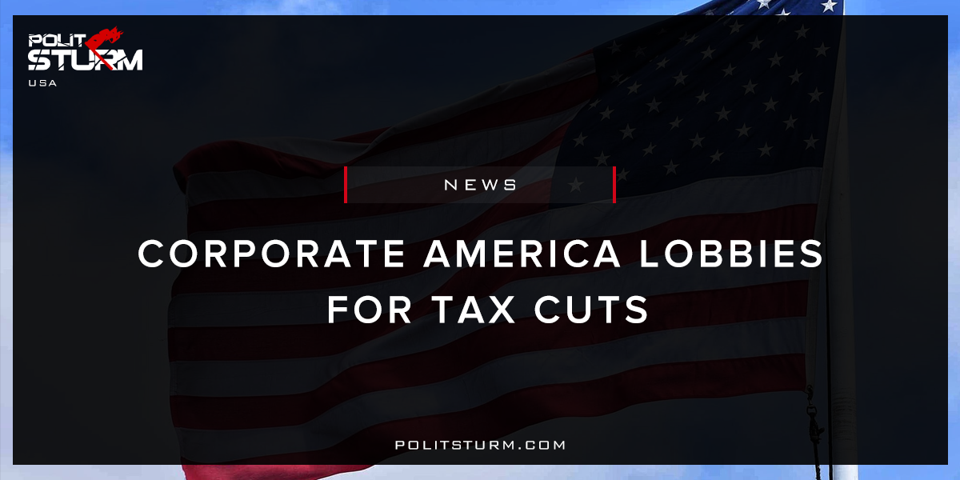

Original article
2017-12-16
3 min read

A recent report from Public Citizen estimates that more than half of all Washington lobbyists have become involved in the recent tax debate. 6,243 of Washington’s 11,000 lobbyists have been listed in lobbying disclosure forms for the first three quarters of 2017 to be working on “tax” issues, an equivalence of 11 lobbyists for every congressman.
26 different sectors of the economy have hired at least 150 lobbyists each to work on the new tax law with pharmaceuticals taking on the most (653). Most surprisingly, five individual corporations have hired more than 15 entire lobbying firms in Washington D.C. to work on the pending tax reforms. They are Comcast (23), Anheuser-Busch (19), Verizon Communications (17), Microsoft (16), and Altria Group (15).
Also mentioned in the report are “44 Trump/Pence-connected lobbyists” working on Tax Issues in 2017, most of whom worked either on Donald Trump’s election campaign or transition team. Citizen Vox, who have reported on the lobbying efforts, referred to the tax bill as “the buffet that keeps Washington’s swamp creatures fed.”
Four corporations won considerable concessions through lobbying the government. Comcast, and their 90 Washington lobbyists, for example, were successful in preserving the advertising tax deduction for businesses, a key source of revenue for cable companies. For Microsoft, who hired 81 lobbyists, they were able to make sure both House and Senate bills retained the R&D tax credit for expenses on innovation. NextEra Energy, who pay little in federal taxes due to the tax credits acquisitioned for renewable energy, succeeded in having tax credits written into the House and Senate bills. Finally, the Altria Group, who produce Marlboro cigarettes and certain wine brands, were able to bring help bring down the excise taxes on beer, wine, and liquor by about 16%.
Politsturm: Political lobbying is a key form of power in the hands of the capitalist class. Starting in the 1970s, business elite began mounting a full frontal assault on the democratic gains from the 30s and 60s by doing away with the New Deal coalition and electing reactionaries to the country’s highest offices. Supreme Court cases such as Buckley vs. Valeo (1976), Citizens United (2010), and McCutcheon vs. FEC (2014) have opened the floodgates to corporate money leading to record-breaking levels of political donations during the elections of the last several decades. Lobbying essentially amounts to a form of legal bribery, in which money is donated to a political campaign in return for political favors or access to the administration in the form of meetings or appointees once that politician comes into office. Large capitalists consider these donations to be a small price to pay for the profits that come from potential government contracts, tax reductions, bailouts, tariff changes, and protection for capital at home and abroad. As for politicians, the choice between accepting and rejecting donations from big business is an easy one. In the majority of elections in contemporary American politics, the side with the most money usually goes on to be the winner.
The recent rush by capitalists of all forms to address the upcoming tax bill shows just how capitalists from all sectors of the economy will come together as a class to address an issue in their common interest. As for the working class, the immense amount of lobbying acts as a way to act as a counterweight to the democratic will of the people, allowing capital an enormous amount of sway in the political process. If the most recent Gallup poll is to believed, 67% of Americans believe that corporations pay too little in taxes and only a minority of Americans approve of the Republican Party’s tax overhaul (with some polls as low as 25%), yet despite that, the corporate tax rate is planned to be lowered from 35% from 20% and while taxes are in fact raised on the lowest 40% of Americans. The bourgeois media has been running overtime to define the bill with ambiguous labels, such as “tax reforms” and “tax cuts” while focusing on the ‘victory’ for Trump and the GOP and ignoring the disastrous effects the bill will have for the working-class. The tax bill is an obvious win for capital. Not only will the largest firms gain from lower tax rates, but this bill, with the expected $10 trillion to be added to the national deficit over the next ten years, sets up the elite for further gains in the future. Assuming calculations are correct and the budgetary pitfall cuts into the funds of social services for the people, it will become much easier for the bourgeois class to justify cutting those programs altogether, claiming that they have failed the American people. This is exactly what class struggle is. American workers should be under no illusions that we live in a “democratic” society, but instead, a “democracy for the rich” or as Marx called it “bourgeois democracy”.
Sources: 1, 2, 3, 4

Original article

