Cornforth on the US
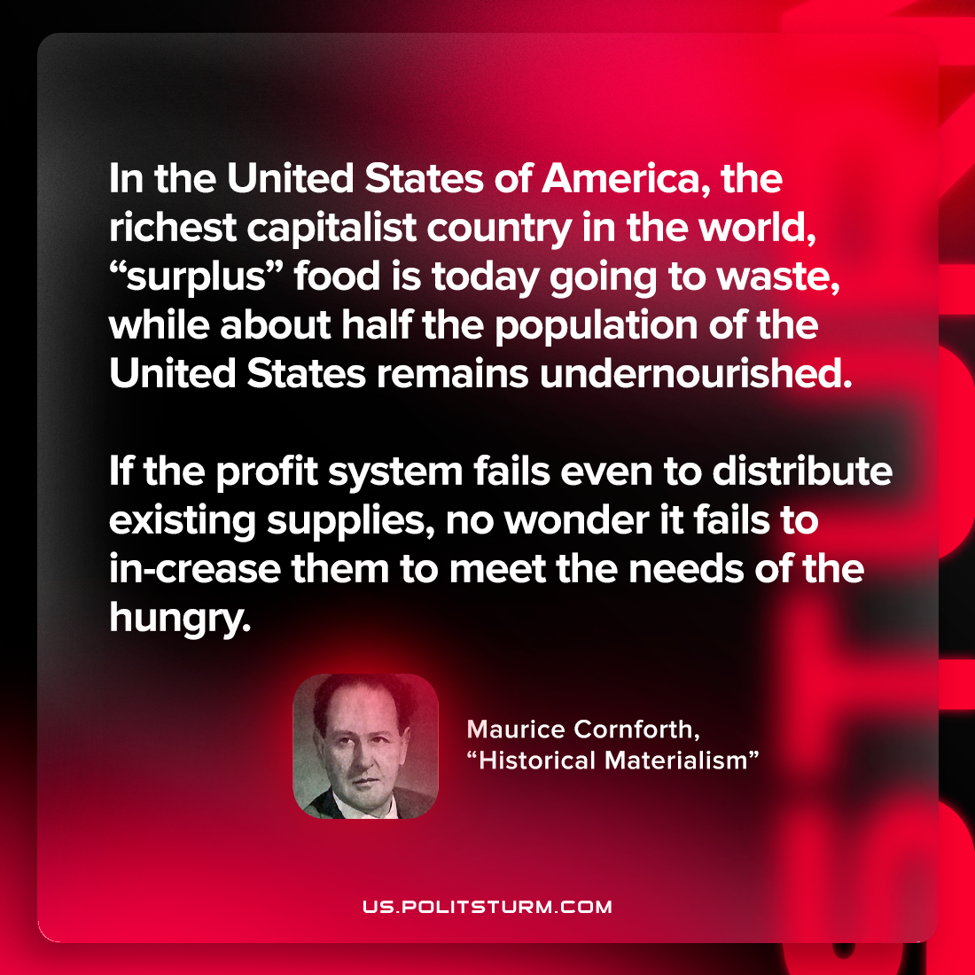

Original article
2022-11-12

In the United States of America, the richest capitalist country in the world, “surplus” food is today going to waste, while about half the population of the United States remains undernourished. If the profit system fails even to distribute existing supplies, no wonder it fails to in-crease them to meet the needs of the hungry.

Maurice Cornforth, “Historical Materialism”

Original article

