Cornforth on Socialism and the Remnants of Capitalism in Minds
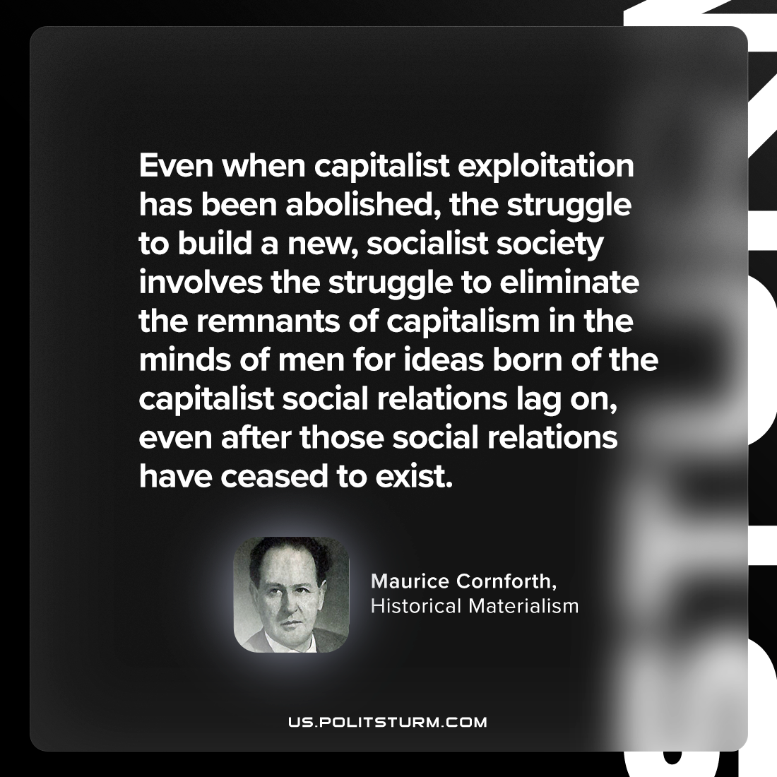

Original article
2023-09-02

"Even when capitalist exploitation has been abolished, the struggle to build a new, socialist society involves the struggle to eliminate the remnants of capitalism in the minds of men for ideas born of the capitalist social relations lag on, even after those social relations have ceased to exist."
Maurice Cornforth, Historical Materialism

Original article

