Cornforth on Monopolies
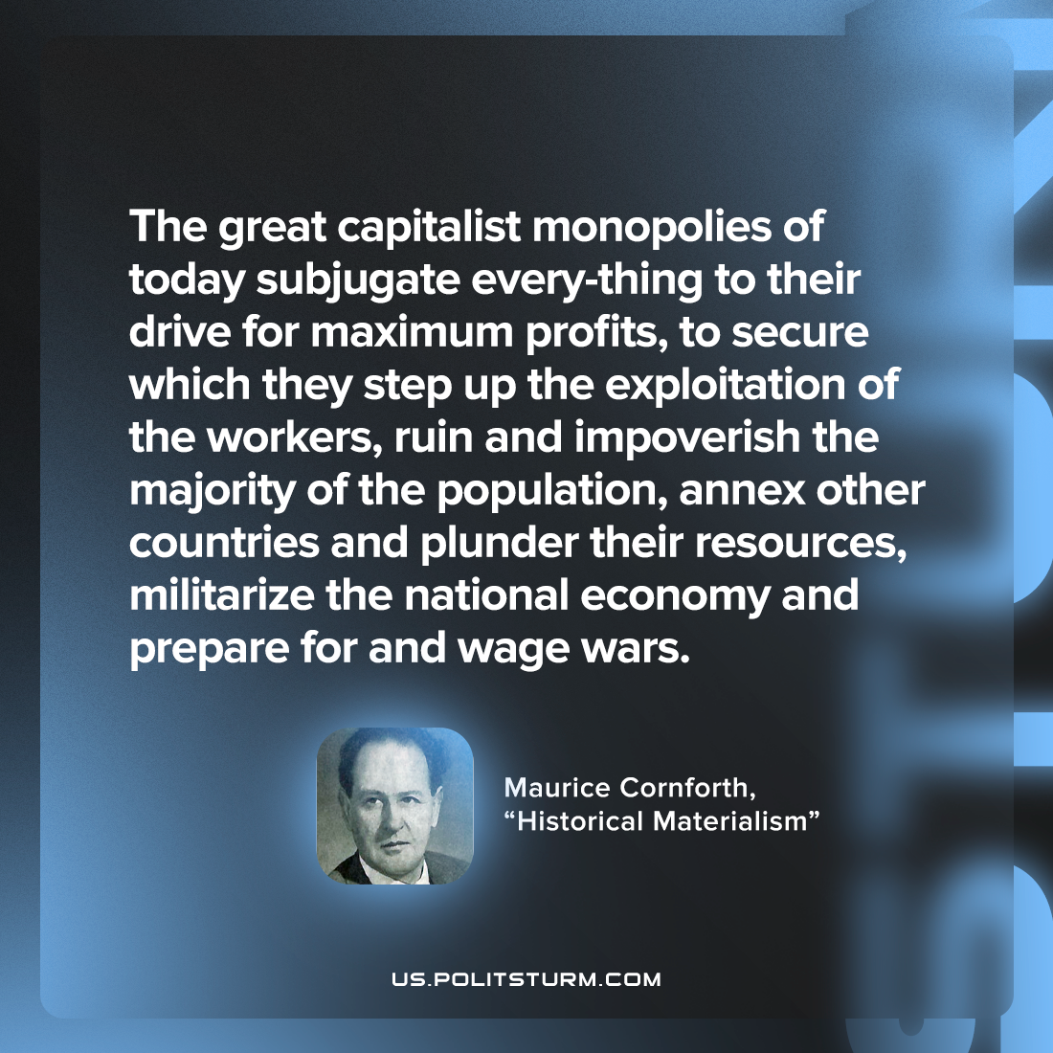

Original article
2022-11-10

The great capitalist monopolies of today subjugate every-thing to their drive for maximum profits, to secure which they step up the exploitation of the workers, ruin and impoverish the majority of the population, annex other countries and plunder their resources, militarize the national economy and prepare for and wage wars.

Maurice Cornforth, “Historical Materialism”

Original article

