Consumerism: Marxist Point of View
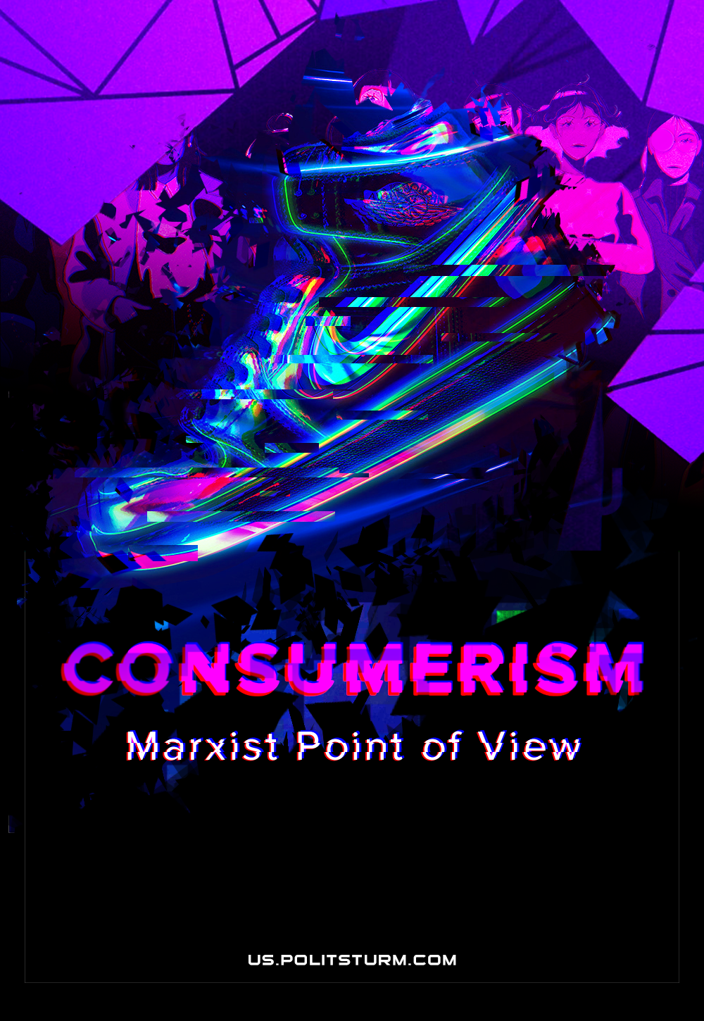

Original article
2021-08-09
13 min read

Today the concept of the so-called “consumer society” is one of the “trump cards” of the capitalist ideology in the struggle against the revolutionary movement of the working class.
The essence of this “truly remarkable” idea lies in the fact that technical development, growth of production and consumption of goods are being called “social progress” by the apologists of the theory of “consumption”. They declare that the problem of the well-being of society has been resolved – every citizen has the opportunity to buy a car, or apartment, or a phone. Of course, for this you need to try – take an onerous loan or exhaust yourself utterly at work. But where have you seen that benefits are given to a person free of charge? Eh, it doesn’t work that way.
In short, work hard and you will achieve happiness, for happiness is expressed in the quantity of goods that you are able to acquire. It is very significant that the antipode of the “consumer society” in bourgeois propaganda is usually “communism” with its sinister manifestations in the form of “total unification” and “equal poverty” as symbols of misfortune and consumer stalemate. It is also clear that the essence of capitalist exploitation remains outside the framework of this theory as something insignificant.
Note that in the interpretation of the bourgeois loudmouths, the concept of “consumer society” has some negative features. For example, the multiplication of goods leads to the loss of the attractiveness of spiritual values; turns people into some kind of robotic automatons, the main content of life is well-fed idleness, mechanized comfort and other golden tinsel in the form of porcelain elephants and golden toilets. “But what can you do”, these clever gentlemen tell us, “such is the inexorable movement of progress”; the triumph of consumer psychology is a natural result of the technological development of production.

What really lies at the heart of the cult of things and that terrible ideological superstructure that towers over this cult?
The real reasons for the emergence and development of consumer psychology are revealed by Marxism-Leninism. It indicates two reasons: alienated labor and commodity fetishism.
Dialectically, alienation is not just the removal of a person from any activity or the results of this activity (the philistine understanding of alienation), but the transformation of activity or its results into an independent force dominating over a person and hostile to him.
The source of labor alienation is the isolation of individuals in production based on private property and the social division of labor. This entails the growth of individualistic sentiments, the transformation of the individual into an object of exploitation and manipulation by the ruling classes. The working person begins to feel indifference to the results of labor activity, because they completely lack methods of control over the conditions, means and products of their own labor. Labor duty under capitalism acts for a person not just as a senseless waste of vital forces, but as a real punishment, a painful burden that they are forced to drag in order not to simply starve to death. In these conditions, idleness becomes a synonym for happiness and freedom, and consumption becomes the meaning of life.
Another root of consumer psychology and ideology is commodity fetishism – the domination of things over people. The source of this phenomenon is the market – the god and the king of modern times, to which all production, all the vital activity of the producers is subordinated. But in the market it is not people who collide with each other, but the goods they produce. Thus, relations between people subjectively act as relations between goods that acquire independence in the course of the process of spontaneous market exchange. On the one hand, all this gives rise to the “personification of things”, when social functions are attributed to certain goods. Today, for example, technology is actively being fetishized, which, it says, is in itself capable of developing and transforming public life. On the other hand, the “reification of the personality” is generated, when a person with this or that thing in their hands is allegedly transferred to the properties that this thing possesses.
Spontaneously arising in the era of development of capitalist production, commodity fetishism very quickly replaced in the public consciousness the once all-powerful natural fetishism, which considered the relationship between things as a hierarchical relationship between people and corresponded to the natural way of running the economy. The transition of capitalism from the stage of free competition to the monopoly stage in the late 19th and early 20th centuries gave a powerful impetus to the spread of this phenomenon among the masses. For it was at this moment that the question of expanding markets and the forced pumping of goods into already developed markets arose before monopoly capital. The era of aggressive advertising began, imposing fetishistic ideas about goods and services on the masses.
Advertising has become a veritable lifeline for decaying capitalism. Primarily because it promoted capitalist exploitation by creating strong emotional incentives for people to acquire things. In this case, the “reification of the personality” has become a huge help: it is thanks to advertising that one or another thing is credited with the ability to convey to owners a wide variety of properties, ranging from social weight to a feeling of happiness.
The other side of the development of the consumer ideology and psychology imposed by the market was the maintenance of the political and ideological domination of the bourgeoisie, the channeling of the revolutionary energy of the working class into the safe channel of the race for certain material values.
Together with capitalist advertising, bourgeois culture also makes its contribution, turned by the ruling class into a separate economic branch. No less effectively, it forges a consumer person, fills his head with ideas that contribute to the preservation of bourgeois hegemony: obscurantism and reactionary idealism, the cult of violence and voluntarism, egoism and principled political passivity, escapism and disdain for work.

The illusion of fighting consumerism
Of course, there are people who, in a fit of despair, shake their fists and curse at the propaganda machine of monopoly capital. As if by mere suggestion, capital was able to turn living people into insane machines for the consumption of various kinds of goods. Everything, everything is forgotten, – these blessed ones get excited, – culture has been reduced to the level of obscene boulevardism and veiled bargaining. Cash prizes are everywhere. Everything is sold and everything is bought. The plastic world has won.
In the ranks of these latter words, there are very many of the worst reactionaries. Those who, following Spengler or Guénon, repeat about the crisis of the modern world and the need to return to the “bright” feudal past, where honor, courage and duty were held in high esteem, where people of noble blood ruled. It is characteristic that along with the “consumer society” these modern “romantics of the Middle Ages”, feeding from the hands of the most brutalized sectors of the bourgeoisie, equally violently castigating socialism with its “herd happiness”, acting as a “green pasture, which would provide food and convenience life for everyone ”(Nietzsche). In both cases, gentlemen reactionaries see only the degeneration of humankind, the reduction of people to the level of animals with limited, purely material desires and needs. The only way out of this vicious circle is to restore the “natural” hierarchy, when some (aristocrats / superhumans / creators / legionnaires, etc.) will enjoy a life filled with high spirituality and spin the wheel of history, while others (rabble) will provide for the elect, this is truly an enviable existence.
A similar course is pursued by all kinds of madmen, fighters for the “purity” of any faith, demanding, for the sake of improving the life of society, a return “back” to the days of obscurantism, feudal tyranny and slave labor.
Another, much more common variation of the “fight against the consumer society” is the various types of “great refusal”/ All sorts of beatniks, hippies, “modern artists”, Buddhists, Rastamans and other similar informal public that loudly and pathetically rattle about breaking with “consumer slavery”, posing as free from the propaganda of monopolies. Sometimes there is even a certain emotion – that’s after all, in our obscene capitalist brothel there are saints. The Wall Street bigwigs are scared to death.
In reality such movements do not go beyond the framework of bourgeois ideology. Judge for yourself: gentlemen rebels, who refuse the consumer cult, refuse, in fact, only from acquiring things, seeing in them (and this must be emphasized especially) some fetters that captivated the free human spirit. Before us, therefore, is a typical example of the “personification of things.” It is to things, objects created by people, that the foolish “nonconformists” attribute some ability to mutilate the personality. It is not capitalist exploitation that is to blame, generating a consumer attitude towards man and nature, striving for profit at any cost, destroying the personality, no. The items are to blame. And it is on the objects that all the fury of these Luddites of the XXI century is directed – whether it is the burning of expensive cars by raging youths with anarchist flags, or walking in rags in protest against the “consumer society”.
But the stupidity and senselessness of dealing with things as such is not so bad. Unable to get out of the influence of bourgeois ideology, pretended “fighters against the consumption system” abandon some items of the commodity fetishist cult and … immediately fill their pockets with others. Let’s remember the notorious hippies. What in fact differed in their wonderful rags painted in all colors of the rainbow (a kind of uniform) from the advertised suits and dresses produced by some fashion brands? Yes, they essentially did not differ in anything. The same cult, the same obligation to wear, the same “reification”, the same lust and emotional dependence arising from commodity fetishism. It is not surprising, therefore, that over and over again the market responds to “revolutionary” tendencies and begins to churn out rags, fetish paraphernalia and T-shirts with Che Guevara for all kinds of “fighters against the system,” like hippies, punks, new leftists, and so on.
In addition to all this, the violent denial of consumerism leads these funny characters to the denial of production as well. In their opinion, material production is allegedly the source of an endless stream of things pouring down on a person. The result of this is the praise of social parasitism, unworkable life, idleness, elevated to a principle. Such sitting on the neck of society is presented as “independence” from the capitalist system of alienated and forced labor.
In the end, under the guise of “fighting the consumer society” we have … the same scheme of the “consumer society”, which is slightly embellished with spectacular verbal radicalism, so beloved by the hysterical petty bourgeoisie. It is not surprising that such a “struggle” does not bring any real harm either to capitalism or to the “consumer society”. On the contrary, without realizing this, the dashing “rebels” only strengthen the bourgeois outlook on the world, only increase, so to speak, the amplitude of the bourgeois ideological scope.

What way out of this sad situation can be offered?
To start with, one needs to point out that consumer ideology and psychology are transitory, temporary. They are not rooted in the human psyche, as the advocates of Freudianism claim; they are not the result of technical or social progress, as religious obscurantists and reactionaries think about it; in fact, they are not just a product of the propaganda of capitalist monopolies, as the left-wing radicals shout about. Consumer ideology and psychology are the product of a certain socio-economic system at a certain stage of development.
The only strictly scientific solution to the problem of “consumer society” is the transition to a more advanced socio-economic system, to the socialization of production. For only socialist production can eliminate the economic base on which consumer psychology and ideology grows in all its rich manifestations.
Firstly, socialized production eliminates the economic competition of individual producers with each other and attracts the masses themselves to solving the problems of production and distribution of products. Thus, both individualism, which is the basis of the capitalist system of “private initiative”, and the alienation of labor are eliminated.
Secondly, socialist production is conducted on a planned scientific basis, thereby undermining the most important basis for the existence of commodity fetishism. The mysterious and unknowable power of market anarchy is becoming a thing of the past. in endowing things with supernatural abilities of self-expansion or accumulation of value.
Thirdly, socialist production is conducted not with the aim of obtaining maximum profit, but with the aim of constantly improving the well-being of the working people. This excludes from public life aggressive and all-encompassing advertising that imposes on the masses fetishistic, anti-scientific ideas about things and the place of things in human life.
Fourthly, socialist production is interested in constantly raising the ideological, moral and cultural level of the working people, in overcoming the division of mental and physical labor. Thanks to this, not only the remnants of the former capitalist worldview will become a thing of the past; the working masses themselves, who have realized the interests of socialized production, will not allow a rollback to consumer psychology, lagging other individuals.
It is this path, the path of transition to a higher level of socio-economic relations, that is the only effective method of combating the sickening system of consumerism that disfigures a person.

Original article

