Connolly on the Capitalist Class
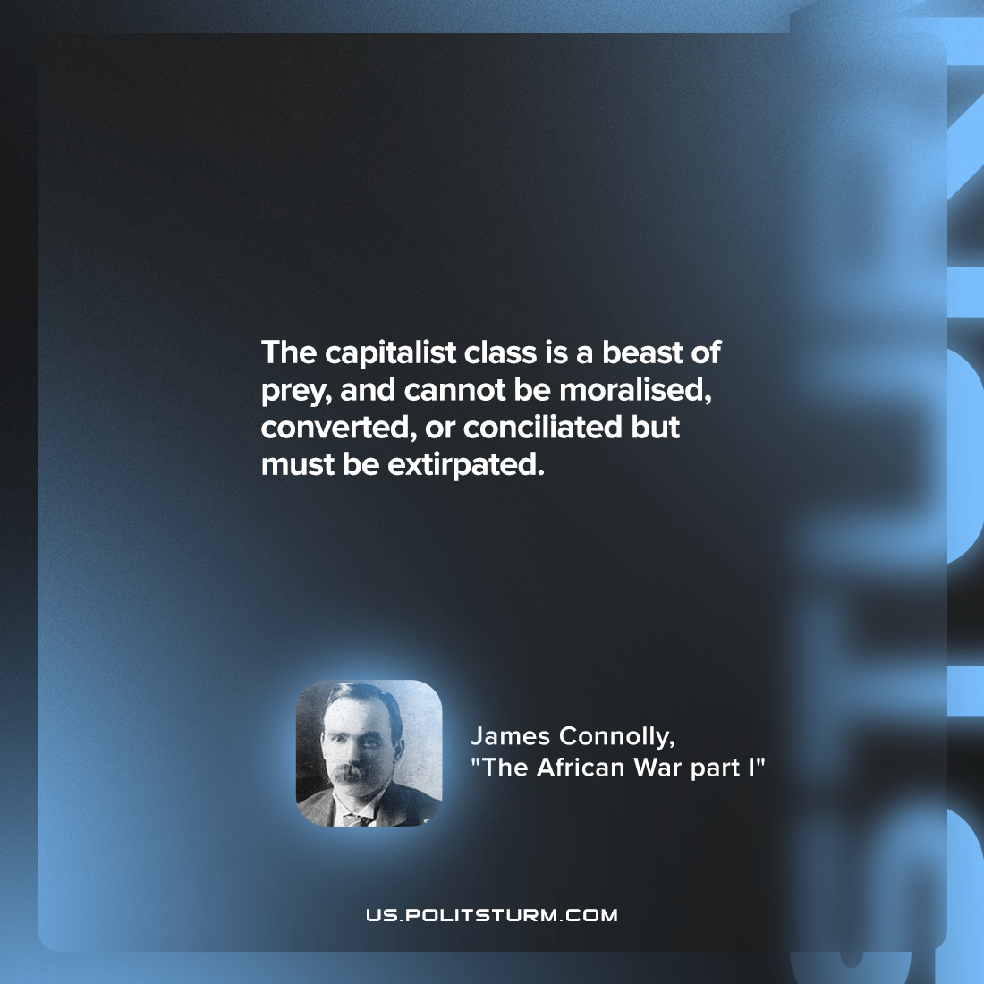

Original article
2022-07-03

The capitalist class is a beast of prey, and cannot be moralised, converted, or conciliated but must be extirpated.

James Connolly, “The African War part I”

Original article

