Connolly on Middle-Class Reformers
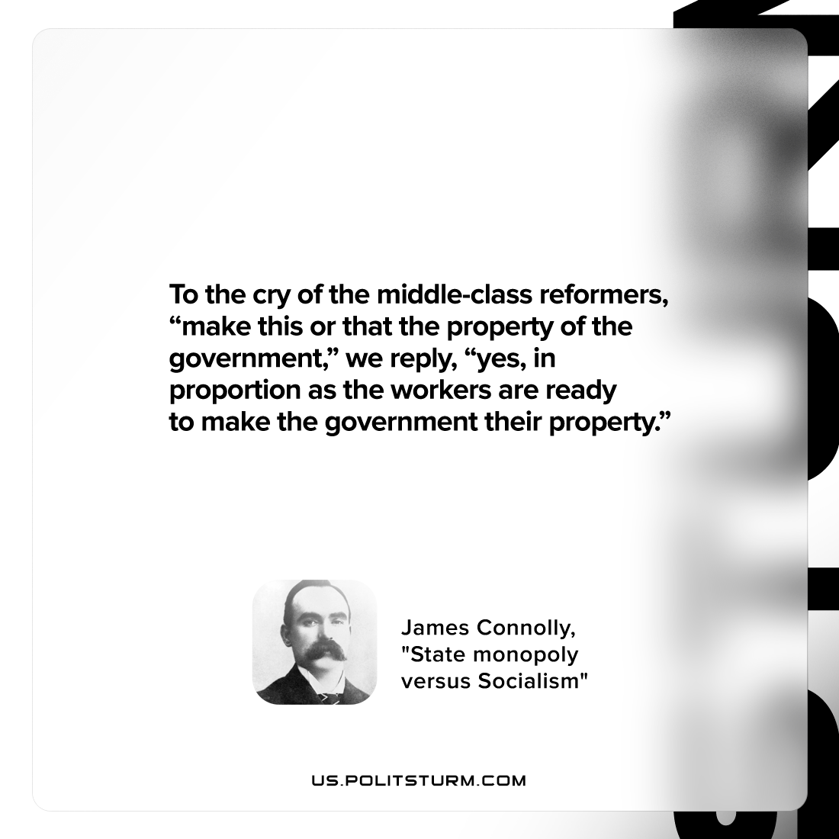

Original article
2022-07-23

To the cry of the middle-class reformers, “make this or that the property of the government,” we reply, “yes, in proportion as the workers are ready to make the government their property.”

James Connolly, “State monopoly versus Socialism”

Original article

