Connolly on Capitalists' Greed
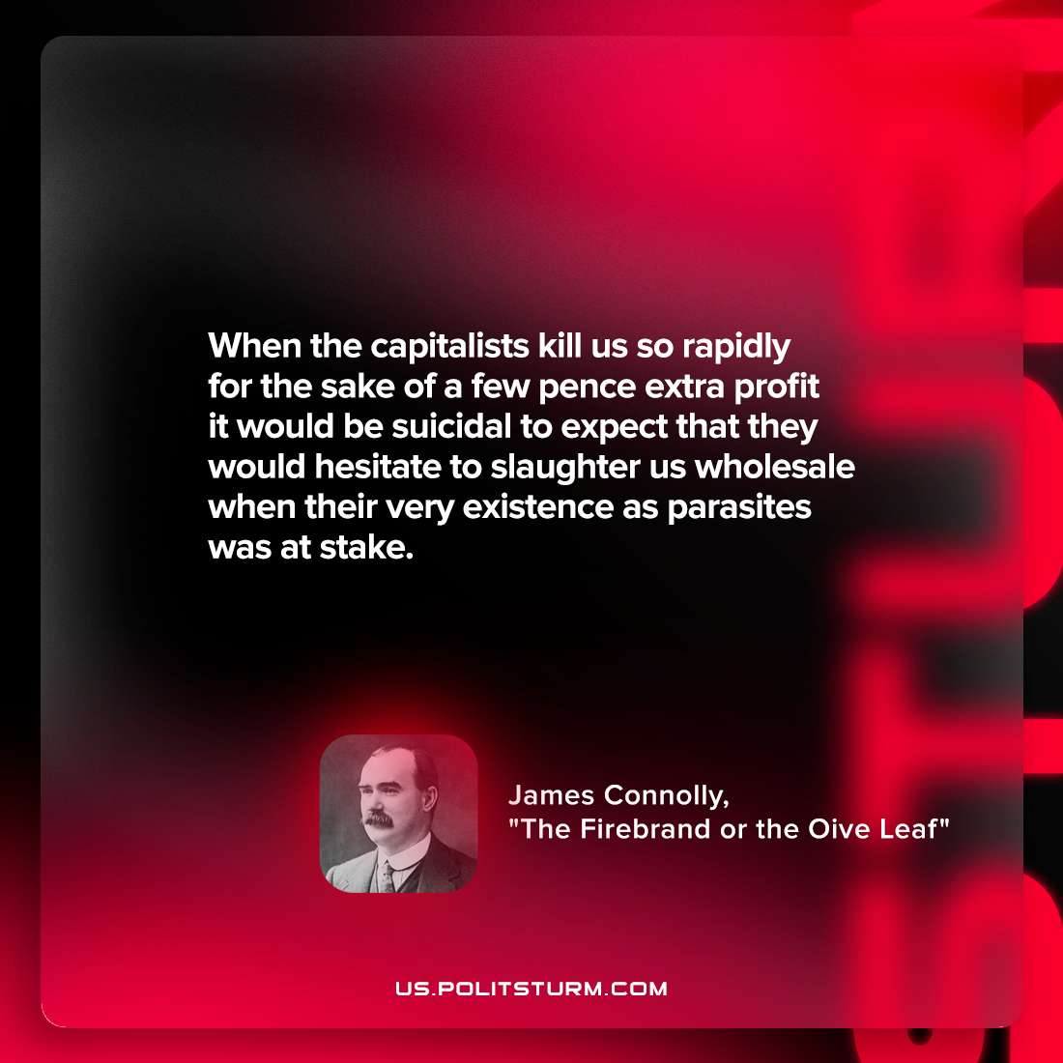

Original article
2022-07-19

When the capitalists kill us so rapidly for the sake of a few pence extra profit it would be suicidal to expect that they would hesitate to slaughter us wholesale when their very existence as parasites was at stake.

James Connolly, “The Firebrand or the Oive Leaf”

Original article

