The 150th Anniversary of the Paris Commune
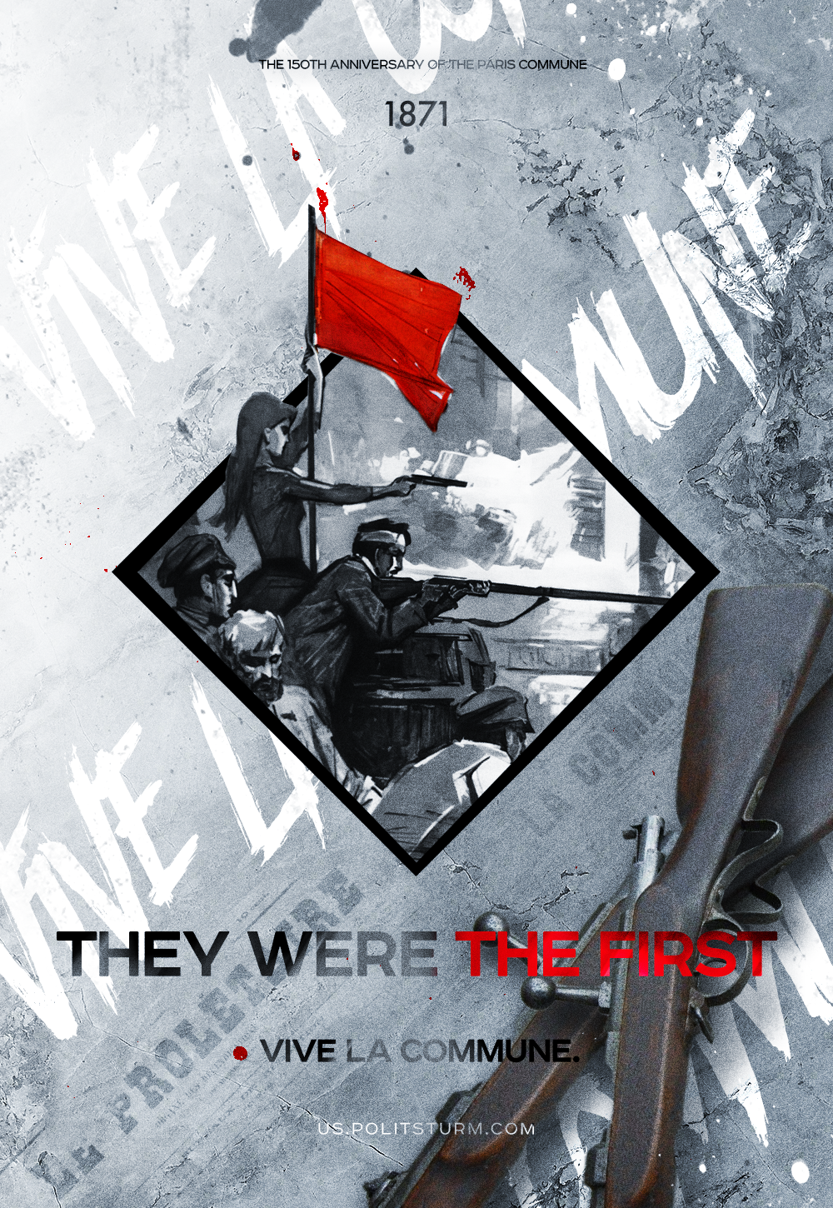

Original article
2021-03-18
3 min read

Even though the Commune lasted only 72 days, falling in an unequal struggle against the French counter-revolution, supported by the German war machine, it left an indelible mark in the history of the liberation struggle of the working class in France and the world.
The Commune provided the most important lesson and historical experience, proving that “the working class cannot simply seize a ready-made state machine and put it to work for its own ends,” as Marx noted in “The Civil War in France”. The proletariat must completely destroy it by creating a principally new state, a state of dictatorship of the people, of the working masses, which is true democracy, devoid of the exploitation of man by man.

Why was the Commune defeated?

The underdevelopment of capitalism in France in the second half of the 19th century
Most of the French proletarians were still in medium and small enterprises. This delayed the growth of their class consciousness and prevented the creation of a unified political organization. When the Paris Commune needed the support of the whole country, the workers rose up scattered and untimely. The uprisings were quickly suppressed by government troops.

Lack of a unified political leadership
The revolutionaries were represented by several currents – Marxists, Bakunists, Blanquists, Neo-Abuvinists, and Left Prudentialists. The leadership of the Commune failed to properly address the question of allies of the proletariat in its struggle. The link between the city and the countryside was not established. This led to the fact that the peasants behaved passively and did not support the revolution, and in some places even acted reactionarily. The commune deprived itself of a strong ally. Moreover, its government was not homogeneous. Because of the existence of disagreements among the representatives of the political composition of the Commune, it was impossible to develop unified revolutionary tactics.

The passivity and indecision of the Commune at crucial moments
At first, the moment was missed to attack Versailles and defeat the capitalist government. When the decision was made, Thiers had already gathered forces loyal to the bourgeoisie and launched his own offensive against revolutionary Paris. The giant funds of the French Bank (which held about 3 billion francs) had not been taken under control. The fight against the counterrevolution was not fully organized. The Communards failed to make sufficient use of the available material and human resources.

Presence of German occupation troops in France
The support given to the French counterrevolutionary bourgeoisie by the foreign occupiers prevented the movement in support of the Paris Commune from unfolding. German troops released more than 100,000 captive French soldiers, armed them and allowed their unimpeded passage to Paris.
The experience of the Commune clearly proved the need for an independent political party of the proletariat as the highest form of class organization. In September 1871, the London Conference of the First International adopted a resolution drawn up by Marx and Engels “On the political action of the working class”. This document stressed that “against the consolidated power of the propertied classes the working class can act as a class only by organizing itself into a special political party, opposing all the old parties created by the propertied classes.
The Russian revolutionaries took into account the experience of the Paris Commune. Forty-six years later, during the Great October Socialist Revolution, the Bolsheviks had to go through the same trials. The Russian Communists created a theory that met the demands of the times and a strong party capable of leading the working masses. They established a strong bond with the peasantry and brought the majority of the country’s population on their side.
Mindful of the heterogeneity of the political composition of the Paris Commune, of the great number of disagreements between them which hampered important decisions, the Bolsheviks refused to establish a “broad” socialist government and to include the SRs and Mensheviks. In the first Council of People’s Commissars, besides the Bolsheviks, only a few left SRs were admitted.
Vladimir Lenin personally devised a plan for the simultaneous nationalization of the banks of Petrograd. On November 14 they were all occupied by units of the Red Guard. A decree of the VTsIK declared a banking monopoly, and the private banks were merged into the State (People’s) Bank. The Bolsheviks deprived financial capital of its main support and at the same time strengthened their position.
Like France, Russia faced the problem of the presence of occupation troops. By quickly signing a vital peace, Soviet Russia protected the revolution from German bayonets and prevented a repeat of the Paris scenario. Although the German imperialists, like in France, supported the Russian counterrevolution, they could not hold out for long. Only a year after the signing of the Brest Peace, a revolution takes place in Germany itself, the Brest Treaty is denounced, and German troops leave the territories they occupy.
The experience of the Paris Commune, confirmed and enriched by the practice of the Great October Revolution, retains its significance for modern communists today.

Original article

