The Colombian Government Shows Its First Signals of Failure
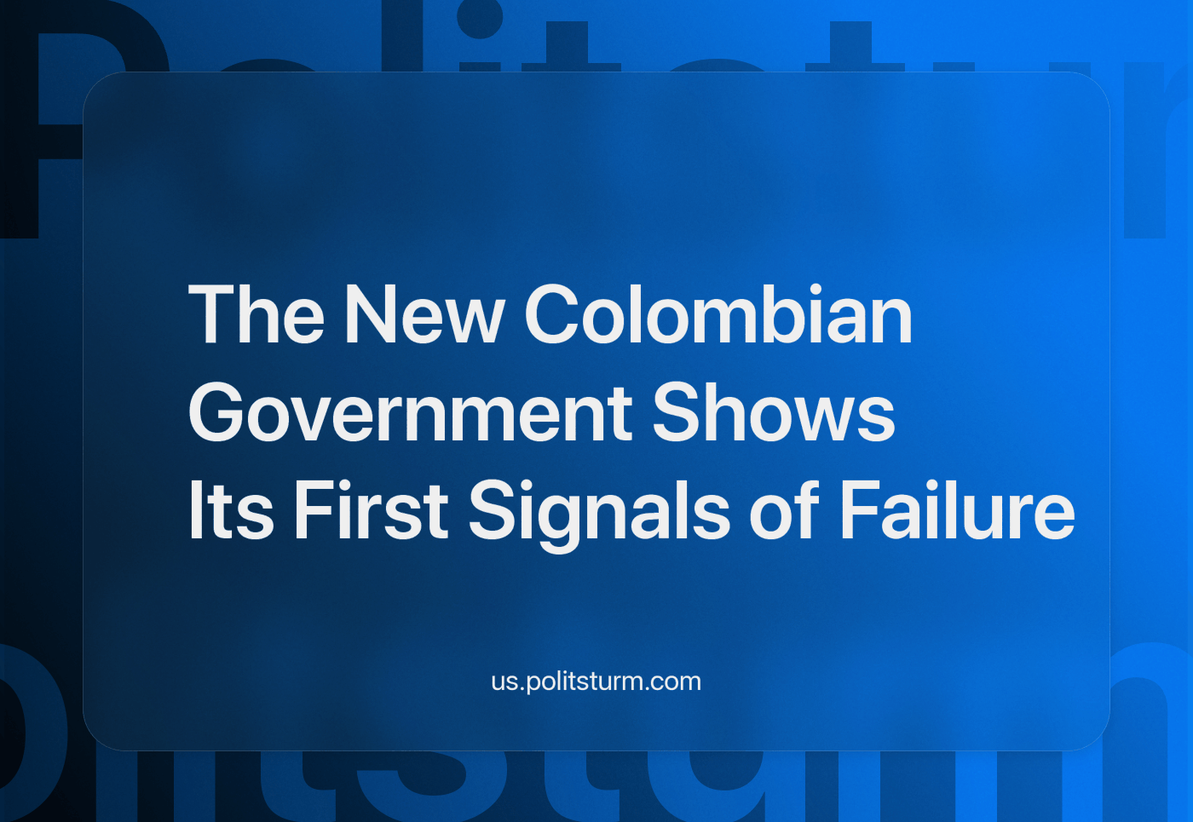

Original article
2023-12-04
4 min read

The first signals of anti-worker compromises from a government that got elected with promises of change became evident recently. Sometime after Francia Márquez, the Colombian Vice President, expressed her anguish at the very slow pace of the changes promised by the government that she is a part of [1].
We have already analyzed the drafts of some of the flagship reformist projects of the Petro government and the context of his election. Recently the legal articles about delivery service workers of the labor reform were modified in the second draft presented to the Congress. These modifications amount to a rejection of the first draft in the previous period. Instead of recognizing the delivery workers as employees, it leaves their legal status as either an independent self-employed or an employee to the will of the delivery service platform they are affiliated with. In the first case, the company will only partially pay for the social security of the rider [2].
The three main nationwide labor unions signed a common letter protesting against this retreat from the original proposal and its consequences over the current disputes over recognition. For reference, the original draft acknowledged the employee-employer relationship between the riders and the delivery platforms and consequently ordered for the latter to pay for the social security of the former in full [2].
These “adjustments” are not the only recent disagreement between the government and the workers’ organizations and not the only demonstration of the unequivocal class character of the Colombian state, and its reluctance to enact changes that favor the workers. A few days ago, the same labor unions issued a communication in response to the privatization of the National Savings Fund (FNA), a state bank that holds the mandatory unemployment savings of all state employees and the private sector workers that opt to use it. As part of this privatization, the workers’ delegates in the directive board fell from 3 to 1 [3].
This occurs within the context of heated accusations between the Government and the media monopolies [4], coup threats from the far-right and the retired armed forces officers [5] and sabotage in the parliament against the reforms, specifically delays to the discussions of the health reform [6] and absurd accusations against the pension reform supporters (like being personally interested in the reform for being a woman or having children) [7]. Furthermore, the Constitutional Court rejected one of the most widely supported parts of the approved tax reform, the separation between royalties paid by mining and other extractive companies and their taxable income, since they deduct the royalties first from the taxes they should pay, reducing the budget for the Government programs [8].
Following his tradition of trying too hard to reach agreements and conciliate with the reactionaries, Petro met with the wealthiest businessmen (financial oligarchs) in Cartagena a few days ago and with the historic leader of the most aggressive reactionary party, Álvaro Uribe, for a second time since he assumed as president [9]. This is not necessarily the direct cause of the regressive measures we exposed but is part of the same process, the stubborn resistance of the capitalist state to any improvement in the life of the toilers. This is illustrated further with the example of the Constitutional Court, which was a democratic referent in the past for blocking the third term of Uribe as president [10] and ordering his pretrial house arrest during his court case for bribing witnesses to his ties with the death squads [11]. However, even this institution is nothing more than the guardian of the illusion of democracy, the state organ that guarantees the legal basis for the rich to profit and get involved in state administration. At the same time, the laws that supposedly provide basic rights for a decent life for all citizens remain as a cynical promise for the poor.
The current lack of change from the Colombian “government of change” is not new, media sabotage, coups and parliamentary blockages have been seen in other countries of the region like Bolivia, Brazil, Paraguay, Honduras, Guatemala and Perú. Power exceeds the confines of the State and with situations like this, it becomes evident that state theatre is merely an exclusive game for the ones that have the time and resources to bribe officials, rent auditoriums, organize campaigns, pay for press attention, fund think tanks and all of this. Ordinary working people cannot do this and have no other option but to spend their time working for a wage in order to feed themselves.
Many people who have fallen to capitalist propaganda think the criticism made on social-democratic or “alternative” movements by Marxists-Leninists is unfair and sectarian: how can a reasonable progressive movement oppose supporting the enactment of some changes to improve the lives of the working masses from the liberal state in favor of unrealistic ambitious plans? Our answer in a few words is that real progressive reforms normally come from the organized struggle of the working classes against the policy of the capitalist class, whose power is embodied in the varied capitalist states of today. This is not a sacred truth; it is the result of experience and in the previous few weeks another case of this can be observed in Colombia.
Naturally, we must use any little space this game of legal politics allows us, not for making empty promises but for denouncing this situation and helping to organize the masses to look for actual and definite solutions for the problems we suffer. Since capitalists use the power they have both inside and out of the state we need first to eliminate the economic foundations of their power before we can actually implement any useful measure. In the meantime, we need to become an independent force, organized as a Communist vanguard party, one that doesn’t rush to unconditionally support the reformists at the first coup threat but one that unequivocally explains why progressive reforms fail every time and why we need a completely different way to organize our society and to lead this fight.
Sources:
[1] https://www.elespectador.com/politica/francia-marquez-dijo-que-a-veces-siente-angustia-porque-no-ve-cambios-rapidos-en-el-gobierno-petro/
[2] https://twitter.com/cutcolombia/status/1727675865666929104
[3] https://cut.org.co/wp-content/uploads/2023/11/2023-11-20-LAS-CENTRALES-SINDICALES-RECHAZAMOS-LA-PRIVATIZACION-DEL-FONDO-NACIONAL-DEL-AHORRO.pdf
[4] https://www.latimes.com/california/latino-life/story/2023-10-02/opinion-struggles-between-gustavo-petro-and-colombias-media-stir-latin-american-populism
[5] https://english.elpais.com/international/2023-05-12/gustavo-petro-issues-colombia-coup-warning-amid-veterans-protest-and-defenestration-remark.html
[6] https://elpais.com/america-colombia/2023-11-09/peleas-vicios-de-tramite-y-plan-tortuga-la-reforma-a-la-salud-de-petro-se-estanca-en-el-congreso.html
[7] https://elpais.com/america-colombia/2023-06-13/asi-funciona-el-sabotaje-de-la-oposicion-y-los-fondos-de-pensiones-para-frenar-la-reforma-pensional-en-el-congreso.html
[8] https://www.reuters.com/markets/colombia-court-strikes-down-ban-deducting-royalties-tax-income-2023-11-17/
[9] https://english.elpais.com/international/2023-11-27/gustavo-petro-30-colombias-president-is-once-again-open-to-a-national-agreement.html
[10] https://www.france24.com/en/20100227-constitutional-court-rejects-uribe%E2%80%99-bid-run-third-term
[11] https://www.hrw.org/news/2020/08/10/those-who-value-rule-law-should-back-supreme-courts-independence-colombia

Original article

