The Dark Side of Coca-Cola: Corporate Repression and Death Squads in Colombia
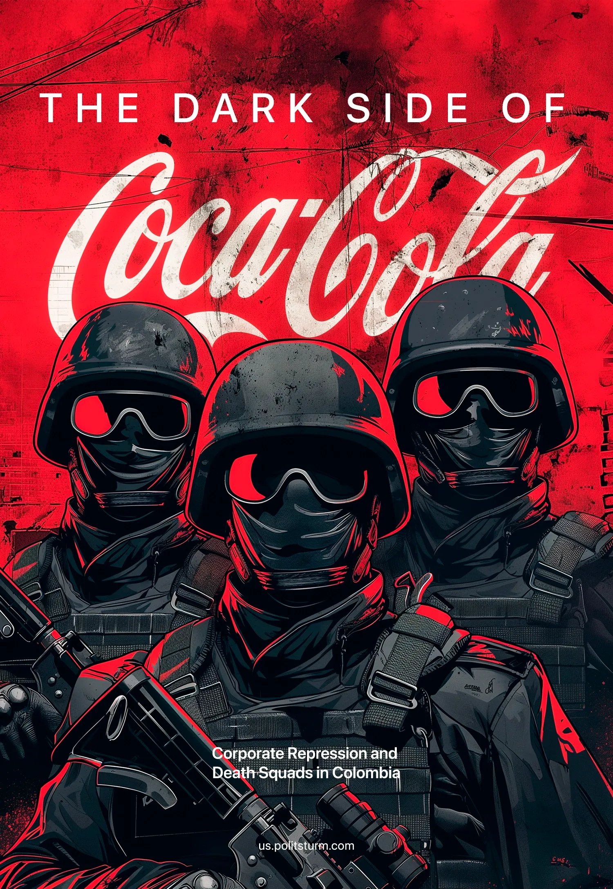

Original article
2024-06-22
10 min read

In recent years it has become commonplace to see “corporate responsibility” media campaigns. These are paid mixes of commercial announcements and favorable reports from renowned journalists and experts telling people that the company in question cares about the community and the environment and has nothing to do with what it is accused of.
Even more recent is the trend for companies to interact as people on social media [1], trying to appeal to a parasocial relationship with their customers that is intentionally distorted as one between two close friends. Far from this marketing trick, companies are huge collectives organized for the sole purpose of increasing the capital of their investors and to do so they can evade the consequences of their actions with many more mechanisms than any real individual person. In this review, we will examine the cases of Coca-Cola and others including Nestle, which have avoided accountability for the anti-union terror from which they have benefited.
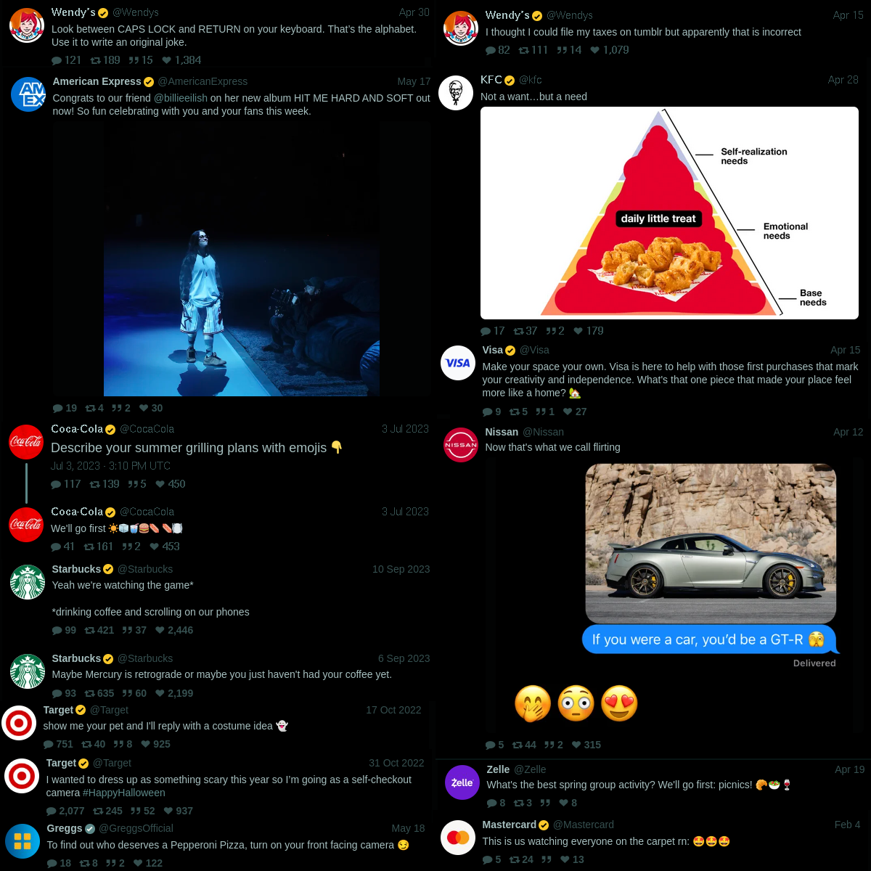
Some examples of companies interacting as people on social media. Taken from Twitter.
Coca-Cola was established in Colombia in 1940 under the model of a franchise - the way the company operates in most of Latin America [2] [3]. Franchising allows multinational companies to operate outside their country of origin by renting their intellectual property and brand rights to a local partner. This association requires constant monitoring of the local partner and joint management of the local operation in order to guarantee the quality and prestige of the product. Above all, franchising allows for subcontracting and allows multinational corporations to deny their involvement in the abuses committed by their partners abroad.
The northwestern regions of Colombia have suffered from the presence of death squads since the late 1980s, and in 1997 the far-right militias throughout the country united to form the so-called “United Self-Defense Forces of Colombia” (AUC). In one of the cities in this region, Isidro Gil, a union leader at the local Coca-Cola bottling plant, was assassinated by these militias, after which the rest of the workers were threatened with the same violence by both the manager and the death squads if they didn’t resign from the union. After the union was dissolved the paramilitaries burned down the union hall [4]. Two years earlier, in 1994, the paramilitaries killed two union members from the same factory in Carepa (in the department of Antioquia, near the border with Panama), José Eleasar Manco and Luis Enrique Giraldo [4], [5]. In 1990, Avelino Chicano was murdered during a strike in the southwestern city of Pasto.
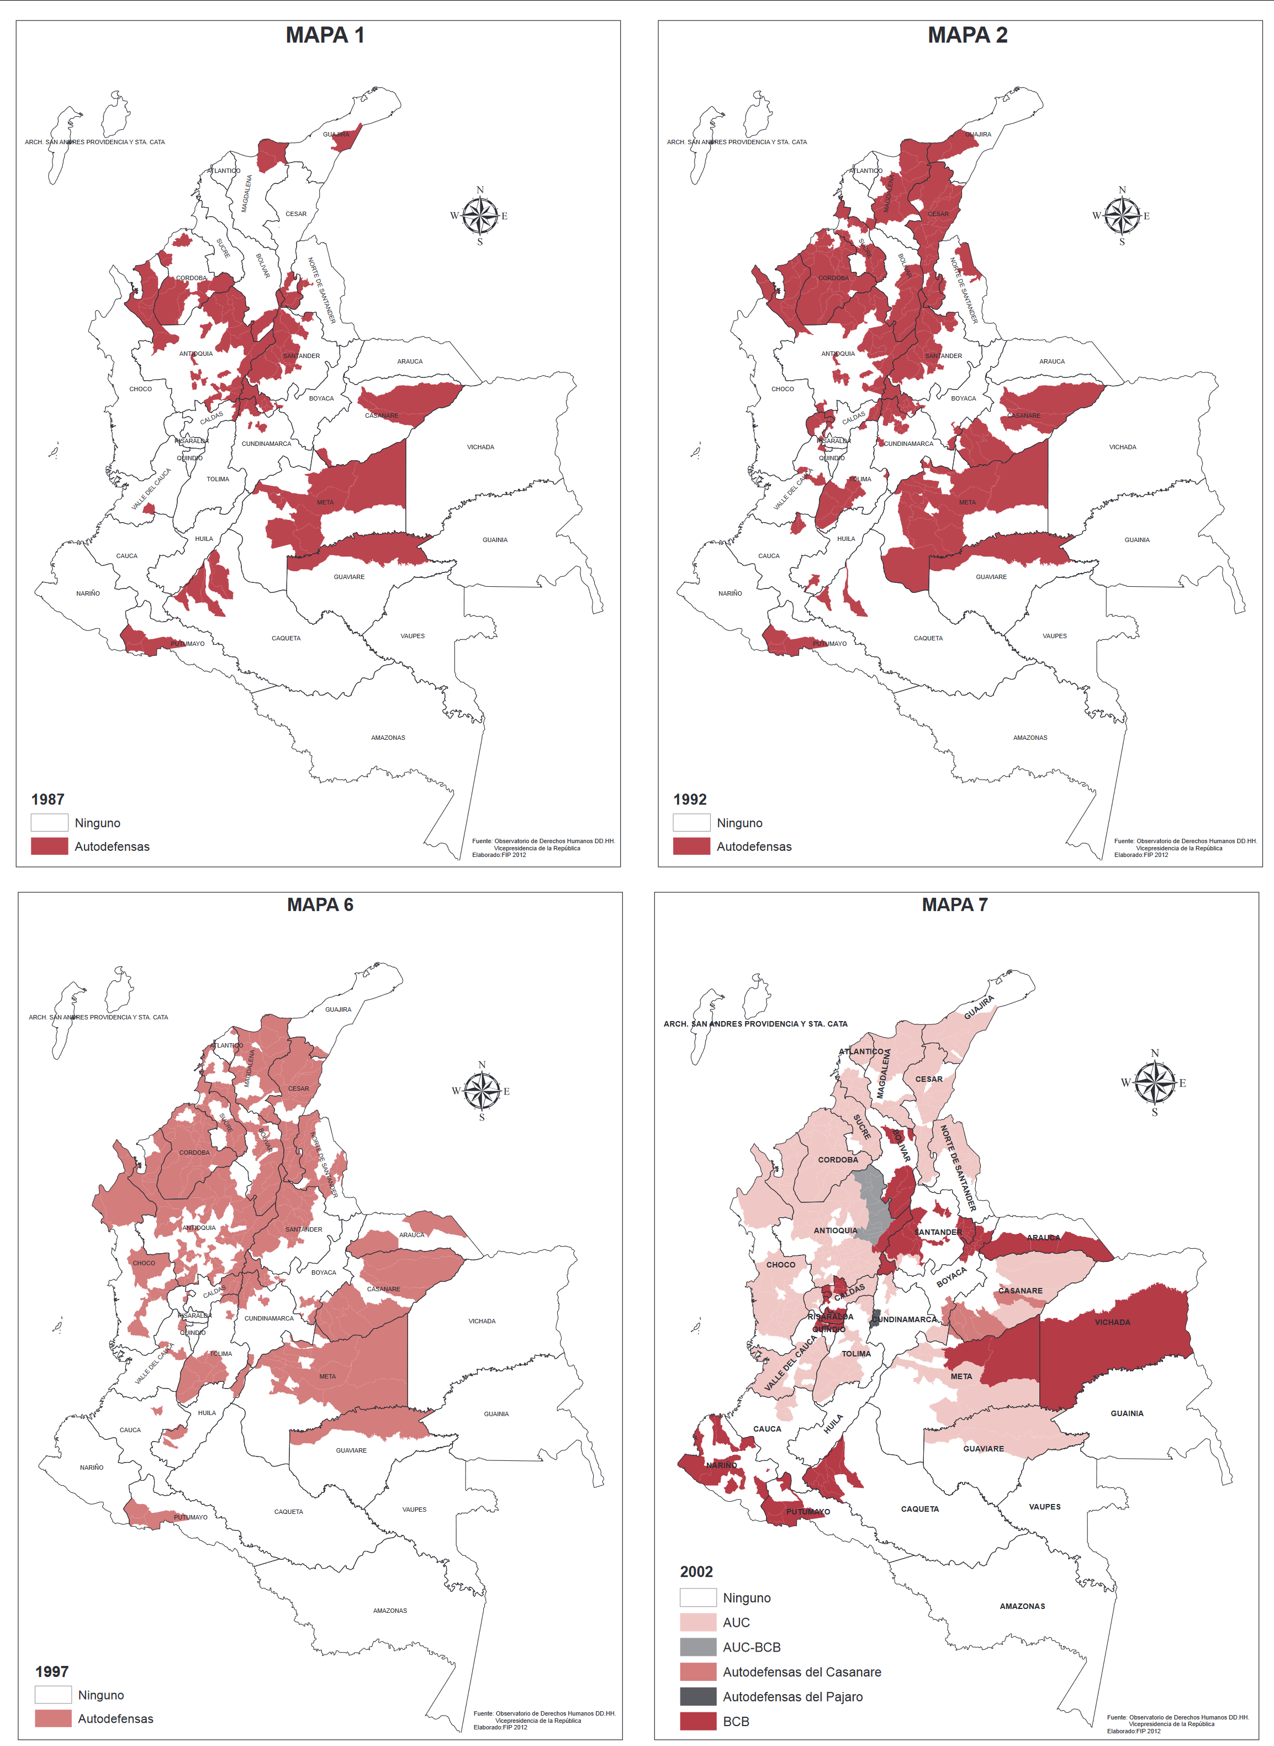
Presence of paramilitary structures in Colombia in various years. Taken from [6].
This doesn’t mean that Coca-Cola is the only company that benefits or has benefited from the anti-union terror of the right-wing militias. Drummond, the company that mines coal in the northern departments (Colombian regional divisions) of Guajira and Cesar, began operations after closing its unionized mines in Alabama. From that moment on, the terror of the death squad was installed in the region, to the point of surrounding and monitoring the mine with troops [4]. In 2001, Valmore Locarno and Victor Hugo Orcasita, the president and vice-president of the local union, were tortured and killed by a group of paramilitaries who stopped the company bus asking for them after months of conflict with Drummond, which accused the union of guerrilla affiliation and refused to protect them [4].
Another illustrative group of cases comes from the Swiss food company Nestlé, in contrast to the two previous cases. In 1986, Héctor Daniel Useche was the first Nestlé worker to be murdered for being a trade unionist. He worked at the company's factory in Bugalagrande, in the southwestern Colombian department of Valle del Cauca. Three years later, Luis Alfonso Vélez was forcibly disappeared after taking part in the 1988 general strike in the same city, which was occupied by virtually all of the state's armed forces.
In Cesar, one of the Colombian departments where Drummond operates mines, 5 union leaders were killed between 1993 and 2000. Harry Laguna was murdered in front of his children and co-workers in 1993 after quitting his job because of repeated death threats. José Manuel Becerra was murdered in 1996, and Toribio de la Hoz was also killed in the same year while celebrating his birthday with his family. Alejandro Matías Escorcia was assassinated in the same year, even after death threats forced him to quit his job. Victor Eloy Mieles died in 1999 after surviving two more assassination attempts and resigning was killed with his wife in front of the company's facilities [5].
In 2005, Luciano Romero was murdered after returning from Spain, where he had fled because of death threats, to testify against the company in a lawsuit over the termination of his contract in the midst of a campaign against the firing of 191 workers [7].
Of course, foreign companies are not the only beneficiaries of this violence; more than 3,000 unionized workers have been killed in Colombia [8], and 60% of the murders of trade unionists worldwide between 2000 and 2010 occurred in the country [7]. Not to mention that through the franchising system, the profits and ownership of local branches of a multinational company are shared between the headquarters and local capitalists. Landowners and other capitalists were ardent supporters of the paramilitary movement in alliance with the drug cartels. The paramilitary groups were responsible for almost 80% of human rights violations in Colombia in 2000 [9] and 90 % of their victims were civilians between 1981 and 2012 [6], including the lives of 3,800 trade unionists killed between 1986 and 2002 [10].
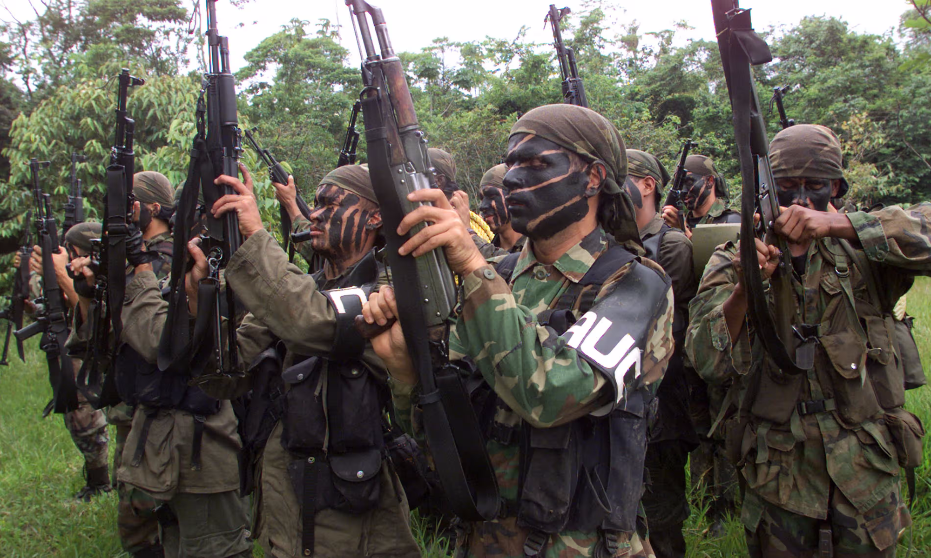
Death Squad troops in 2000. Taken from [11].
Anti-worker terror in Colombia is not something that happens spontaneously without the active support of the state. Even the U.S. State Department now admits that death squads were armed and provided with intelligence by state officials, and when a massacre occurred, the state forces purposefully looked the other way [12]. Since his return from extradition to the U.S., Salvatore Macuso, a former AUC commander, has testified about the deep and close collaboration between the bourgeoisie (both national and foreign), the state as a whole, and the paramilitaries. Mancuso confirmed that Coca-Cola and Drummond, among others, financed the right-wing militias while the state provided them with logistical support and both gave them indirect orders by accusing union members, peasant leaders, and other leftist civilians of being guerrilla collaborators [11].
The testimony of Mancuso and other death squad commanders is not the only source of these accusations. General Jaime Uscátegui organized the transport of AUC members from the northwest of the country to the southeast region of San José del Guaviare to carry out the five-day Mapiripán massacre, in which more than 30 residents were tortured and killed. He also secured the surrounding area so that guerrilla troops wouldn't interfere [9]. In 2006, 30 members of Congress were convicted and another 30 were under judicial investigation for complicity with death squads [13], out of a total of 268 seats in both chambers.
On the side of the companies, Coca-Cola insisted on the formal independence of the local branches to shirk any responsibility from the accusations while the representative of the local branch said that they had no choice but to support the death squads [10]. Meanwhile, they were implementing plans to replace the personnel of the local factories with temporary workers in order to reduce the social security and other costs of the permanent workers and to avoid any risk of unionization. Some of the murdered union members were already fighting against these plans at the time they were killed. At the same time, representatives of the transnational company repeatedly tried to declare the union illegal and to legally block the unionization of the outsourced workers [2].
Nestlé responded in a very similar way, releasing a statement in 2013 denying any responsibility for the murder of Luciano Romero. They argued that he was not their employee at the time of the murder and that their executives had no responsibility for the crime, nor any relationship with the Colombian death squads. Nestlé also accused Swiss public television of “trying to manipulate public opinion” by airing a documentary about its abuses in Colombia and the Philippines [14].
Although this level of terror is almost exclusive to Colombia, at least between the years analyzed, the anti-worker policies (outsourcing, threats, accusations, etc.) are replicated by both companies and many others abroad [15], [16]. As if nothing had happened, these companies cynically state on their websites that they fully support and respect freedom of association and demand this recognition from their suppliers and local partners [17] [18] [19].
The cases described here show how imperialist investments work politically at the local level, and how capitalists of different nations cooperate and use their states, and their legal and illegal systems to profit while evading the consequences. In both cases, the companies tried to save their reputation and their board of directors by throwing the ball of responsibility to other actors, who in time excused themselves with the same tactic, until the accusations ended with the already illegal forces that acted for the benefit of the whole chain. What's more, it’s worth noting that the expansion of both companies in dependent countries (like Colombia) was very similar. The way their anti-worker policies (outsourcing, anti-union practices, refusal to negotiate policies) were implemented was using the already existing forms of class violence and legal protections.
It is also worth mentioning that the very knowledge of this history and the few scant legal processes against these abuses exist only because of the international cooperation of trade unions and human rights organizations. This last conclusion shows how the interests of the working class develop internationally by their very nature. However, we can only consciously affect events as a whole while organised in a genuinely Communist party, united by principles and iron discipline. Unfortunately in Colombia, and most other countries, no such party exists.
We work towards the formation of such parties - Join us.
Sources:
[1] https://www.forbes.com/sites/forbesagencycouncil/2022/06/22/humanization-the-key-to-brand-success-on-social-media/
[2] https://www.cetim.ch/human-rights-violations-by-coca-cola-in-colombia/
[3] https://www.twn.my/title2/resurgence/2014/290-291/human1.htm
[4] https://digitalcommons.law.seattleu.edu/sjsj/vol2/iss2/19
[5] https://www.colombiasolidarity.org.uk/2008/09/campaa-nacional-e-internacional-contra-la-impunidad-colombia-clama-justicia/
[6] https://www.files.ethz.ch/isn/159688/Info%2019%20dimensiones%20geograficas_final%20web.pdf
[7] https://www.dw.com/en/nestle-under-fire-over-colombian-murder/a-16195009
[8] https://www.ecchr.eu/en/publication/nestle-and-the-death-of-a-trade-unionist-in-colombia/
[9] https://www.hrw.org/news/2001/02/12/colombia-military-tribunal-continues-army-cover-atrocity
[10] https://prospect.org/features/coca-cola-killings/
[11] https://www.theguardian.com/world/2023/may/19/colombia-paramilitary-salvatore-mancuso-auc-death-squads
[12] https://www.theguardian.com/world/2000/apr/19/martinhodgson
[13] https://www.theguardian.com/world/2008/apr/23/colombia
[14] https://www.nestle.com/sites/default/files/asset-library/documents/media/statements/2013-feb/documentaire-suisse-contre-nestle-jusqua-mort-en.pdf
[15] https://eiler.ph/news/labor-ngo-decries-nestle-wyeth-union-busting-and-mass-lay-off/
[16] https://www.iuf.org/news/coca-cola-s-attack-on-unions-in-the-philippines-invites-violence-against-workers/
[17] https://www.nestle.com/ask-nestle/human-rights/answers/labour-unions-operations
[18] https://www.nestle.com/sites/default/files/2023-07/nestle-human-rights-policy.pdf
[19] https://www.coca-colacompany.com/content/dam/company/us/en/policies/pdf/human-workplace-rights/california-transparency-in-supply-chain-act/human-rights-policy-pdf-english.pdf

Original article

