Border Clash between Taliban and Iran
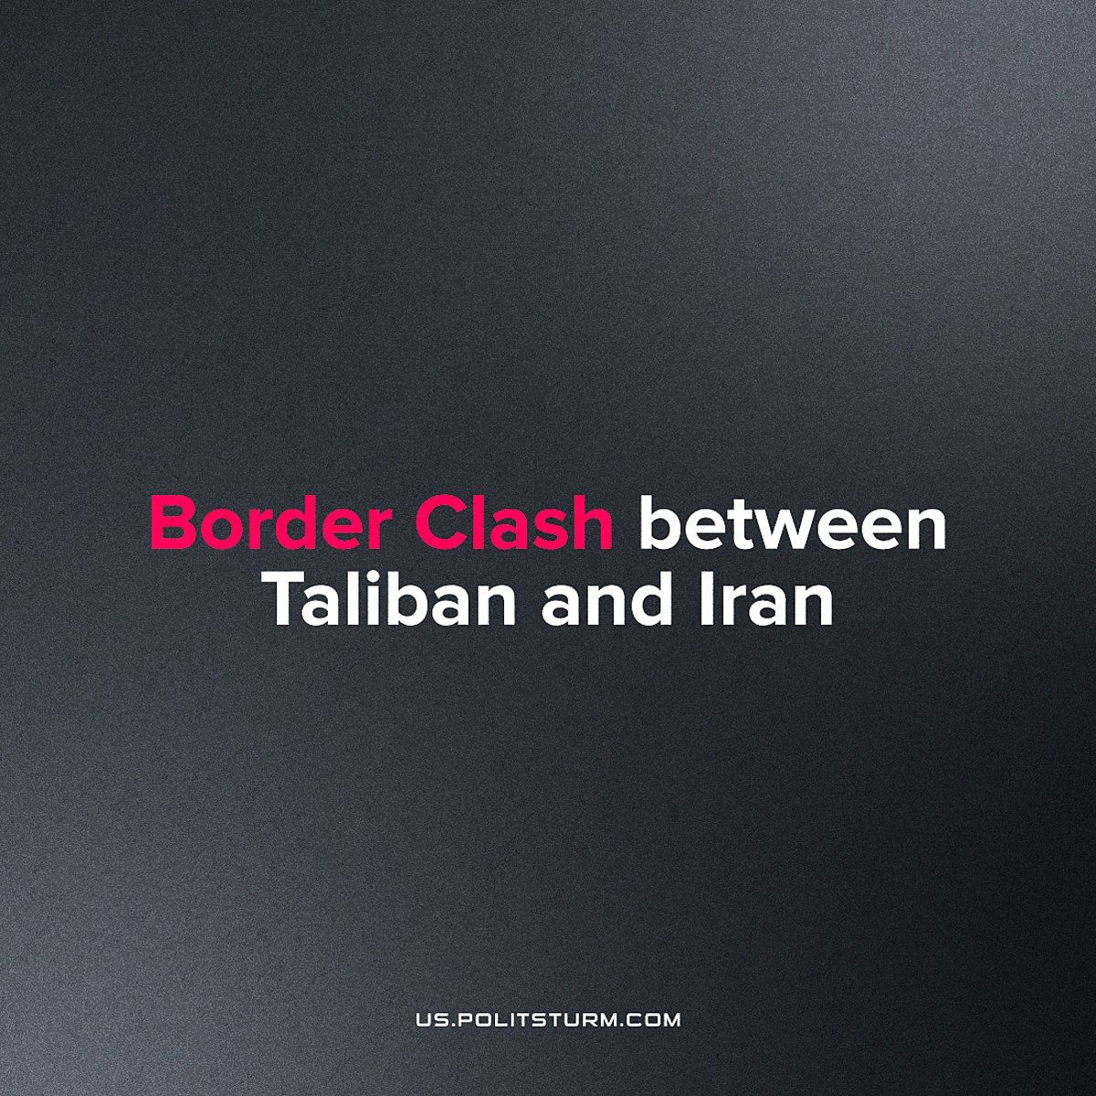

Original article
2023-06-05
2 min read

Escalating hostilities between the Afghan forces of the Taliban and Iranian border guards lead to a deadly border incident along the Afghanistan-Iran border, in the Afghan Nimruz province and the Iranian Sistan and Baluchestan provinces. At least three were killed in the firefights and several were injured. This incident marks the just one of many border skirmishes between Iran and the Taliban’s Afghanistan.
In our earlier publication on the Taliban's political rule in Afghanistan, we discussed how the U.S. withdrawal is simply a resolution of inter-imperialist contradictions through diplomacy. Now, we can see that the decision was not a total geopolitical failure for the American capitalists.
The disputes between Iran and Afghanistan were sparked over rights to the water of the Helmand river. Iran is concerned about dams built on the Helmand river during the previous regime, being used by the Taliban, which treaties signed in 1973 outlined to include Iranian use. The National reports Iran is recieving only 4% of its due portion of the waters which flow from Afghanistan. The Helmand river holds significant importance as a crucial water source in the Sistan province, where agriculture heavily relies on its waters. The seizure of a border post by a local Taliban commander occured just after Iranian President Ebrahim Raisi warned the Taliban not to violate Iran's rights to the water of the Helmand.
The relation between the Shiite Iran and Sunni Taliban have been tense. Iran even funded and helped the northern alliance before the US involvement in Afghanistan. After the Taliban takeover in 2021, there was a similar border clash in the Nimruz region between Iran and the Taliban.
Sistan, being in the driest place on the earth, relies heavily on the water of Helmand river since the destruction of wetlands in the region, making the agricultural economy dependent on this issue. Bocking the water before it's able to flow downstream would endanger the livelihood of tens of thousands of peasants. As the climate crises worsen and these places become drier it's only a matter of time till a full conflict erupts over water.
Capitalism is now unable to cope with the crises it has created in the form of climate change. As the climate crisis worsens, the contradictions of capitalism will also worsen. In such an environment imperialist wars between nations may be the only solution for Capitalism to fight for the resources, land and now water. As this crisis continues we would see intensification of such conflicts.
Sources: 1, 2

Original article

