Clarifying The Position, Pt.2: American Left Organizations on the Russia-Ukraine Crisis
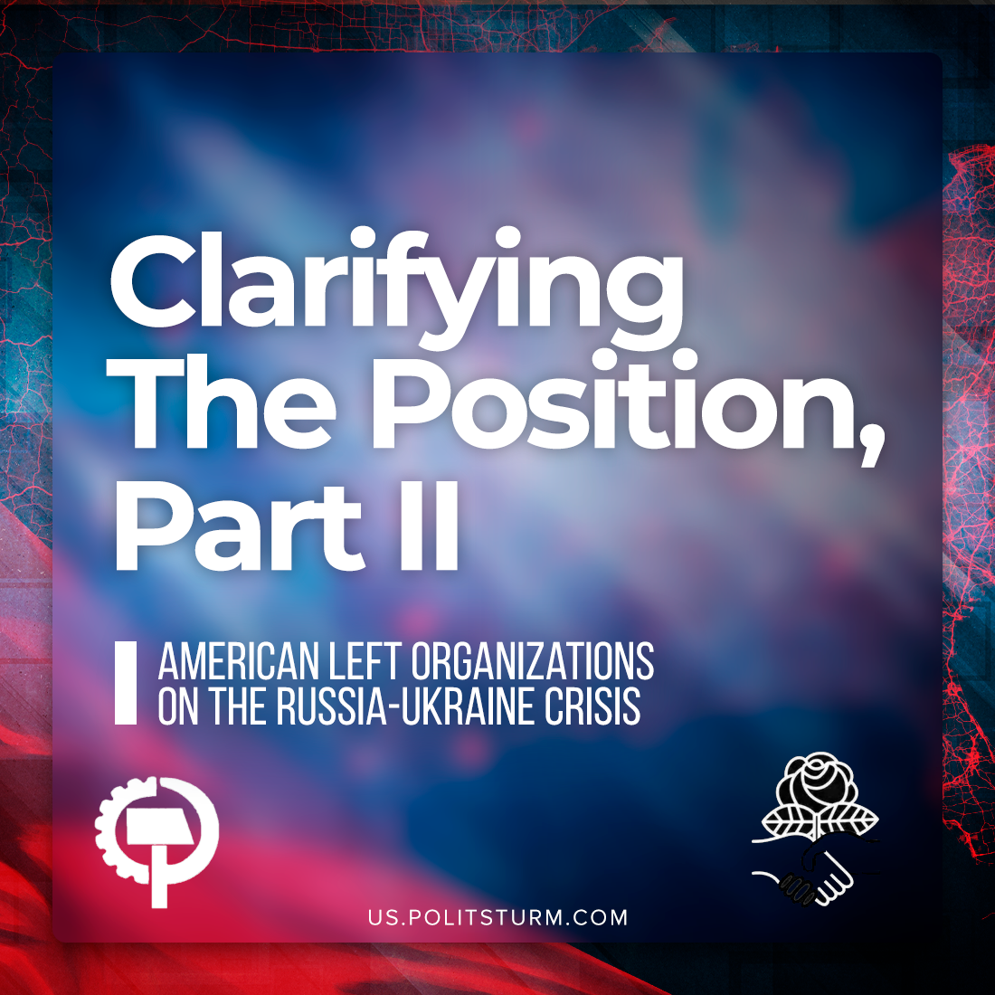

Original article
2022-04-03
11 min read

More than a month has passed since the start of the Russian “special operation” in Ukraine. We have already reviewed the positions of the British communists, which seem far from being communist. Now, let’s take a look at their comrades across the Atlantic – the American communists.
We want to remind our readers that we support the Joint Statement of Communist and Workers’ Parties and this position can be considered truly communist. We have posted our position several hours after the outbreak of the events on February, 24.
We will start with the well-known “official” communist organization. Shortly after the beginning of those events, the Communist Party of the United States of America (CPUSA) published their statement. The position of the CPUSA is based around the dangers of NATO. The major part of the statement is dedicated to expansionism of this imperialist bloc. However, the role of an opposite bloc in these events, represented by Russia, remains uncovered. Without a proper analysis, CPUSA comes to a teethless conclusion: “Ukraine’s “neutral” status is possible” and supposedly will calm the situation in the region.
It’s obvious that the whole discussion about Ukraine becoming “neutral” makes no sense. One should take a look at the modern capitalist world, entangled with webs of different blocs and alliances, and ask: is it possible to stay “neutral”? Every capitalist state will sooner or later find itself in this or that bloc.
If we take into account that this phrase is one of the cornerstones of Russian capitalist propaganda, the CPUSA basically takes the side of Russian imperialism and supports brainwashing the workers of the world by their social-chauvinist propaganda. Of course, it’s not something extraordinary: this organization supports Chinese imperialism, so its position is quite “logical”.
It’s difficult to say what is the real position of CPUSA, as their materials leave space for maneuvers. For example, an article was published on March 21, 2022. Written by Joe Sims – co-chair of the CPUSA – it comes up to reveal that the modern Russian state is actually capitalist, that the Western capitalism labels them “socialist” to increase Russophobia in those countries.
Error loading image
“Don’t you know comrades, that capitalism was restored in Russia and that the country is now led by a ruling class whose ill-gotten gains were the result of the wholesale theft of public property after the USSR’s collapse?” – these words look promising. If only the party followed them. Unfortunately, the position in general is inconsistent. Russia is capitalist – but question of the Russian government’s alignment (it’s imperialist, by the way) is left as discussionable. Russia’s “anti-imperialism” is at least questioned (big progress for such a party as CPUSA) – and we have words about “Kremlin’s vengeance in response to the NATO encirclement”. The place of the imperialist Russia in the capitalist international political system is described without the conclusion – naming things right, i.e. naming Russia imperialist.
So, what is the position of CPUSA on those events? One can take this statement, and another one contradicting it as well.
Despite heightening economic precarity in the US and the world at large, the CPUSA cannot sustain its positions, delivering a feeble impact due to its ideologically scattered clubs across varying CPUSA chapters who are free to develop their own activities and contradictory analyses, of which we can today highlight apologia for Russia’s attack. This chaotic decentralized organization is not the organization of a Communist Party at all.
What about their opponents? In this vein of analytical mis-alignment, the Party of Communists USA (PCUSA) demonstrates its own integral problems. They take up this rhetorical framing as well, showing support for the theses of Putin’s speech: Russia is fighting fascism and defending the “people’s republics”. This reflects a deeper misunderstanding of the events, which must be understand not as an anti-fascist struggle, but as a competition between capitalists, the Russian side of which merely intends to manipulate the Lugansk and Donetsk “People’s Republics” as a piece on its game-table – not to offer freedom.
It’s no wonder that their position is shared with joy by the “Russian Communist Workers’ Party” – their fellow social-chauvinists from Russia, and this micro-party is well known among Russian communists for its political degradation. For example, they go as far as assisting Russian nationalists. Just recently they held a conference featuring infamous right-winger, anti-Semite and conspirologist colonel Kvachkov.
Just like CPUSA, PCUSA lacks the execution of centralizing authority, and the character of their stances may shift from one department to the next, depending on the individual feelings involved. There are some rumors about the struggle between different groups within the party on the question of Russia-Ukraine, but the current position of the party is definitely social-chauvinist. The international secretary of the CC of the PCUSA formally associates with and supports the “Center for Political Innovation” (which we will discuss later), and his completely opportunist rhetoric corresponds with the statement of the PCUSA.
Now we will review the positions of the broad left organizations. As the true manifestation of social democracy in America, the political developments inside the Democratic Socialists of America (DSA) which produced their statement on Russia reveal the fate of such a bourgeois-electoralist broad-left party.
On January 31st, responding to Western reports of the military build-up and logistical preparations by Russia around Ukraine, the International Committee (IC), a working body which rose to prominence due to its increased activity which corresponded to the general feelings on the Left, called for the end to NATO expansionism and “a immediate mutually agreeable security measures to avoid any military breakout”. Since both NATO and Russia are imperialist countries, whose commitment to military solutions are motivated by material interests and not merely due to the personal tensions between the leaders, these directives fall short of a real rallying cry for the international working class.
Buffed along by the general trends in the American Left, the IC only serves as a pressure valve for the popular feelings in the DSA, which the dominant, ruling-class forces at the head of the party can open and shut when they see fit.
The National Policy Committee (NPC), the effective ruling body of the DSA, was well-placed by the criticism of the IC’s Jan. 31st statement to deliver an even more stifled response as the intervention began, amounting to a simple repetition of their call for the US to leave NATO.
Shortly afterward, on March 18th, the pro-Palestine DSA working group BDSWG, an ideological and political ally of stances held in the IC, was unilaterally dissolved by the NPC. Since this action so obviously seemed to contradict the pro-BDS policy which had been elected in the most recent DSA Convention, many on the left wing of the DSA saw that it reflected a cynical program by the NPC to move the DSA further into the realm of bourgeois acceptability. These developments have directly led to a serious and ongoing fracturing in the party, demonstrated by a wave of resignations from active committee members and organizers.
By cracking open the door to a new world of bourgeois electoral and social legitimacy which the young American Left has never experienced, opportunists at the head of the party can keep the many activists which DSA has drawn to itself under the direct management of the bourgeoisie.
The weakening as a force representing the Left and the working classes that has happened over these few years is unavoidable for an organization which sits inside of the state apparatus. Acting as an internal organ for the progress of fascization which is rapidly underway in the US, the heads of state and industry are organizationally equipped to undo any step forward which activists may take.
Opportunist trends are exposed by real situations which demand a real response: something their compromised interests restrain them from giving. These limitations and necessary movements aggravate hidden divisions and cause new eruptions from the existing pressures.
Following the prevailing trends represented in the IC of the DSA, but without an explicit rightward gravitation, the Party of Socialism and Liberation (PSL) oversees nationwide anti-imperialist activities within the ANSWER Coalition.
Their principles are immediately apparent in their material, in which they place ultimate responsibility for Russia’s intervention on US and NATO, reinforcing the legitimacy of the “denazification” and national liberation which Putin cited when he launched the imperialist operation. With a myopic view fixed on the role of the US, PSL renders itself incapable of a genuine Marxist response to the crisis itself.
Their directive “No War on Russia” is essentially lifted from previous campaigns for “Hands Off” of Cuba and Venezuela, despite the categorical difference between those circumstances and the present aggression. This attitude which views Russia as the victim of its own “operation” fails to reasonably address the serious consequences – of violent death, economic chaos, and an unstable future – which Russian and Ukrainian people, along with the people of the whole world, will face because of the decision by the Russian state to satisfy the needs of its capitalist ruling class.
While the liberal wing of bourgeois politics embraced nationalist chauvinism, many American leftists embraced their brands of social chauvinism. The modern version of this trend seeks to unite the anti-Americanism of the former and the support for capitalist Russia.
Holding desperately onto the moral legitimacy of the struggles of Donetsk and Lugansk, they have taken the bait firmly in their teeth – so now that Putin has pulled in the reel with the recognition of those states and subsequent escalation “on their behalf”, scores of ignorant Westerners are now caught on the hook with one of the imperialist camps.
Error loading image
When fighting first ensued, no American cheered “Hail Victory!” for Putin and the Russian forces louder than Caleb Maupin, Infrared and their associates with the Center for Political Innovation USA (CPI). This photo says it all. These people consider socialist Soviet Union and capitalist Russia equal, and the latter is, of course, “progressive”. This is clearly a social-chauvinist approach.
Russia has NOT invaded Ukraine.
Russia is protecting Donetsk & Lugansk, dismantling the Nazi-infested Ukrainian military.
They should have done it sooner.
My prayers are with all the people’s of the region in these hard times.
I’m glad Russia is bringing peace.
— Caleb T. Maupin (@calebmaupin) March 1, 2022
Marx states in the Manifesto that the Communists “have no interests separate and apart from those of the proletariat as a whole.” and it is in this spirit which we call for the position of the world proletariat, not in the interest of bourgeois Russia nor of America.
So, what we see is no wonder. We can clearly say that none of the major Left organizations in the USA apply Marxist method to current events, as none of them supported the Joint Statement we mentioned before (except “League of Young Communists USA”). The opportunist tendency is very strong in the US, and in that case they don’t differ greatly from the UK. What is the reason? The communist movement in the US is split as well as in the UK. It has neither theoretical, nor practical basis for unity. However, it’s never too late to work for such unity.

Original article

