CIA and MI6 Say World Order Under “Cold War-Like Threat”
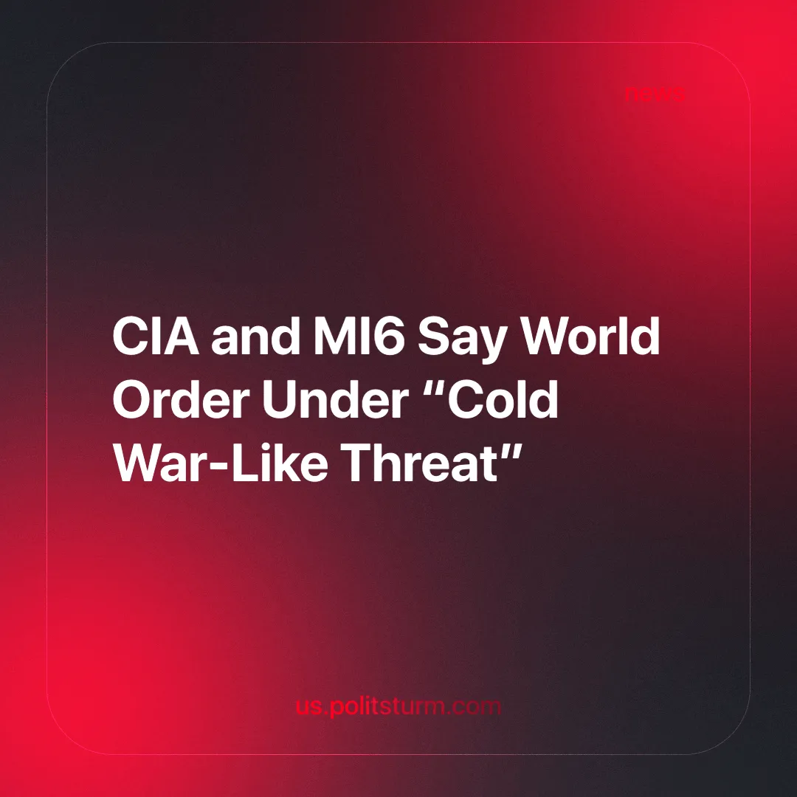

Original article
2024-09-18
3 min read

CIA director Bill Burns and Richard Moore, chief of MI6 published a joint article in the Financial Times commenting on the cooperation between the two organisations and discussing the current threats to “world order”. [1]
According to them, Russia's so-called 'special military operation' in Ukraine, Russia's assertive posture in general, and 'the rise of China' are 'the most important intelligence and geopolitical challenge of the 21st century'.
They affirm that the UK and the US will work together to counter this perceived threat. They recall “the closest of collaborations through the First World War, Second World War and Cold War, followed by a shared struggle against international terrorism” and conclude that “that partnership lies at the beating heart of the special relationship” between the two countries.
They state that funding and assistance to Ukraine will continue and that they will also work to achieve a ceasefire in Palestine and to de-escalate the situation in the Middle East.
The heads of the two intelligence services then go on to discuss the role of new technologies in combating these new threats, mentioning “harnessing commercial and military satellite imagery, drone technology, high and low sophistication cyber warfare, social media, open-source intelligence, uncrewed aerial and seaborne vehicles and information operations”.
The main purpose of their article is to convince the reader that the world order they defend has brought relative peace, stability and rising living standards and that China, Russia and other nations and organisations are a threat to this order.
Such claims of rising living standards are incompatible with reality. Even capitalist sources show that the number of people living on as little as $15 a day has increased since the 1980s and that most of the wage rises have come from East Asia and the Pacific [2]. Even still this simplistic measure of poverty doesn't account for the fact that many people in East Asia and the Pacific previously lived with pre-capitalist relations (i.e. peasantry) and were not dependent on money in order to have access to food. Now they are, and, just like the rest of the world, the price of rice and other staple foods in the region have risen faster than wages have [3].
Peace and stability have also been absent for the majority of people. While low wages mean that people are constantly struggling to make ends meet, there is also the glaring issue of the numerous wars that the West has been involved in since the Cold War (the US will be involved in 251 military interventions between 1991 and 2022) [4] and the complacency and complicity towards various humanitarian crises (such as the Rwandan genocide [5] or the current war in Palestine), not to mention the worsening climate catastrophe affecting millions of people.
The world order they defend is simply the one that best suits the interests of their own capitalists and can bring them the highest profits and allow for the most extensive exploitation. Russia, China and other rising imperialist powers are not seeking to end exploitation, they are seeking a bigger slice of the pie for their own capitalists. This is what the theories of "multipolarity" that they expound really mean. The West is threatened in the sense that it will no longer hold the dominant position in world exploitation. Under imperialism (or monopoly capitalism) different powers fight among themselves to redivide the world.
Capitalism cannot do away with this feature. Capitalist competition leads to the creation of powerful monopolies owned by the capitalist class. Having dominated their national market, they escalate their competition to the international stage, and the states of each nation work in the interests of their imperialist bourgeoisie in a struggle against their counterparts in other countries. War is just another means of competition. We have a more detailed analysis of capitalist monopolies and competition in an earlier article.
The technologies they are proudly developing are not being used to meet human needs, but to deepen exploitation, increase surveillance and create new tools of war. We discussed the role of AI in this in a previous article.
This imperialist competition is not in the interests of the masses. Only socialism, a system in which the capitalist class no longer exists, can end this violent cycle. In socialism, the means of production belong to the workers and are therefore used in their interests. This means that production and technology will be directed towards the development of society, the satisfaction of human needs and the end of the exploitation of man by man.
This can only be achieved through a strong and well-disciplined communist party under the guidance of Marxism-Leninism. Only a party like this can lead the workers in their struggle against exploitation. Through Marxist-Leninist philosophy, communists can truly understand the class content of events and know what actions to take that will benefit the working class in its fight for socialism.
Do you want to help towards building a party that can work to achieve socialism? Join Politsturm.
Sources:
[1] Financial Times — Bill Burns and Richard Moore: Intelligence partnership helps the US and UK stay ahead in an uncertain world — 07/09/2024
[2] World Bank — Poverty and Inequality Platform — Accessed: 10/09/2024
[3] Research Gate – Why does the Philippines import rice? Meeting the Challenge of Trade Liberalization – 01/01/2006
[4] Congressional Research Service — Instances of Use of United States Armed Forces Abroad, 1798-2023 — 08/03/2022
[5] The Guardian—America’s secret role in the Rwandan genocide —12/09/2017

Original article

