Metropolitan of the Russian Orthodox Church Links Vaccines to Worship of Satan
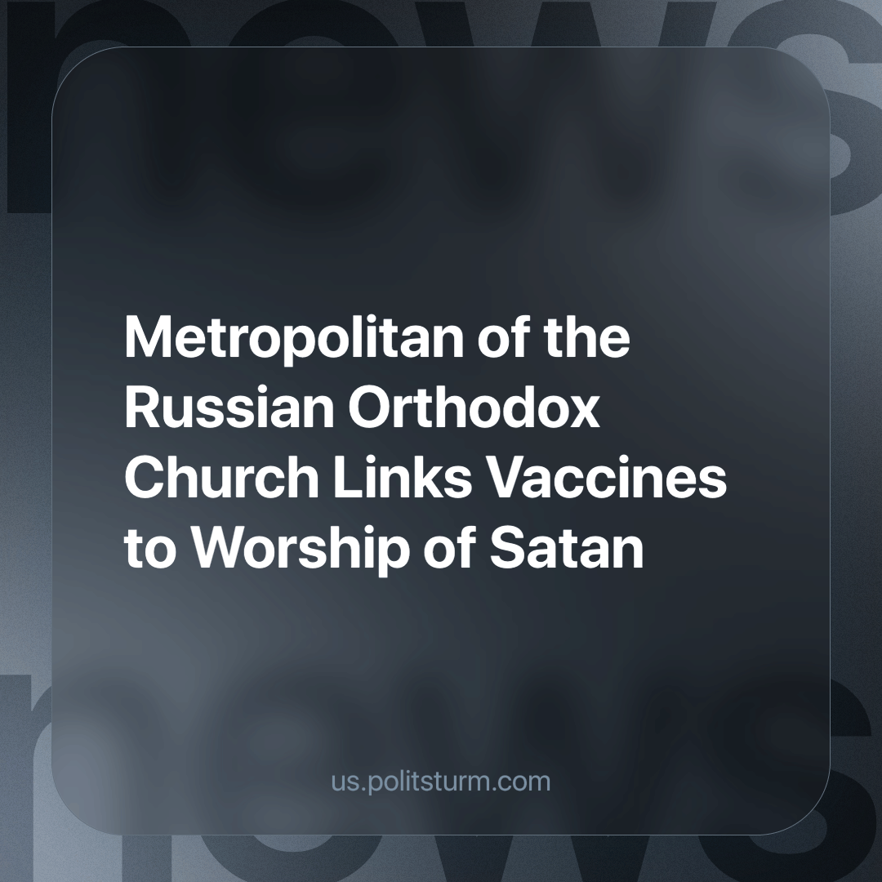

Original article
2024-03-15
1 min read

Metropolitan Yevgeny of Yekaterinburg and Verkhoturye suggests that vaccines, masks, vaccinations, and even social networks serve as instruments for hidden forces, which, through their followers on Earth, seek to compel people to worship Satan.
He interprets masks and social media registration as part of a special ritual, claiming that the head of the World Health Organization serves merely as a puppet behind which these secret forces operate.
Yevgeny also asserts that by exploiting human communities, Satan constructs a system to control people so that they worship him. He gives the example of vaccinations, stating, "I will give you a vaccine — you will live.”
Another representative of the Russian Orthodox Church (ROC), Protopriest Alexander Abramov, expressed the need for a temporary moratorium on the use of brain chips.
Statements like these from ROC representatives lead people to reject conventional medical tools, thereby becoming carriers of diseases. For instance, during last year's measles outbreak in the Lipetsk region, it was revealed that 70% of the infected had not been vaccinated.
Sources: Gazeta.ru - "Metropolitan of Yekaterinburg Links Vaccines to Secret Forces and Worship of Satan" dated February 8, 2024.
Vesti Lipetsk - "More than 70% of Measles Patients in the Lipetsk Region Were Unvaccinated" dated February 7, 2024.

Original article

