China’s Leadership Sets Economic Goals and Prepares for Future Conflicts
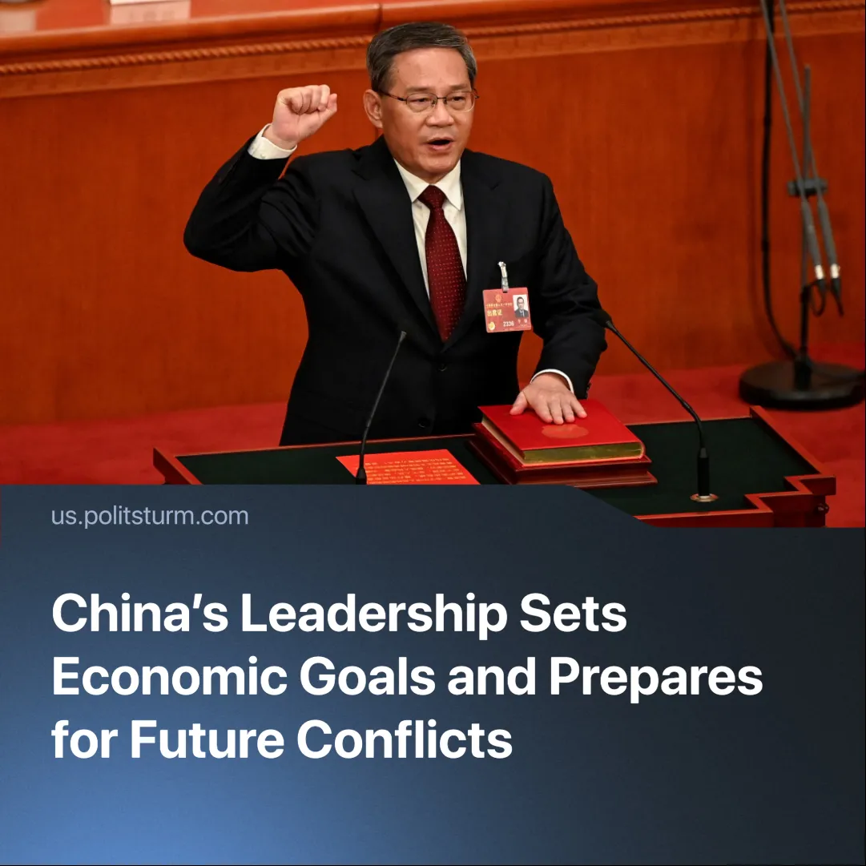

Original article
2025-03-20
2 min read

On March 5, 2025, Chinese Premier Li Qiang attended the annual Two Sessions meeting to present the government’s economic priorities at the National People’s Congress (NPC).
Details. Li Qiang’s outline focused on GDP growth, employment, military expansion, and global trade influence. The main focus remains maintaining China’s economic growth, with a GDP target of around 5%—the same as previous years.
► The government reaffirmed a 5% GDP growth target and pledged to create 12 million urban jobs. However, it continues to rely on entrepreneurs rather than direct state intervention to stimulate employment.
► China’s military budget rose 7.2% to $246 billion, continuing previous increases.
► The government reaffirmed its commitment to the Belt and Road Initiative (BRI), which involves investing in overseas infrastructure and strengthening economic ties with developing nations.
► China set a 2% consumer price index (CPI) target to boost domestic consumption, marking the lowest level in over two decades—down from 3% or higher in previous years.
► China will invest in AI and tech, while also promoting environmental protection.
Context. These priorities stem from rising global militarism, weak domestic consumption, and competition in AI markets. China’s domestic policies are shaped by its global strategic positioning—balancing between the U.S., EU, and Russia while expanding its economic foothold in developing nations.
► China manoeuvres between competing imperialist blocs, strengthening trade with Europe while keeping Russia economically dependent—extracting resources from Moscow without direct confrontation.
► Many nations receiving BRI loans struggle with repayment, allowing Chinese capital to seize key assets and exert political influence.
► China remains firm on the One China Policy, prioritizing Taiwan for its semiconductor industry and control over the Taiwan Strait, through which a significant portion of global trade flows.
► China faces growing internal contradictions—youth unemployment, debt burdens, and weak consumer spending highlight the fragility of its economic model, pushing it to expand abroad to sustain profits.
► In recent months, the U.S., EU, and Russia have all increased military spending and reshaped trade alignments, signalling that every major power is preparing for heightened rivalry and future conflict.
Important to Know. While China presents itself as a counterbalance to Western imperialism, its expansion ultimately serves its own ruling class—reinforcing capitalist exploitation at home and abroad.
► China now has the second-highest number of millionaires and the most billionaires in the world. According to one report, in 2018 there were 153 representatives classified as 'super-rich' with a combined wealth of $650 billion. These capitalists dictate economic and political life, while workers see little improvement in their conditions.
► Unemployment is a direct consequence of capitalism and cannot be eliminated under Chinese state capitalism—unlike in socialist countries, where employment is planned and guaranteed.
► Capitalists can offer temporary concessions—slightly alleviating poverty and unemployment—but will never abolish these problems, as they are inherent in a system where labour-power is a commodity.
► The 2% CPI target reflects China’s struggle with overproduction—a crisis inherent to capitalism, where falling demand leads to excess supply and economic instability.
► China manoeuvres through inter-imperialist contradictions, leveraging economic dependencies while avoiding direct military confrontation, but this strategy becomes increasingly unstable as global conflicts intensify.
Conclusion. China’s economy displays the typical contradictions of imperialism — balancing between rival powers while using foreign expansion to offset domestic instability. Like its competitors, China prepares for war not to defend workers, but to protect the profits of its capitalist class.

Original article

