How is Chinese Capital Subjugating the Iranian Economy?
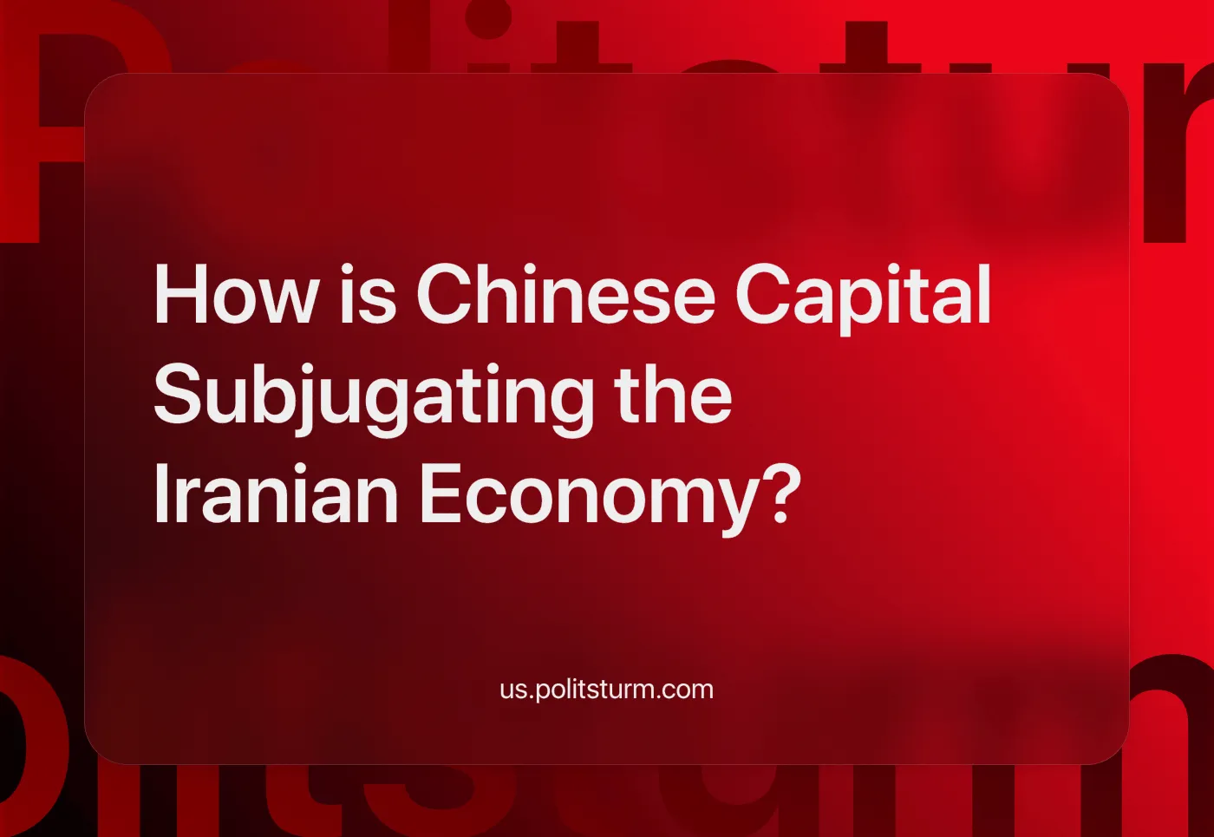

Original article
2024-08-17
12 min read

The Iranian working class, which helped the national bourgeoisie overthrow the Pahlavi regime, a political order deeply subservient to foreign imperialism, now feels that the new ruling classes have sold out their sovereignty once again in order to survive.
Since the purge of progressive forces by Islamists in the aftermath of the popular 1979 revolution, Iranian workers have been continuously disillusioned with false national bourgeois anti-imperialism. From the mass executions of communists [1] upon American warnings [2] to the rapid advances of capitalism under President Rafsanjani, who established temporary labor contracts as the main mode of wage labor in Iran [3].
And now, to add insult to injury, the ruling factions are quarreling over whether to open the gates to Western or Eastern capital, competing to see who can grant them the greater concession. This is while 3 million child workers exist in Iran and a growing segment of the working class is struggling to survive.
The epoch of the latest stage of capitalism shows us that certain relations between capitalist associations grow up, based on the economic division of the world; while parallel to and in connection with it, certain relations grow up between political alliances, between states, on the basis of the territorial division of the world, of the struggle for colonies, of the “struggle for spheres of influence.” - Lenin, Imperialism, The Highest Stage of Capitalism, Chapter V

Iran-West Relations
The key to understanding the relationship is to consider both the unity and the contradiction of the Western and Iranian capitalism. On the one hand, both share the common goal of maintaining wage labor and their class rule; on the other hand, they want to exploit the West Asian consumer market, labor power and immense fossil fuel reserves.
Moreover, the existence of the Soviet Union to the north gave Iran a strategic role in Washington's Cold War agenda; a Soviet-aligned Iran would have been far worse than an anti-American national bourgeois regime.
Therefore the post-revolutionary regime contrary to its boastful anti-imperialism has cooperated with the Western imperialists at key historical moments (see the Iran-Contra affair or Iran's role in the US invasion of Iraq).
After the Cold War, due to the loss of Iran's anti-communist utility, the US Congress passed the Iran-Libya Sanctions Act (ILSA), effectively ending the growing trade between Iran and the US (which had reached a peak of $747 million in 1992 [4]) and preventing major investment in Iran.
European powers denounced it and made a new European Community regulation to protect EU companies from its effects [5]. Although investment in Iran and trade were greatly reduced, by 2004 Europe was leading the way in any small investment, with Germany in particular playing a prominent role [6].

The Iranian Nuclear Program
Before 1979, the Western powers were more than happy to do nuclear-related business with the imperial state of Iran. Germany's Kraftwerk Union AG and France's Cogéma both built reactors, and U.S. Chiefs of Staff even suggested to place nuclear weapons in Iran as part of its close links [7].
With the rise of a hostile bourgeoisie in Iran, the anti-nuclear sentiments of the West were suddenly awakened. But until November 2011, when the International Atomic Energy Agency reported on Iranian experiments aimed at designing a nuclear bomb [8], Iran's facilities were not a real concern.
As a result in 2012, the western powers decided to "significantly broaden restrictive measures", with the toughest sanctions imposed against any other country (recently surpassed by Russian sanctions) [9].
As a result, oil exports dropped to a dangerously low 1,200,000 barrels per day as early as 2013, and the Islamic Republic scrambled to save itself from bankruptcy by negotiating the Joint Comprehensive Plan of Action (JCPoA).
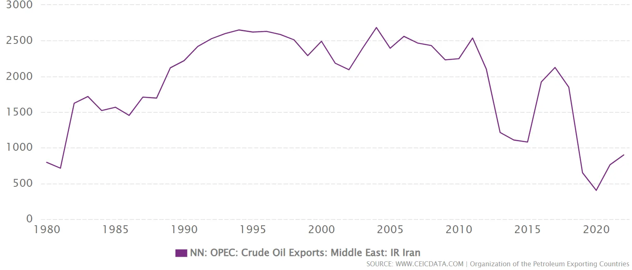
With the conclusion of the JCPoA agreement in 2015, foreign powers had ensured (through on-site monitoring) that Tehran could not acquire nuclear weapons in exchange for the lifting of nuclear-related sanctions.
In addition, they could now exploit a young population of 85 million, massive fossil fuel reserves and an educated workforce. Take, for instance, Chevrolet, which planned to resume manufacturing in Iranian auto-plants after 34 years [10], or the French consortium, TotalEnergies, which signed a $4.8 billion deal and planned participation in exploiting the world's largest gas field located in Iran [11].

Maximum Pressure Campaign
When Trump became president, American monopoly capital adopted a much more aggressive policy. The 26th U.S. National Security Advisor John Bolton openly declared that it is the administration's policy to "end Iran's Islamic Revolution before its 40th anniversary" [12].
Trump withdrew from the JCPoA and ordered a new round of sanctions. Mike Pompeo, CIA director and US secretary of state, listed the conditions for renegotiation as ending support for Hezbollah, withdrawing from Syria, disarming Shiite militias in Iraq, and ending the proliferation of ballistic missiles in addition to nuclear weapons [13].
Essentially, Iranian capitalists should surrender their sphere of influence and disarm themselves.
France, Germany and the UK in a joint-statement expressed regret at the American decision, and EU said it was determined to preserve the deal [14].
After the demise of the JCPoA, the Europeans failed to salvage the agreement due to the subservient position of EU capital to the US. A similar scenario was repeated with regard to the Russian sanctions.
Foreign Direct Investment (FDI) flows to Iran further declined. Instead, there was a shift in investment from Western countries to China, the United Arab Emirates, and Russia.
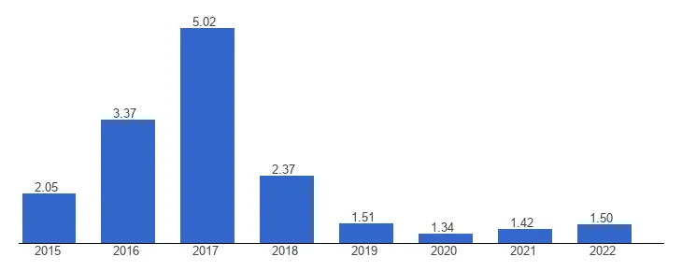
FDI flows to Iran

Look to the East Policy
"In foreign policy, the preference of the East over the West, the preference of the neighbor over the distant, the preference nations and countries that have something in common with us over others is one of our priorities today [15]" -Supreme Leader Ali Khamenei, Tabriz Speech 2018
In response to aggressive American demands, the IR establishment decided to increasingly align itself with China and Russia. Gazprom became the largest investor in Iran's energy infrastructure, and Chinese capital remains the largest buyer of Iranian oil at a steep discount. The so-called hardliners and the IRGC have further consolidated their power and influence over various sectors of the economy.
But the reformists, a group of Iranian capitalists, are not enthusiastic about the current situation with Chinese and Russian capital. They are a small section of Iranian capitalists whose main point of difference with the hardliners is their willingness to approach the West through huge concessions.
They have openly criticized the lack of loyalty shown by the Chinese to the Iranian ruling classes, saying they had "thrown us under the bus" [16], on another occasion they even went as far as to demanding the immediate cancellation of all existing agreements and contracts with China [17].
The reformists' criticism of China's exploitation of the Iranian economy is not about their sensitivity to imperialist domination and exploitation of the Iranian working class. It's about their inability to carve out a profitable niche as middlemen in this case.
It is true, however, that China has proven reluctant to deepen its economic engagement with Iran [18] and has sided with rival states when geopolitically convenient [19].
With the recent election (as they are strictly controlled in Iran) of the reformist Masoud Pezeshkian, one can see that Ayatollah Khamenei (and the currently dominant wing of Iranian capital) also fears over-reliance on China and desires [20] to see the presidency occupied by the bourgeois faction most willing to make concessions, in order to potentially counter-balance the growing Chinese influence.
In his "My Message to the New World," Pezeshkian had this to say about China:"We deeply value this friendship. Our 25-year roadmap with China represents a significant milestone towards establishing a mutually beneficial "comprehensive strategic partnership," and we look forward to collaborating more extensively with Beijing as we advance towards a new global order" [21].
But on closer reading of his letter, it is predictably in line with the reformists' agenda. First, he points to Trump's aggressive policies and withdrawal from the JCPoA and urges Europe to engage in "constructive dialogue" to cooperate on "economic cooperation," "energy security," and "transit routes".

Chinese Imperialism
"The non-economic superstructure which grows up on the basis of finance capital, its politics and its ideology, stimulates the striving for colonial conquest."-Imperialism, The Highest Stage of Capitalism, Chapter VI
China consistently claims that it promotes development and supports developing countries, unlike Western imperialism. "China is a friend that Africa can count on," Xi said at the BRICS-Africa Outreach [22]. An ideology of "multipolarity" is repeatedly put forward by Chinese officials [23].
Moreover, China's new ambassador in Iran has recently written: "China will work with Iran to jointly safeguard the one-China principle and other basic norms of international relations, oppose hegemonism and act of interference, and make due contributions to the establishment of a fair and reasonablenew international order" [24]. The fairness and reasonableness attributed to an international order based on private property are empty words, mere masks for imperialism.
The reality is that Chinese capital is just as eager to make a profit as its Western counterparts, and the most glaring evidence of this is the purchase of Iranian oil at a steep discount. From January to September 2023, Iran lost a staggering $4.2 billion as a result [25].
The oil trade system between the Iranian and Chinese economies bypasses Western banks and shipping services—and is particularly lucrative for the Chinese. The Iranian economy is dependent on oil revenue. To maintain this lifeline, Tehran is prepared to offer large discounts, denominate payments mainly in Chinese currency (CN¥) and transport the oil by "dark fleet" tankers [26] to avoid Western sanctions.
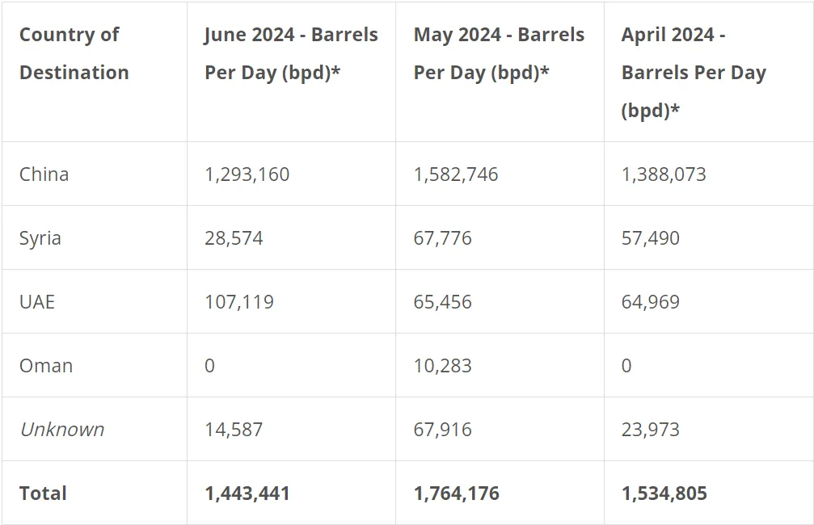
Source: United Against Nuclear Iran (an American congress advocacy group)
Chinese capital is more willing to be a lender than an investor in Iran, just as it is in Russia. Contrast the meager $3 billion direct investment [27] by China in 2023 with the $10 billion loan agreement of 2017 [28].
Under these circumstances, the Central Bank of Iran's limited foreign exchange reserves inevitably lead to increased imports of Chinese goods and services. For example, Iran purchased $2.12 billion worth of machinery and $1.43 billion worth of electronics from China [29].
The reliance on Chinese goods and capital helps explain why Iran was led to unilaterally abolish visa requirements for Chinese nationals [30] or why, in the midst of an economic crisis that has left millions unemployed, several contracts for construction and transportation projects are being awarded to Chinese companies.
"We have finalized agreements to develop five five-star hotels in collaboration with Chinese companies, construct 200,000 housing units, and establish two amusement parks and two water parks in Tehran."– Zakani, Mayor of Tehran [31]
This led the former Minister of Roads and Transportation under the prominent reformist President Khatami to state openly that "we have given China privileges that are unprecedented in our country" [32].
The continuation of this trend is highly plausible, given that the West's policy remains the same as before, namely maximum pressure, and in addition Chinese capital continues to establish itself even more firmly in West Asia through the consolidation of non-antagonistic relations between Iran and the Gulf Cooperation Council (GCC) [33].
The Iranian ruling classes, with the aim of overcoming the Western sanctions and obstacles on their way to grab a sphere of influence in West Asia, and despite the agitation of the reformists, have joined all the China-aligned organizations, from the BRICS+ to the Shanghai Cooperation Council.
But due to the nature of Chinese imperialist foreign policy, not only have they failed to overcome Western sanctions, but they have also given up a substantial share of oil sales profits and are devastating national industries with Chinese imports.
Therefore, such memberships indicate the subordination of the Iranian bourgeoisie to China's imperialist ambitions, as the aim of such organizations is only to expand their share of the world market and increase the number of countries dependent on them. See our material on this topic: Chinese Imperialism and the Debt Trap System.
The Iranian working class faces a challenge. Foreign capital, whether Eastern or Western, supports its crisis-ridden Iranian bourgeoisie as a source of cheap oil and a consumer market. The only force strong enough to overcome this is the mighty power of the working classes of the world united by Marxist-Leninist parties. The first step towards this goal is the formation of such parties, which we at Politsturm are involved in,joinus today!
Sources:
- https://www.amnesty.org/en/latest/campaigns/2018/10/blood-soaked-secrets/#:~:text=Between%20late%20July%20and%20September,death%20toll%20at%20around%205%2C000.
- Tower, John; Muskie, Edmund; Scowcroft, Brent (1987). Report of the President's Special Review Board. p. 104
- Tasnim (a semi-official newspaper) -https://tn.ai/2978710
- https://www.census.gov/foreign-trade/balance/c5070.html#1996
- The legal disputes between U.S. and EU capital regarding Iran -https://heinonline.org/HOL/LandingPage?handle=hein.journals/stet27&div=53&id=&page=
- Shana Petro Energy Information Network-https://en.shana.ir/news/90678/FDI-Hits-7b-in-Iran
- https://web.archive.org/web/20070728234400/http://www.oxfordresearchgroup.org.uk/work/middle_east/iranchronology.php
- https://www.reuters.com/article/us-nuclear-iran-iaea-idUSTRE7AG0RP20111118/
- https://www.bbc.com/news/world-middle-east-19947507
- https://financialtribune.com/articles/auto/16226/chevrolet-officially-entering-iran
- The Journal of Petroleum Technology-https://jpt.spe.org/total-prepares-exit-big-iran-project-us-sanctions-renewed
- John Bolton Opinion Piece -https://www.wsj.com/articles/beyond-the-iran-nuclear-deal-1516044178
- Pompeo M. (2018), after the deal: A new Iran strategy, The Heritage Foundation, Washington.
- https://www.bbc.com/news/world-us-canada-44045957
- https://farsi.khamenei.ir/others-note?id=38981
- Aarmaane-Melli reformist newspaper-https://www.pishkhan.com/news/287784
- https://www.pishkhan.com/news/287278
- https://www.wilsoncenter.org/publication/last-among-equals-china-iran-partnership-regional-context
- https://www.al-monitor.com/originals/2024/06/rare-clash-iran-china-reaffirms-solidarity-uae-over-disputed-islands
- https://www.japantimes.co.jp/news/2024/07/29/world/politics/iran-supreme-leader-ties-west/
- https://www.tehrantimes.com/news/501077/My-message-to-the-new-world
- https://english.news.cn/20230824/0f2e8d7ce25e4203962d4335e8b1e2b4/c.html
- https://www.aa.com.tr/en/asia-pacific/china-s-xi-reiterates-call-for-equal-orderly-multipolar-world-/3260528#:~:text=China's%20President%20Xi%20Jinping%20Friday,five%20principles%20of%20peaceful%20coexistence.%22
- https://en.irna.ir/news/85480679/Adhering-to-the-One-China-Principle-China-and-Iran-Stride-Forward
- Oil Discounts to China -https://www.reuters.com/article/idUSL1N3BF0KB/
- Iran-China dark fleet -https://www.atlanticcouncil.org/blogs/new-atlanticist/the-axis-of-evasion-behind-chinas-oil-trade-with-iran-and-russia/
- https://en.otaghiranonline.ir/news/45326
- https://www.meed.com/chinese-firm-signs-10bn-iran-loan-agreement/
- https://tradingeconomics.com/china/exports/iran
- https://www.iranintl.com/en/202304125368
- https://www.iranintl.com/en/202402051907
- https://www.jamaran.news/fa/tiny/news-1625029
- https://www.scmp.com/news/china/diplomacy/article/3265379/old-issue-china-iran-continue-strong-relations-despite-beijings-stance-disputed-gulf-islands

Original article

