China and the EU Reaffirm Ties to Protect Capital Against US Disruption
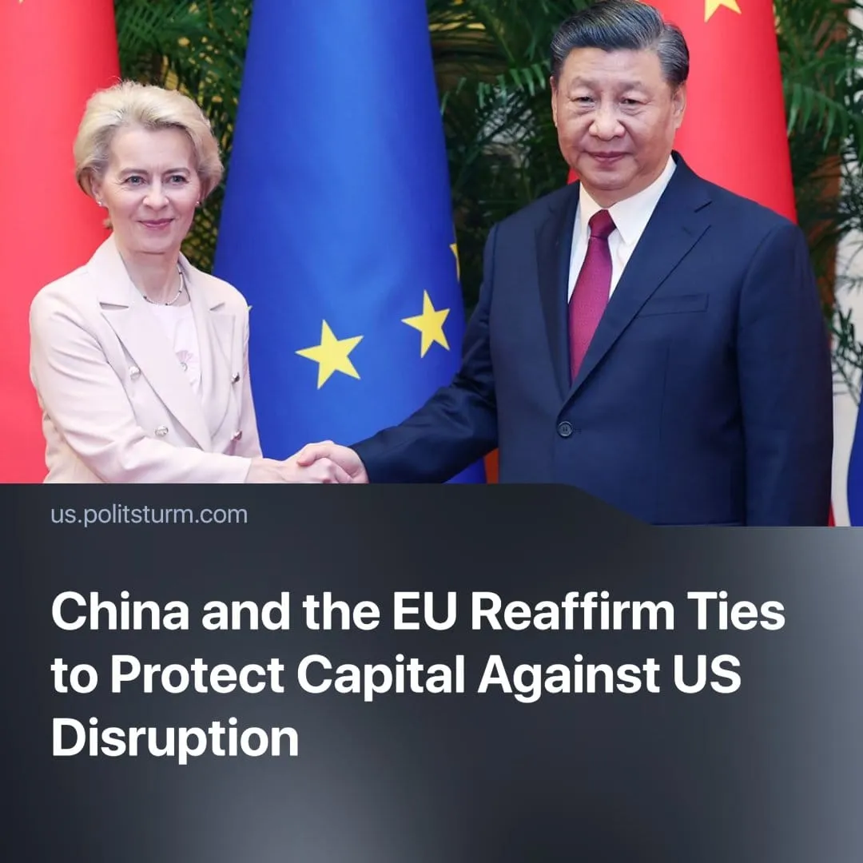

Original article
2025-05-13
2 min read

China and the EU are moving closer under U.S. pressure, but for different reasons — Beijing wants new markets, while Brussels is trying to assert itself as an independent bloc.
Details. On 6 May, to mark the 50th anniversary of the establishment of diplomatic relations between China and the EU, the two sides exchanged letters reaffirming their commitment to closer ties. They pledged to deepen cooperation amid rising tensions with the United States, particularly those sparked by Donald Trump’s actions.
► China urged the EU to oppose the unilateral “bullying” from the United States, and called on the EU to work together for global challenges under the banner of multilateralism.
► China lifted sanctions that were imposed on some EU officials, hoping to ease diplomatic pressure. The EU, on the other hand, decided not to lift its sanctions it had placed on officials running internment camps in Xinjiang.
► The EU did not soften its criticism of Xi Jinping’s government. EU MEPs continue to denounce China’s state-led industrial policies—accusing them of causing “market distortions”—as well as ongoing human rights violations, including those previously mentioned.
Context. This comes amid growing tensions between the US and China, fuelled by global tariffs imposed by Trump to extract more favourable terms for the US and increase other countries’ dependence on it. As trade with the US becomes less profitable, the EU is turning to alternative economic partners like China.
► Political and military tensions between the EU and the US have also worsened since Trump’s inauguration. His unilateral negotiations in Ukraine, repeated threats to withdraw from NATO, and open hostility toward the EU — calling it a project designed to “screw” the US—have strained the transatlantic alliance. With the US military as NATO’s backbone, this has left the EU increasingly exposed.
► These tensions are pushing the EU to reinforce its internal cohesion and position itself as a third imperialist bloc, distinct from both the US and China. However, for now, the bloc remains divided—some member states push for closer ties with Beijing, while others align more firmly with Washington.
► The US is attempting to isolate China by brokering deals with both Russia and Iran—traditional Chinese allies and former US adversaries, in an effort to curb China’s global influence.
► Trump’s tariffs have sharply reduced China’s access to the US market, increasing the risk of overproduction and deepening the threat of economic stagnation for Chinese capital.
Important to know. China and the EU are imperialist powers serving capitalist interests. Their cooperation is temporary and purely profit-driven.
► China’s appeals to “openness” mask a deeper economic need: to resolve domestic overproduction by exporting surplus capital and goods. Through dumping cheap exports into the EU, China hopes to relieve internal pressures while weakening US containment strategies by making Europe more economically dependent, though this has triggered resistance from Brussels.
► While keeping sanctions on China, the EU is deepening trade ties to offset economic dependence on the US—a move driven not by diplomacy but by the defence of its own monopoly-capitalist interests. At the same time, the EU is accelerating rearmament to reduce its military reliance on the American army in NATO and carve out a more autonomous imperialist bloc.
► The working class has no interest in supporting either bloc. Governments from Beijing to Brussels protect only capitalist interests. Neither EU nor Chinese workers are saved by their local capitalists, who are cutting wages and rights to stay competitive. Rising militarism and repression in both blocs serve the capital, not the class. The real enemy isn’t abroad. It’s at home.

Original article

