China Cuts Regulations on Foreign Ownership of its Oil and Gas Supply
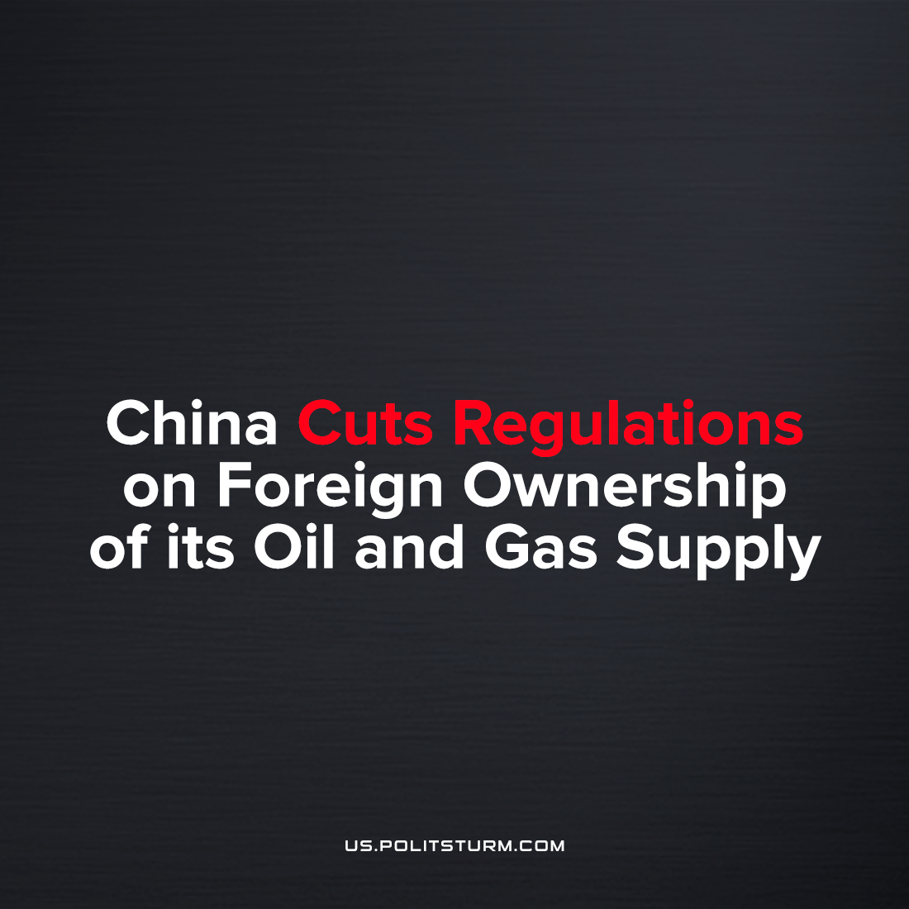

Original article
2023-04-17
3 min read

China has eased foreign ownership rules for oil and gas distribution in cities, according to S&P Global Commodity Insights, imperialist corporations are no longer required to form joint-ventures with domestic firms, finally ending the monopoly by Chinese companies on the domestic and international Chinese fuel market.
The policy of protectionism in China's natural energy exploration and production sector has been in place since 2019. Now it is being replaced by a competitive policy.
China's policy regulator National Development and Reform Commission and the Ministry of Commerce on Sunday published the 2019 edition of the Special Management Measures for Foreign Investment Access, also known as the "Negative List," which details restrictions on foreign companies in China. [1]
The activities of foreign companies extracting natural resources were previously banned entirely, despite the existence of Western companies like Chevron. This obviously allowed the Chinese natural resource sector to accumulate free resources and develop its productive forces quickly, leading to the dominant market position of China in global production today. The lack of competition with foreign monopolists provided an opportunity to begin a new cycle of competition and expansion under better conditions.
part of a wider swathe of ongoing market reforms aimed at opening up Chinese industries to foreign companies
Error loading image
Although officially the goals of foreign investment in the Chinese market are to undermine the market position of national monopolies, increase their own domestic production by sending profits back to imperial centers, and diversify investment, but in fact it is a statement of readiness to enter economic competition with foreign imperialists, hoping to prevail in it and not to destroy but to strengthen national, domestic monopolies.
For the Chinese oil giants, the big problem is the depletion of domestic oil sources. That is why it is so important for them to compete for foreign markets and resources. And China has carefully prepared for this competition. The optimism towards China's strategy of expansion and strengthening its own monopolies can be seen even in the securities markets. Monopolies cannot stop the expansion and subjugation of markets, because to stop it is to lose the competition and to be taken over. That is why competition for foreign resources is of vital importance for Chinese oil businessmen.
The main problem is that foreign resources and markets will never be given up without resistance. The insoluble contradictions of the bourgeois class, caused among other things by competition, cause wars, which is what is happening now. Optimistic forecasts of stock analysts for some reason do not take this into account.
China's capitalists are when they talk about destroying the national monopolies of oil companies. The period of limiting the activities of foreign oil companies in China no doubt allowed CNPC, CP&CC, CNOOC, YPIL to accumulate free resources, because during this period they did not face competition in the domestic market. These free resources were undoubtedly be used for more successful expansion of Chinese oil giants, and domestic manufacturing.
Now, world-spanning liberal policies have reached China, but what has changed is that their capitalists can now rest secure on their dominance over much of the world's production and international relations. The actions of imperialist states and monopolies are aimed at fighting for the right to receive exclusive profits and for depriving competitors of these rights. Chinese businessmen, although they call themselves communists, are no different from other imperialists and only discredit the red flag and communist symbols with their actions. The Chinese imperialists, on a par with the rest of the imperialists, are dragging the working class into a war for corporate profits. However secure their position, it is the Chinese oil and gas workers which may now see downsizing and the loss of their employment to 'off-shoring' in places such as Kazakhstan, Mongolia, and Russia.
Sources: 1, 2, 3, 4, 5

Original article

