Childfree Propaganda Will be Banned in Russia
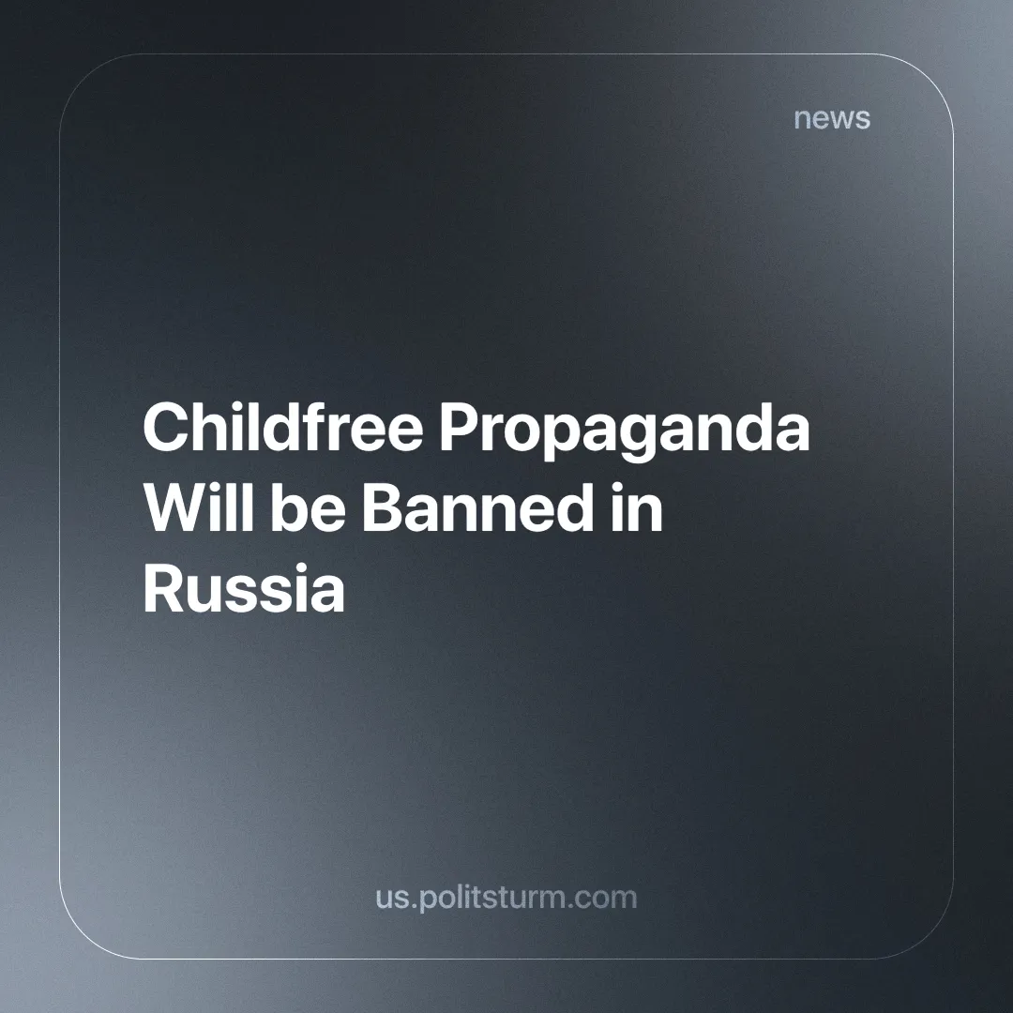

Original article
2024-07-31
1 min read

Irina Yarovaya, deputy chairwoman of the State Duma, has proposed to ban childfree propaganda, comparing it a weapon. Yarovaya spoke about it during her speech at the St. Petersburg International Legal Forum (SPILF) on June 26.
“This is truly destructive content. The question is whether this information should be labeled or simply purged and banned. This is an important question. Because when we talk about the defense of life, it is clear to the law enforcer what to do. If there is a person in front of you with a weapon in his hands, a law enforcement officer can act as actively as possible, even to the point of hitting a target that threatens society. How should we act here when we are also dealing with weapons that are directed against the younger generation? Should we wait or should we act? Our discussion led to the main conclusion: we still need to act,” said Yarovaya during the session “The Role of Artificial Intelligence in Countering the Propaganda of Radical, Extremist and Terrorist Activities.”
She said that many decisions have already been taken in Russia to counter terrorism and extremism, but some important issues have not been resolved, including the discourse on having children. According to Yarovaya, the propaganda of the childfree movement “changes the minds of girls who are supposed to become mothers.”
These are just more prohibitions that will lead to even greater problems for society. The bourgeoisie and its agents of influence have long been brainwashing people with the idea that having children is a matter of mindset rather than material conditions. This unwillingness of the ruling class to actually improve living conditions for people, as it would cut into their profits, exposes the true nature of the so-called "patriots" who, in the face of the global crisis, prefer to solve problems with further bans.
The only way to stop the birth crisis is to destroy the market economy, which cares only about profits and not about billions of the poor.
Source: Fontanka – “Deputy Chairwoman of the State Duma Irina Yarovaya compared childfree propaganda to weapons. And she proposed to ban it” dated June 26, 2024.

Original article

